In: Thomas J. La Belle (Ed.), Educational Alternatives in Latin America. Social Change and Social Stratification (pp. 238 – 254). Los Angeles: UCLA Latin American Center Publications, 1975

Radio Schools in Nonformal Education:
An Evaluation Perspective

Emile G. McAnany

Recent interest in nonformal education has generated research in the form of surveys of existing nonformal efforts. Although there have been strong recommendations to use more mass media in out-of-school projects, few projects using media exist. Latin America, however, through its radio schools has had a long-standing nonformal system that should be carefully assessed before launching expensive media projects.
The evaluation literature suggests a useful paradigm for an assessment of the radio schools under the categories of effort, performance, adequacy, efficiency, and process. How have radio schools performed on each of these criteria? In effort, or the amount of work done, the evidence is impressive: radio schools exist in practically all Latin-American countries and reach an estimated 250,000 people in organized listening groups, plus a much greater but unorganized audience among rural people. The performance criterion asks what effect radio schools have had on their audiences, and here the evidence is much less clear cut, although an increasing number of evaluations have attempted to measure their impact. The adequacy question is whether radio schools have had an impact relative to the nonformal education needs of the rural audience; there is little data but, looking at needs, radio schools are a long way from meeting them. Efficiency asks a comparative question: Are radio schools the best (most cost-effective) way of meeting rural education needs? Again, no cost and little effectiveness data leave this question open. Finally, process calls for an understanding of why radio schools succeed or fail and we are getting more answers to this question with more studies and self-evaluations.

The hope is that better evaluative research on radio schools will
_____________
p 238

serve three purposes: to get rid of efforts that are wasteful, to improve efforts with greater promise, and, especially, to help plan better use of radio for future nontoxic education in Latin America.

In the recent literature accumulating on nonformal education, there has been an emphasis on achieving agreement on a definition, discussing the general problems and theory relating to the phenomenon, and, recently, surveying existing programs.[1] At the same time, people have been looking ahead to a new era when nonformal education will become a recognized part of countries' educational planning and financing. In anticipation of such a new era, many have tried to suggest different ways in which educational resources can be made available to large groups of learners outside the formal school system. One strong suggestion, coming from a number of sources, [2] is a greater use of mass media in the variety of tasks in a nonformal approach to learning. There has been relatively little use of media for these goals in the past and those projects using media have often done so haphazardly and have not been carefully evaluated so as to provide future planners with sufficient information for guidance .[3] A closer look at the history of mass media use for education in developing countries reveals that television has tended to dominate the attention of education during the past decade (Schramm, 1973). This attention was logical since television was used to reinforce formal school projects, often in predominantly urban areas. Formal systems were expanding rapidly at this time and enjoyed increasing proportions of national budgets. Large claims had been made for the potential of TV for formal schools, but the outcomes in most cases have not revealed that potential's achievement (Coladarci and Arnove, 1973). Few examples can be cited that could be called cost-effective.[4]
Today people are suggesting smaller, more flexible, and lower cost technologies such as radio, cheap printed materials, and simple audiovisual aids as most appropriate for nonformal learning because they are often already existing technologies that countries can immediately apply to nonformal education, especially in rural areas. Radio has been one of the technologies most often cited as appropriate for furthering the goals of reaching rural, out-of-school masses of people. A review of radio's use in rural development (McAnany, 1973) reveals a history of increasing use in a variety of ways in almost every developing country. What is evident is that radio has been used widely but hap-
________________
[1] Coombs, Prosser, and Ahmed (1973); ICED (1974); Coombs and Ahmed (1974); Foster and Sheffield (1973)- Sheffield and Diejomaoh (1972); Michigan State University (1973).
[2] Coombs, Prosser, and Ahmed (1974); ICED (1974); Faure et al. (1972); A.I.D. (1973).
[3] McAnany (1973); Hornik, Mayo, and McAnany (1973).
[4] Hornik et al. (1973); Mayo, McAnany, and Klees (1973).

_____________
p 239

hazardly; it has many adherents, but little evaluation evidence exists about its effectiveness and costs.
Latin America, relatively media rich in comparison with Asia and Africa, has had a long history of using radio for a variety of tasks. With new pressures to create more learning opportunities for masses of marginal people, especially in the rural areas, Latin American countries have perhaps more naturally turned to media such as radio. To date there have been few new nonformal programs launched in Latin America. Before a spate of media-based programs is launched, it would be good to illustrate from a single example both the potential strengths and weaknesses of a medium like radio.
The Latin American radio schools represent, perhaps, the most widespread form of media-based nonformal education in the world. Beginning in 1947 with a single radio transmitter and a few people, they have spread to most Latin American countries and reach several hundred thousand rural people. There has been relatively little evaluation of this phenomenon although a nucleus of studies does exist.[5] If evaluation may be identified with asking difficult questions about success or failure, then there is a real need to do more evaluation on the nonformal educational efforts the radio schools represent.
The following pages will attempt to review, from an evaluation perspective, the radio schools as they exist today. This general review should illustrate both the strengths and weaknesses of the radio school model so that improved under-standing may contribute to the future needs of nonformal education in Latin America.

I. An Evaluative Review of Radio School Efforts in Latin America
The evaluation process is a complex one. There have been a few serious efforts to evaluate radio schools, but not enough to have created a single model to be followed in future evaluations. From the perspective of evaluation, the basic question to be asked of the radio schools is, What have they accomplished in the last 25 years? Too often in the past, the potential of the medium has been stressed without sufficient thought of what it has accomplished. The radio has long been used in Latin America: radio schools are a quarter of a century old. If there is potential for this nonformal educational tool, then we should know what it is by now.

Suchman (1967), in his treatment of the evaluative research process, names "five categories of criteria according to which the success or failure of a program may be evaluated": effort, performance, adequacy, efficiency, and process. Briefly they refer to the following aspects of evaluation of a project:
- effort: the quantity and quality of the work done in the program; (2) performance: the effect that the effort expended in the program has produced

___________________
[5] most of these are cited in McAnany (1973).

___________
p 240

among its target population; (3) adequacy: "the degree to which effective performance is adequate to the total amount of need"; (4) efficiency: the ratio of input to output or effort to effect with the further question of genuine alternatives to the method chosen,(often included in cost-effectiveness studies); (5) process: how and why a program works or fails to work.
Ideally, the radio schools individually and collectively could be reviewed under each of these categories. The result would be to provide information for the future of these schools in three important ways: (a) to improve some existing radio schools so that they functioned better (formative or feedback evaluation); (b) to discontinue other projects in the light of their achievements over a period of several years (summative evaluation); and (c) to provide a better understanding of the costs, benefits, and especially the process of radio schools so as to better plan new projects using radio for nonformal education (planning evaluation). As I have pointed out, however, such evaluative data do not exist for most radio schools. Therefore, the remainder of the paper will attempt to include what is known about the radio school projects under each of these categories and to assess their overall impact on a general level.
Such a review begins with several caveats: radio schools are not identical everywhere in Latin America; little written evidence (even descriptive) exists on many of these projects; certain questions raised about problems that seem common to the idea of radio schools or their management may not be true for some existing projects.

A. Effort

What has been the scope of effort in Latin American radio schools? There are several ways to look at this category. The Colombian radio schools of Accion Cultural Popular (ACPO) were the prototype in this effort. Begun in 1947 by a parish priest in the small town of Sutatenza, the effort in Colombia today has grown to include 22,212 listening centers with 167,451 registered students (1968), printing presses, a network of radio transmitters, a record company, and an annual budget of between $4 million and $5 million (U.S.) (Brumberg, 1972). What is apparent from this is that ACPO not only has survived over time (a key evaluative criterion that many projects do not meet) but has grown and institutionalized its efforts.
A second way of looking at the effort is to examine how the radio school innovation has diff-used to other places. Table I gives a summary of some other radio schools in Latin America. In 1973 the ACPO idea was found in at least twenty-three other projects in sixteen Latin American countries. An examination of the dates of foundation also shows that most projects have been begun within the last decade and thus represent a relatively new trend toward expansion.
A third way to look at the effort is to see how many people these radio schools serve. Here there are no absolutely reliable numbers, but figures reported in
_____________
p 241

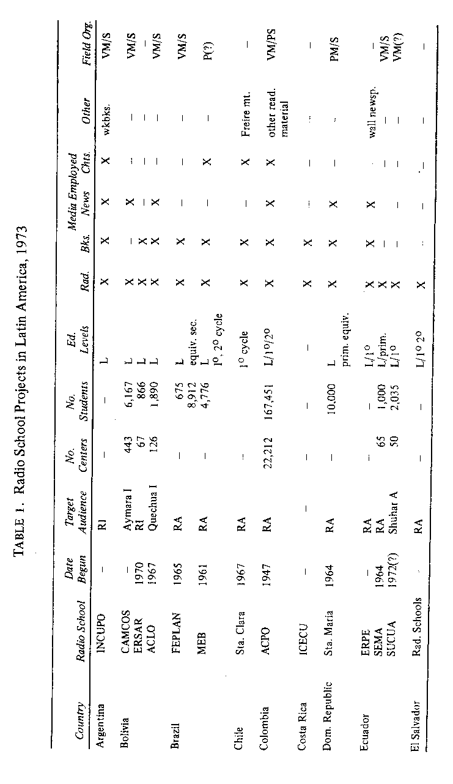

_______________
p 242

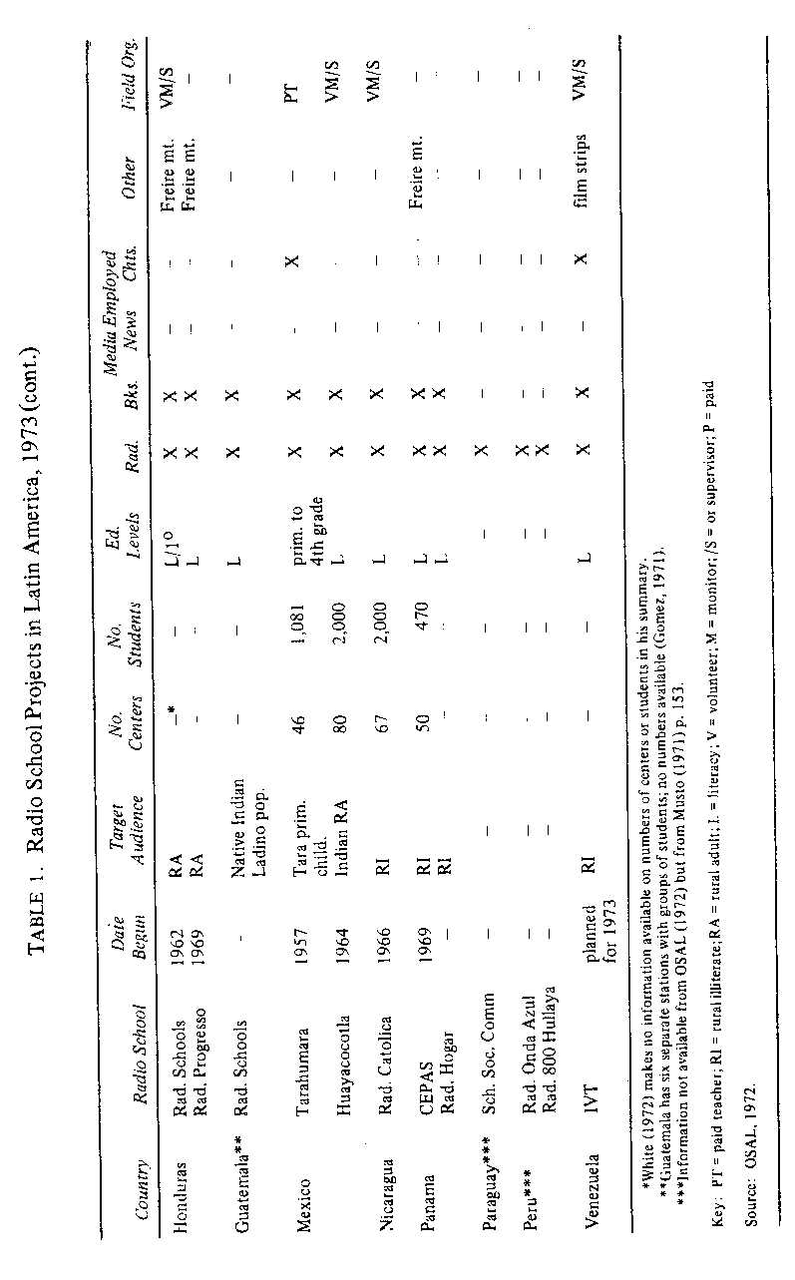

___________________
p 243

1972 (OSAL, 1972) and a conservative estimate for projects that do not report their figures indicate that the radio schools served about a quarter of a million people in their listening centers. A careful distinction needs to be made here between the estimated number of people enrolled in listening groups and those who may listen to radio programs but who are not enrolled in a group. There is no easy way to estimate this latter number. Rural people in most Latin American countries seem to own or have access to radios in large numbers. Radio schools, in addition to their educational programs for groups, often do programming that is educational in a general sense. Thus, a much wider potential audience is open to the informal learning that often comes vii radio and other influences in ft environment .[7]
A fourth category of effort would have to be the quality of work performed. Such a consideration would include important operational aspects of radio schools as (1) their ability to plan and clearly define objectives; (2) the quality of software (radio programs, printed materials, audiovisual aids, etc.); (3) managements (including supervising groups and getting feedback from them); (4) financing. All of these are vital elements in producing an effective radio school product. Although relatively little public evidence on the quality of the operation and the product exists, what does exist [8] seems to indicate that major improvements could be made here.
In summary, the evidence concerning effort for the radio schools in Latin America is certainly impressive. There has been a steady increase m growth, over the past ten years especially. The concern for quality is manifested, for example, in the meeting of the radio schools in 1972 (OSAL, 1972) and the more recent formation of an international body, Association of Latin American Radio Schools (ALER). There is still lack of information about the quality of the effort but some studies have pointed to serious shortcomings in planning, management, and financing, as well as software quality. The radio schools have continued to show a record of growth in the efforts they have been making.

B. Performance

The difference between the criteria of effort and performance in the evaluative task is often a critical one. To ask a project, "What have you done?", will bring a barrage of statistics, programs made, people enrolled, budgets, and so forth. To ask a project "What have you accomplished?" is quite another thing and brings anxiety and excuses from project directors. This is why evaluation is often done by outside groups who will not try to justify the administration. Ideally, a critical self-evaluation is what projects could most profit by.
_________________
[6] beginning attempt to create an evaluation model for educational television, especially for developing countries, can be found in McAnany, Hornik, and Mayo (1973).
[7] Scribner and Cole (1973); Coombs, Prosser, and Ahmed (1973).
[8]White (19172); Musto et al. (1971); Schmelkes de Sotelo (1973); Spain (1973).

_______________
p 244

How have the radio schools performed? is the question asked by a growing number of evaluative studies. [9] The problem has been in goal definition. Evaluation, often an uncomfortable activity, involves the researcher in finding out what the goals of a project are and then examining the evidence as to whether those goals have been accomplished. There seem to be two common problems for radio schools regarding performance or accomplishment: (1) The goals of the projects are often so vaguely stated that it is difficult to pin them down to see whether they have been achieved. If a radio school proposes to create the "new Latin American man" among its audience, the task of defining the goal and estimating its accomplishment often prevents any real performance evaluation. (2) Project directors frequently (and often sincerely) confound effort and performance; thus they will say they have accomplished a good deal in creating a radio station, developing programming, printing study guides and training monitors and supervision. All this is true and an evaluator seems ungrateful if he presses on to ask how many people have become literate through the process; yet that is a performance question.
What is the existing evidence on performance of the radio schools? The answer must be qualified by a reference to the stated goals of the schools. In a recent document, a summary of goals indicates a large degree of overlap with those of the best known example, ACPO of Colombia (OSAL, 1972). ACPO's goals are clearly stated in many places and can be summarized as follows: (1) motivation of the campesino or rural farmer for development; (2) human promotion or education of the whole man; (3) integration of the campesino into society; (4) organization and development of the community especially by participation in local organization; (5) productivity of the campesino in his agricultural work; (6) spiritual development of the campesino in his personal life. [10] The problems with the performance question are obviously two: choosing which of the goals to evaluate performance on and explicating the general terms of the goal in such a way to find appropriate and observable indicators. Both are difficult tasks but there have been an increasing number of researchers who have attempted both.
Briefly, how have some of these goals been examined by researchers and what have they concluded about performance?
Motivation. -DeKadt (1970), looking at the radio schools in Brazil's MBE (Movimento de Educacao de base) from 1961 to 1966, judges the impact of the 1964 military coup on the motivation of campesinos (and certainly on MEB workers themselves) by showing a failing off in enrollment from 111,066 in 1963 to 30,920 in 1966. Others like Musto (1971) suggest that official radio school statistics are often inflated and do not reveal the real and often shrinking number of students in the radio schools. Musto thinks that shrinking numbers in
__________________
[9]The best of these have already been cited: White, Musto, Schmelkes, and Brumberg.
[10] Musto (1971) gives a summary from official ACPO documents.

_______________
p 245

Colombia indicate lack of motivation of the campesino to attend classes and flagging interest in ACPO.
Human promotion or education.-Most evaluations have tried to focus on the obvious educational goal of radio schools, literacy. White (1972) has tried to make a careful estimate of the effect of the Honduran radio schools on literacy over a ten-year period. The performance was disappointingly small and would be discouraging were it not that the Honduran project was attempting to create a leadership for a movement to mobilize rural people. On this score, White observes that perhaps the impact was small but indirect (i.e., on leaders who would later reach people). Schmelkes de Sotelo (1973) evaluated the educational accomplishments of a radio school's effort among Tarahumara Indians of Northern Mexico. She found that for the few Tarahumara who got through a fourth grade of the radio schools, learning was comparable to regular primary schools. However, she also showed that educational achievement meant almost certain loss of the best students from their own native communities to the larger urban centers. Others have tried to evaluate educational performance with the conclusion that it is by no means as simple as it seems. Yet if radio schools are promoting the training of people in useful learning skills, they must be able to answer the performance question of whether they are achieving something or not.
Integration of the campesino into society.-One of the great problems of the radio schools and similar projects is a basic one of the development model that underlies their attempts at social change. The relationship of the campesino to his society is a critical one. If the campesino is exploited and the attempt of those working with him is to help him overcome his exploitation, then some explanation of who or what is exploiting him is demanded. If the goal is to change the unjust structures of society, as is often stated by ACPO and other radio schools, even if it is indirectly through education, then integrating him into that society may not be the best strategy. There are sharply divided opinions here. DeKadt, Musto, and Schmelkes would not think the goal is correct and would go beyond evaluation to a critique of the philosophy behind the radio schools themselves. The difference in attitude is perhaps best illustrated by the tides of the two readers that Brazilian radio schools of MEB published just before and just after the military coup of 1964. The first was called Viver é Lutar (To Live Is To Struggle) and the second, Mutirão (Cooperation); the titles emphasize the difference of approach. The first was militant, the second conciliatory. There is little consensus on what exactly the goal of integration means, much less any good measure of its performance. Fundamentally, the question may come down to a simple one about performance of radio schools: Have the radio schools helped the campesino to be any less exploited?
Organization and community development. -Another problem manifests itself when the question of participation of radio school people in community
______________
p 246

organization and development is concerned. Again it is as much a problem of the goal as in judging performance concerning it. ACPO has encouraged its students to participate in other community organizations but has stayed out of organizing or mobilizing communities itself. The radio schools in Brazil and Honduras, on the other hand, have called themselves "movements" and have attempted to mobilize the campesino. The criteria for judging performance on this goal would be quite different in the two cases. In the cases where radio schools see themselves as limited strictly to education, one would have to examine, for example, how much being a member of a radio school encouraged a campesino to join local community organizations. Musto and Brumberg did not really examine this question; Vega and Keeler's (1971) evidence shows little or no relationship between the two. White has most closely examined the other side of the question and has evidence to indicate that the Honduran radio school movement has had some impact on creating communities that are more dynamic.
Productivity.-This is an important goal for agricultural people but it has not been subject to much rigorous evaluation among radio school projects. If radio schools are teaching skills and attitudes that lead the campesino to be a better farmer, then the test of performance would be to ask if he is producing a larger crop (and if this crop finds a market to increase his income). Where some measure of performance has been attempted, the problem of proper evaluation design arises. Evidence often shows that it is the campesino who is better off who is a member of a radio school and has larger crop yields as well. But it is also true that he is relatively better educated, has higher status in his community, and is generally better off than others (Rogers, Ascroft, and Roling, 1970). It is difficult to establish causal direction in radio school projects-whether the relatively better off people in a community are able to take advantage of the radio schools as they do of most community resources or whether the radio schools create a better educated, more modem, and more productive campesino.
Spiritual development.-This goal is a dimension that is most difficult to judge and has been left to church leaders to deal with. The measures of performance on the other goals, however, have been attempted although no final answers are available. The definition of the goals themselves have often been in dispute. Musto, in a critical evaluation of the ACPO project in Colombia, probably summarized the feelings of many by admitting that despite all the criticism of ACPO it still had accomplished something positive during its twenty years of existence. The question, however, is not whether radio schools accomplish anything but whether they are making a serious difference in the solution of the problem addressed.

C. Adequacy

The third criterion of evaluation, adequacy, asks an even more difficult
_______________
p 247

question of radio schools. It is not whether the radio schools have done something or made some change, but how relevant that performance is to the problem. White (1972) asked the adequacy question in his study of the Honduran radio schools not only by estimating the total number of people made literate in ten years (certainly an accomplishment in itself), but also by comparing this with the total number of illiterates. He found that during the ten years about 7,000 people had been affected decisively in their literacy through radio schools. When this is compared with the approximately 500,000 illiterates in Honduran rural areas, we can see that the program has had relatively little impact. If radio schools in Honduras had for their main goal during the first decade of their existence the teaching of literacy, their performance was hardly adequate to the task and perhaps some other solution need be sought. The adequacy question may be turned to formal schools in the rural areas of Latin America and a similar answer given. Formal schooling is simply not reaching the vast majority of rural people needing education. It is inadequate to the task and therefore nonformal solutions are being sought.
The problems that the radio schools have focused upon are problems of the rural masses. Thus, the radio schools are involved in mass goals whether they like, it or not, and they will be judged partly on whether their performance reaches a significant number of campesinos. This is not just a question of numbers of people enrolled in programs (as included in the section on effort). Rather it is a follow-up question to performance: If radio schools educate, change attitudes, or increase productivity, how many participants are there and who are they? If the numbers are few and they are the relatively better off campesinos, there is certainly a question of whether the radio schools are adequately solving the problems incorporated into their goals. Schmelkes showed that in a formal school setting, the Tarahumara project reached few of the children with the full benefits of four years of basic education, and even those who were benefited tended to be from better off families and were often lost to the community by migration.
Few projects ever hope to solve a problem completely, but some criterion must be set to judge the level of performance relative to the whole problem. In Brazil a report on educational radio projects spoke of a potential campesino audience of 40,000,000 (IPEA, 1973). In reporting that only 40,000 or 1 percent of the whole was actually enrolled in the radio projects, the authors demonstrate the gap between need and response. The criterion of adequacy is obviously a relative one that must take into account the time a program has had to grow and its potential for expansion, provided the program can solve certain internal problems. Nevertheless, the question of adequacy is a difficult one that needs to be posed of any project after a certain period of trial: Will the project help to solve a significant enough proportion of the problem to justify the resources put into it, or should some alternative be sought?

______________
p 248

D. Efficiency

The question of efficiency is a comparative one. Two comparisons are assumed here: comparing the amount of input (or effort) to the output (performance) and then looking at this ratio across several alternatives for solving the same problem. Cost-effectiveness analysis is usually concerned with the question of efficiency: given a goal to be achieved, what is the most effective and least costly way of attaining it among an array of possible alternatives. Radio is often proposed as one of the most efficient means of achieving educational goals in rural areas both because of its accessibility by large numbers of people and because of its lower costs, especially in comparison with alternatives like television.
Evidence for the efficiency of radio schools is almost wholly lacking because little reliable data on performance and even less on costs exists. It is mainly through monetary equivalents like costs in dollars that alternatives can be judged. Thus if two media alternatives like radio and television were to be compared on both effectiveness and costs, it is likely that radio would be more efficient. [11] When one is comparing several different educational systems like radio schools and the cultural action centers of Paolo Freire however, the question becomes more difficult. Goals often differ and, furthermore, costs have not been gathered in most radio school projects so that viable comparisons are not often possible.
There is an added consideration in looking at alternatives. What is almost wholly absent from the- planning literature on media projects is a careful projection of cost and a realistic estimate of performance so that serious alternatives to media might be considered (Carnoy, 1973). Whether documents are produced only for public relations or whether project planners are unable to consider serious alternatives to expensive, capital-intensive media projects, there has been a great lack of critical alternative thinking in the planning stages of such projects. As better evaluations are performed on radio school projects, a better estimate of their efficiency may lead to either improvement of performance or serious consideration of nonformal education alternatives that might not employ radio as a primary instructional resource.
Another aspect of the efficiency question among radio schools is the definition of audience. Cost per student will vary greatly if only the more restricted audience of enrolled students is counted. The problem with counting the unorganized listening audience, presumed to be many times larger than those persons working in organized listening groups, is that there is almost no way really to evaluate the impact on this group. If one assumes no impact beyond the students enrolled in groups, then one disregards considerable evidence of

_______________
[11] For a discussion with some cost data, see Jamison and Klees (1973).

____________
p 249

large radio listening audiences in rural areas and evidence of media effects on such audiences. On the other hand, e valuations are based on evidence, not assumptions, of effectiveness. The -answer must include better audience research that would give estimates of both size and degree of message effectiveness among the unorganized audience. Once this is included, more realistic comparisons can be made between radio schools and possible alternatives.

E. Process

The final category of evaluation is the most difficult to study. The question to be answered is why radio schools succeed or fail. It is the most critical question because it helps planners and project managers to improve radio schools in the future. There is, however, an important element in each radio school project that is unique and often it is this element that has made the difference. Such elements are ordinarily not quantifiable but the evaluation effort is not itself based solely on quantitative measures (McAnany, Hornik, and Mayo, 1973). Factors of leadership have been among the most important for radio schools. It would be difficult to measure this, but no one acquainted with ACPO can discount the enormous influence of Msgr. Salcedo as founder and leader. Political factors are also of great importance as DeKadt documents in the case of the Brazilian radio schools of MEB. Among radio schools where much depends on the volunteered services of large numbers of people, the level of enthusiasm and belief among volunteers is fundamental to survival. All of these factors enter into the process of goal achievement and help to explain the relative success or failure of radio schools. Radio schools obviously differ in terms of these factors. In planning each project, these contextual factors have to be taken into consideration.
Other questions of process are more easily quantified if not more easily studied. There is real need to isolate those other factors in the learning process of rural people to be able to provide better materials or more appropriate organization of instruction. Radio school studies, therefore, have confined themselves to answering mostly questions dealing with effort (how many students, what quality of program) or performance (what was taught, how were people changed) but little about adequacy or efficiency, often because of lack of cost data. There is, nevertheless, a gradually accumulating body of data that will begin to allow questions about process to be answered. There are, in addition, two other favorable factors. First, there is a growing collective experience among radio school projects that could be analyzed to provide better insight into how the radio school idea might be made to work effectively. Second, there seems to be a growing attitude of critical self-awareness on the part of the radio schools that would favor evaluation studies that include questions of process.
_____________
p 250

II. The Future of Radio Schools for Nonformal Education

An evaluation perspective on the radio schools can serve a double function: looking over past performance and building a better program for the future. Evaluation is often accused of being negative, of finding fault instead of helping to improve. There are three general goals for evaluation, as we mentioned above: to improve projects through feedback (formative evaluation); to judge projects' success or failure (summative evaluation); to provide for planning needs (planning research or evaluation). In some sense all three goals can be positive rather than negative for the radio schools. Let us briefly examine them to see how evaluation might benefit the radio schools.
There is an important underlying assumption that the radio school model is a viable and useful instrument for serving nonformal education needs of Latin America. Is this correct? There is some positive evidence to support this assumption as well as some negative. No generalization is valid for all radio schools since each is the adaptation of a general model to local conditions. Nevertheless, some estimate can be made about the model.
The positive features of the radio school approach in Latin America for nonformal education are several. First, radio schools have historically always focused on the campesino audience in rural areas where learning needs are greatest. Second, several features of their approach fit in with important learning principles: the group-learning approach; multi-media instructional methods (radio, printed booklets, newspapers, and audio-visual aids) coordinated around learning objectives; supervision by a local person who can relate to and motivate the learning group. Third, the radio schools have been built on an already existing and important structure in rural areas, the parish church. The priest is an important legitimizing factor that has helped radio schools survive in the rural areas where the power structure is generally oppressive to campesinos. Fourth, the radio schools, by being mostly private and church sponsored, have been free of identification with the government and its policies.
There are, however, some negative features that also must be faced regarding radio schools; several have already been mentioned. First, the heavy emphasis on literacy seems to be a misdirection of effort. There is a much wider range of information/education concerning rural areas that may well need to precede literacy and may be best conveyed by radio and through the monitor of listening groups who presumably would be literate. Second, radio schools often do not involve themselves in community. development, claiming to be strictly educational. The Freire critique of such a "banking" kind of education would suggest that the education learned in radio schools be applied to real problems of campesinos. There is a tension here, of course, between attacking real social problems and remaining in business. The experience of MEB in Brazil suggests that careful consideration of consequences of social action are neces-
_____________
p 251

sary. Third, until now the radio schools have remained relatively small and their impact on rural life limited. These results may be partly due to lack of proper financing but may also come from poor planning and management of the existing projects. Fourth, radio schools may have lost their appeal for real change in rural life and may be seen only as another half-hearted attempt by the power structure -this time the church and not the government -to give campesinos the minimum of social services so that they are satisfied with their position in society. There is some evidence, moreover, that even in rural areas the relatively better off are the most likely to benefit from such services. Finally, the major efforts of radio schools seem to be focused on the mass media messages without giving sufficient attention to feedback from rural groups in order to reflect their needs and interests in the messages.
The future of radio schools in Latin America will partly depend on their ability to respond to the real needs of campesinos. If their goals incorporate these needs, as they should, then the radio schools should play a vital part in the future of Latin America. However, even if there is a real need, radio schools may have to change to meet those needs. An ability for critical self-examination and evaluation is one of the primary tools for improvement. Evaluative research can help in this task by posing difficult but important questions concerning effort, performance, adequacy, efficiency, and process. Radio school leaders and planners should be willing to answer these questions. They should also have the courage to act upon the results and make necessary changes in their efforts so as to make the radio schools help meet the needs of education and change in Latin America.

Bibliography

Agency for International Development. The A.I.D. Education Program Strategy. Washington, D.C.: Agency for International Development, 1973.

Brumberg, S. Acción Cultural Popular: Mass Media in the Service of Colombian Rural Development. Essex, Connecticut: International Council for Educational Development, April 1972.

Carnoy, M. "The Economic Costs and Returns to Educational Television." In Coladarci and Arnove, 1973. Pp. 103-174.

Coladarci, A., and R. Arnove, eds. Educational Television: A Policy Critique and Guide for Developing Countries. Stanford: School of Education, 1973.

Coombs, P.H., with M. Ahmed. Attacking Rural Poverty: How Nonformal Education Can Help. Baltimore: Johns Hopkins, 1974.

_____________
p 252

Coombs, P.H., with R.C. Prosser and M. Ahmed. New Paths to Learning for Rural

Children and Youth. New York: International Council for Educational Development for UNICEF, 1973.

DeKadt, E. Catholic Radicals in Brazil. London: Oxford University Press, 1970.

Faure, E., et al. Learning to Be: The World of Education Today and Tomorrow. Paris: UNESCO, 1972.

Foster, P., and J. Sheffield, eds. The World Year Book of Education, 1974: Education and Rural Development. London: Evans Brothers, 1973.

Gomez, A. Federacion Guatemalteca de escuelas radiofonicas (FEGER). Mexico City: Friedrich Ebert Foundation Seminar on Rural Radio, Dec., 1971.

Hornik, R., et al. Television and Educational Reform in El Salvador: Final Report.
Stanford: Institute for Communication Research, 1973.

Hornik, R., J: K. Mayo, and E. G. McAnany. "The Mass Media in Rural Education. " In Foster and Sheffield, 1973. Pp. 69-9 1.

Instituto de Planejarnento Econoniico e Social (IPEA). "Diognostico de Radio Educativo No Brasil." Rio de Janeiro, 1973. Mimeo.

International Council for Educational Development. "Building New Educational Strategies To Serve Rural Children and Youth." New York: ICED for UNICEF, 1974. Mimeo.

Jamison, D., with S. Klees. The Cost of Instructional Radio and Television for Developing Countries. Stanford: Institute for Communication Research, 1973.
Mayo, J., E. G. McAnany, and S. Klees. The Mexican Telesecundaria: A Cost-Effectiveness Analysis. Stanford: Institute for Communication Research, 1973.

McAnany, E. G. Radio’s Role in Development: Five Strategies of Use. Washington, D.C.: Information Center on Instructional Technology, 1973.

McAnany, E. G., R. C. Hornik, and J. K. Mayo. Studying Instructional Television:

What Should Be Evaluated. Stanford: Institute for Communication Research, 1973 (draft for UNESCO).

Michigan.Stat,e University. Non-Formal Education Discussion Papers, nos. 1-6. East Lansing: Michigan State University, 1973.

Musto, S., et al. Los Medios de Comunicaci6n Social al Servicio del Desarrollo:
Andlisis de Eficiencia de "Acci6n Cultural Popular-Radio Sutatenza, " Colombia. Bogota: ACPO, 1971.

Oficina de Servicios para Am6rica Latina (OSAL). Las Escuelas Radiof6nicas en Am,grica Latina: II Seminario de Directores de Escuelas Radiofónicas de América Latina. Bogota: OSAL, 1972.

Rogers, E., J. Ascroft, and N. Roling. Diffusion of Innovation in Brazil, Nigeria,
and India. East Lansing: Michigan State University, Department of Communication; 1970.

Schmelkes de Sotelo, S. The Radio Schools of the Tarahumara, Mexico: An Evaluation. Stanford: Institute for Communication Research, 1973.

Schramm W. Big Media, Little Media. Stanford: Institute for Communication Research, 1973.

Scribner, S., and M. Cole. "Cognitive Consequences of Formal and Nonformal Education," Science, 82 (Nov. 1973), 553-559.

Sheffield, J., and V. Diejomaoh. Non-Formal Education in African Development. New York: African-American Institute, 1972.

Spain, P. L. A Report on the System of Radioprimaria in the State of San Luis Potosi, Mexico. Stanford: Institute for Communication Research, 1973.

Suchman, E. Evaluative Research: Principles and Practice in Public Service and Social Action Programs. New York: Russell Sage Foundation, 1967.

_____________
p 253

Vega, E., and H. Keeler. "Evaluation of the Radio Schools Program for Basic Literacy in Tabacundo, Province of Pichincha, Ecuador." Quito: Centro de Motivaci6n y Assesoria (CEMA), 1971. Mimeo.

White, R. The Adult Education Program of "Acci6n Cultural Popular Hondurena": An Evaluation of the Rural Development Potential of the Radio School Movement in Honduras. 2 vols. St. Louis: St. Louis University, October 1972.

_____________
p 254

