Todaro, M. P. (1994). Economic Development (5th ed.). New York, London: Longman.

Appendix 2.1

Social Indicators as Alternative Measures of
Development: The Physical Quality of Life
and Human Development Indexes
Rationale and initial Measurement Attempts
The problems associated with using per capita GNP as a measure of development are well known. Among the major objections to this measure are its failure to include nonmarketed (and therefore nonpriced) subsistence production, including much of homemakers' work, and to incorporate welfare and income distribution considerations. As a result, there have been numerous efforts both to remedy its defects and to create other composite indicators that could serve as complements or alternatives to this traditional measure. Basically, such indicators fall into two groups—those that seek to measure development in terms of a "normal" or "optimal" pattern of interaction among social, economic, and political factors and those that measure development in terms of the quality of life.
One of the early major studies on the first group of composite indicators was carried out by the United Nations Research Institute on Social Development (UNRISD) in 1970.2 The study was concerned with the selection of the most appropriate indicators of development and an analysis of the relationship between these indicators at different levels of development. The result was the construction of a composite social development index. Originally, 73 indicators were examined. However, only 16 core indicators (9 social indicators and 7 economic indicators) were ultimately chosen (see Table A2.1). These indicators were selected on the basis of their high intercorrelation to form a development index

Table A2.1 : United Nations Research Institute on Social Development (UNRISD)
List of Core Indicators of Socioeconomic Development.

Expectation of life at birth
Percentage of population in localities of 20,000 and over
Consumption of animal protein, per capita, per day
Combined primary and secondary enrollment
Vocational enrollment ratio
Average number of persons per room
Newspaper circulation per 1,000 population
Percentage of economically active population with electricity, gas, water, etc.
Agricultural production per male agricultural worker
Percentage of adult male labor in agriculture
Electricity consumption, kw per capita
Steel consumption, kg per capita
Energy consumption, kg of coal equivalent per capita
Percentage GDP derived from manufacturing
Foreign trade per capita, in 1960 U.S. dollars
Percentage of salaried and wage earners to total economically active population

SOURCE: UNRISD, Contents and Measurements of Socioeconomic Development (Geneva, 1970), p. 63.
using weights derived from their various degrees of correlation. The development index was found to correlate more highly with individual social and economic indicators than per capita GNP correlated with the same indicators. Rankings of some countries under the development index differed from per capita GNP rankings. It was also found that the development index was more highly correlated with per capita GNP for developed countries than for developing ones. The study concluded that social development occurred at a more rapid pace than economic development up to a level of $500 per capita (1960 prices).
Another study that sought to measure development in terms of a pattern of interaction among social, economic, and political factors was conducted by lrma Adelman and Cynthia Morris, who classified 74 developing countries according to the 40 variables listed in Table A2.2.3 Factor analysis was used to examine the interdependence between social and political variables and the level of economic development. The researchers found numerous correlations between certain key variables and economic development.
The major criticism of these studies is that they seek to measure development in terms of structural change rather than in terms of human welfare. There is also the implicit assumption that developing countries must develop along the lines of the developed countries, as illustrated by researchers' use of indicators such as animal protein consumption per capita or energy consumption per capita. Furthermore, there is usually an emphasis on measuring inputs, such as the number of doctors or hospital beds per 1,000 population or enrollment rates in schools to measure health and education, when outputs, such as life expectancy and literacy, are the actual objectives of development. In response to these criticisms, several studies have sought to develop composite indicators that measure development in terms of meeting the basic needs of the majority of the population or in terms of the quality of life.

The Physical Quality of Life Index (PQLI)
One well-known endeavor in this area was Morris D. Morris's development of the Physical Quality of Life Index (PQLI).4 Three indicators—life expectancy at age I, infant mortality, and literacy—were used to form a simple composite index. For each indicator, the performance of individual countries is rated on a scale of I to 100, where I represents the worst performance by any country and 100 the best performance. For life expectancy, the upper limit of 100 was assigned to 77 years (achieved by Sweden in 1973) and the lower limit of I was assigned to 28 years (the life expectancy of Guinea-Bissau in 1950). Within these limits, each country's life expectancy figure is ranked from I to 100. For example, a life expectancy of 52., midway between the upper and lower limits of 77 and 28, would be assigned a rating of 50. Similarity for infant mortality, the upper limit was set at 9 per 1,000 (achieved by Sweden in 1973) and the lower limit at 229 per 1,000 (Gabon, 1950). Literacy rates, measured as percentages from I to 100, provide their own direct scale. Once a country's performance in life expectancy, infant mortality, and literacy has been rated on the scale of I to 100, the composite index for the country is calculated by averaging the three ratings, giving equal weight to each.
Although the study found that countries with low per capita GNP tended to have low PQLIs and countries with high per capita GNP tended to have high PQLIs, the correlations between GNP and PQLI were not substantially close. Some countries with high per capita GNP had very low PQLIs—even below the average of the poorest countries. Other countries with very low per capita GNP had PQLIs that were higher than the average for the upper-middle-income countries. Table A2.3 provides a sample of Third World countries ranked both by per capita incomes and by PQLIs in the early 1980s. The data
Table A2.2 : Social, Political and Economic Variables Used by Adelman and Morris.

Size of the traditional agricultural sector
Extent of dualism
Extent of urbanization
Character of basic social organization
Importance of the indigenous middle class
Extent of sodal mobility
Extent of literacy
Extent of mass communication
Degree of cultural and ethnic homogeneity
Degree of social tension
Crude fertility rate
Degree of modernization of outlook
Degree of national integration and sense of national unity
Extent of centralization of political power
Strength of democratic institutions
Degree of freedom of political opposition and press
Degree of competitiveness of political parties
Predominant basis of the political party system
Strength of the labor movement
Political strength of the traditional elite
Political strength of the military
Degree of administrative efficiency
Extent of leadership commitment to economic development
Extent of political stability
Per capita GNP in 1961
Rate of growth of real per capita GNP between 1950-1951 and 1963-1964
Abundance of natural resources
Gross investment rate
Level of modernization of industry
Change in degree of industrialization since 1950
Character of agricultural organization
Level of modernization of techniques in agriculture
Degree of improvement in agricultural productivity since 1950
Level of adequacy of physical overhead capital
Degree- of improvement in physical overhead capital since 1950
Level of effectiveness of the tax system
Degree of improvement in the tax system since 1950
Level of effectiveness of financial institutions
Degree of improvement in human resources
Structure of foreign trade

SOURCE: lima Adelman and Cynthia Taft Morris, Society, Politics, and Economic Development (Baltimore, Md.: Johns Hoplons University Press, 1967).
Table A2.3 : Per Capita Gross National Product (GNP) and Physical Quality of Life Index (PQLI) for Selected Less Developed Countries 1981.
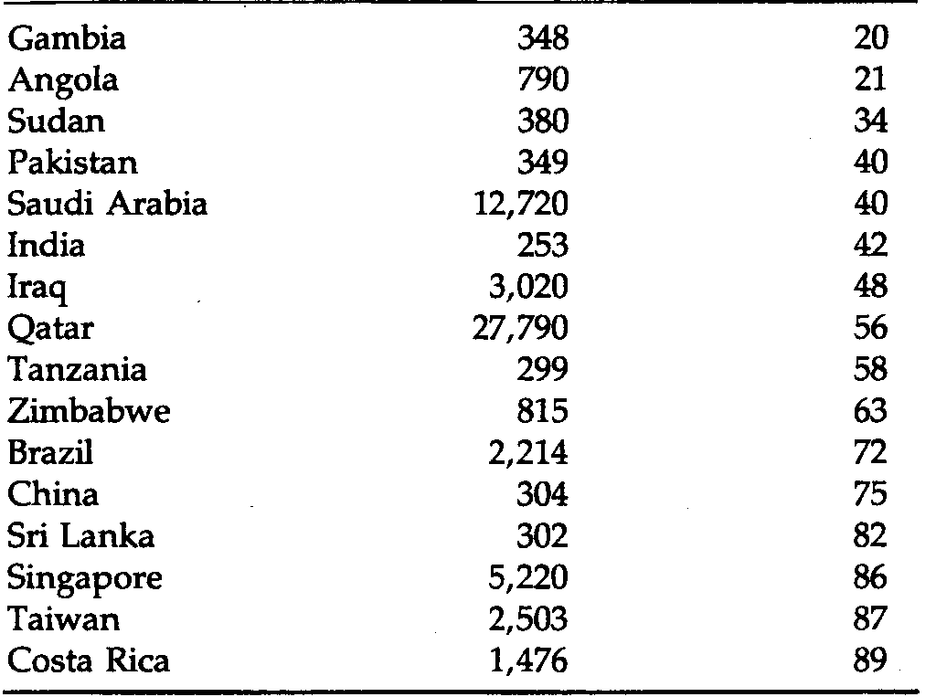
SOURCE: John P. Lewis and Valeriana Kallab (eds.), U.S. Foreign Policy and
the Third World, Agenda 1983 (New York: Praeger, 1983), tab. C-3.

Country Per Capita GNP ($) PQLI

seem to indicate that significant improvements in the basic quality of life can be achieved before there is any great rise in per capita GNP or, conversely, that a higher level of per capita GNP is not a guarantee of a better quality of life. Note in particular the wide PQLI variations for countries with similar levels of per capita income such as Angola and Zimbabwe, China and India, Tanzania and Gambia, Taiwan and Iraq, and Costa Rica and Brazil. A particularly striking contrast is that between Saudi Arabia and Sri Lanka.

The Human Development Index (HDI)
The latest and most ambitious attempt to analyze the comparative status of socioeconomic development in both developing and developed nations systematically and comprehensively has been undertaken by the United Nations Development Program (UNDP) in its annual series of Human Development Reports ⁵ The centerpiece of these reports, which were initiated in 1990, is the construction and refinement of a Human Development Index (HDI). Like the PQLI, the HDI attempts to rank all countries on a scale of 0 (lowest human development) to 1 (highest human development) based on three goals or end products of development: (1) longevity is measured by life expectancy at birth, (2) knowledge as measured by a weighted average of adult literacy (two-thirds) and mean years of schooling (one-third weight), and (3) income as measured by adjusted real per capita income (i.e., adjusted for the differing purchasing power of each country's currency and for the assumption of rapidly diminishing marginal utility of income). Using these three measures of development and applying a complex formula⁶ to 1990 data for 160 countries, the HDI ranks all countries into three groups: low human development (0.0 to 0.50),
medium human development (0.51 to 0.79), and high human development (0.80 to 1.0). It should be noted that HDI measures relative, not absolute, levels of human development and that its focus is on the ends of development (longevity, knowledge, material choice) rather than the means (as with per capita GNP alone).
Table A2.4 shows the 1990 Human Development Index for a sample of 20 developed and developing nations ranked from low to high human development (column 3) along with their respective adjusted real GDP (column 4) and a measure of the differential between the GDP per capita rank and the HDI rank (column 5). A positive number shows by how much a country's relative ranking rises when HDI is used instead of GDP per capita, and a negative number shows the opposite. Clearly, this is the critical issue for HDI as well as any other composite social indicator such as the PQLI. If country rankings did not vary much when HDI is used instead of GDP or GNP per capita, the latter would (as some economists claim) serve as a reliable proxy for socioeconomic development, and there would be no need to worry about such things as health and education indicators.
We see from Table A2.4 that the country with the- lowest HDI (0.050) in 1990 was
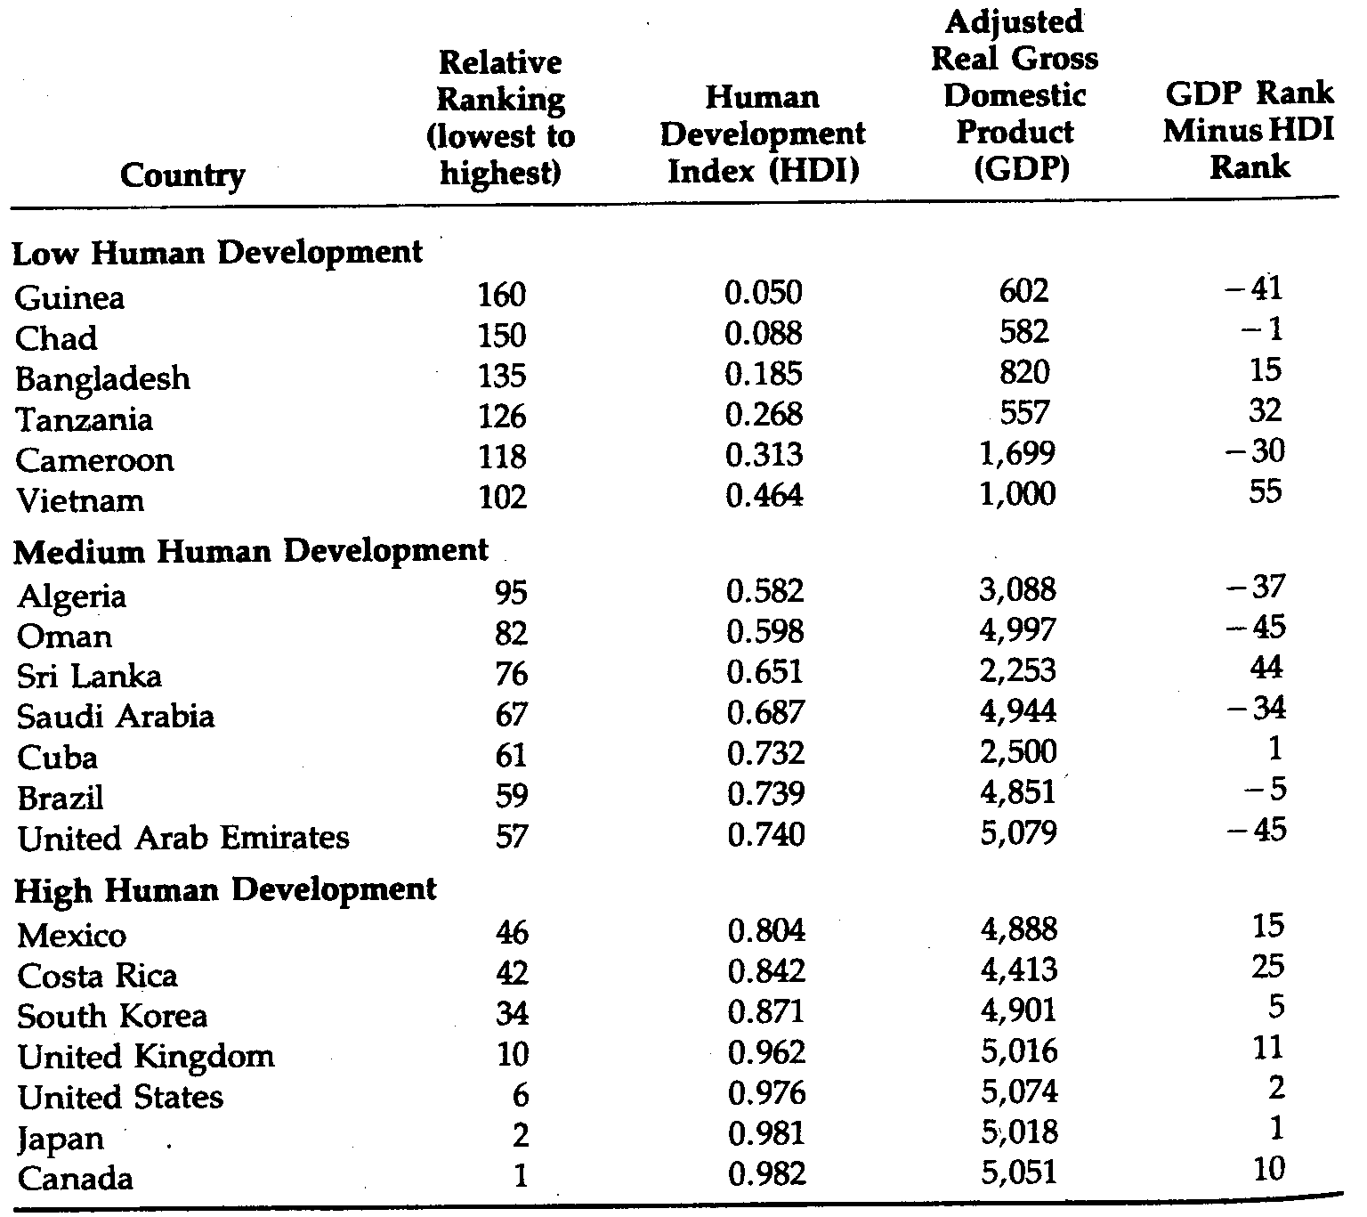
Table A2.4 : Human Development Index for Twenty Selected Countries, 1999.
SOURCE: United Nations Development Program, Human Development Report, 1992 (New York: Oxford University
Press, 1992), pp. 127-129.
Guinea and the one with the highest (0.982) was Canada. What is more interesting for our purposes is that even though countries with high HDI tend to have higher adjusted real per capita GDP (and note that we are not using the more commonly quoted unadjusted per capita GDP, as in, say. Figure 2.1, where distortions are even greater), within and occasionally across the three subgroups we find some countries whose HDI is considerably higher than others even though the latter have substantially higher per capita incomes. Thus, for example, we see that Tanzania's HDI is five times higher than Guinea's, even though Guinea's real per capita GDP is almost 10% higher than Tanzania's. Similarly, Sri Lanka, with less than 75% of the income of Algeria, has an HDI 29% higher, while Brazil, with a 10% higher GDP than Costa Rica, has a 13% lower HDI. Although far less significant, the United States, with a higher income, has a lower HDI than Canada. Although the HDI gives us a broader perspective on progress toward development, it should be pointed out that (1) its creation was in part motivated by a political strategy designed to refocus attention on health and education aspects of development; (2) the three indicators used are good but not ideal (e.g., the U.N. team wanted to use nutrition status of children under age 5 as their ideal health indicator, but the data were not available); (3) the national HDI may have the unfortunate effect of shifting the focus away from the substantial inequality within countries; (4) the alternative approach of looking at GNP per capita rankings and then supplementing this with other social indicators is still a respectable one; and, finally, (5) one must always remember that the index is one of relative rather than absolute development, so that if all countries improve at the same weighted rate, the poorest countries will not get credit for their progress.

Notes to Appendix 2.1
1. Two excellent early surveys of social indicators are Nancy Bastor, "Development indicators: An introduction," in Nancy Bastor (ed.). Measuring Development: The Role and Adequacy of Development Indicators (London: Cass, 1972), and Norman L. Hicks and Paul P. Streeten, "Indicators of development: The search for a basic needs yardstick," World Development 7 (June 1979): 567-580.
2. United Nations Research Institute on Social Development, Contents and Measurements of Sodoeconomic Development (Geneva: UNRISD, 1970).
3. lrma Adelman and Cynthia Taft Morris, Society, Politics, and Economic Development (Baltimore, Md.: Johns Hopkins University Press, 1967).
4. Morris D. Morris, Measuring the Condition of the World's Poor: The Physical Quality of Life Index (London: Frank Cass, 1979). An alternative and more controversial attempt to measure the quality of life in LDCs was undertaken in 1987 when the Population Crisis Committee of Washington, D.C., published the International Human Suffering Index. This index was created to measure, in a single figure, differences in living conditions among countries. Each country index was compiled by adding 10 measures of human welfare related to economics, demography, health, and governance. The index of suffering incorporates these measures: (1) income, (2) inflation, (3) demand for new jobs, (4) urban population pressures, (5) infant mortality, (6) nutrition, (7) clean water, (8) energy use, (9) adult literacy, and (10) personal freedom. The greatest suffering was found to exist in Mozambique, Angola, and Afghanistan, while the best living conditions existed in Switzerland, western Germany, and Luxembourg.
5. United Nations Development Program, Human Development Report, 1992 (New York: Oxford University Press, 1992).
6. Ibid., pp. 91-93.

Statistical Ranking of Third World Countries
Statistical Ranking of Third World Countric

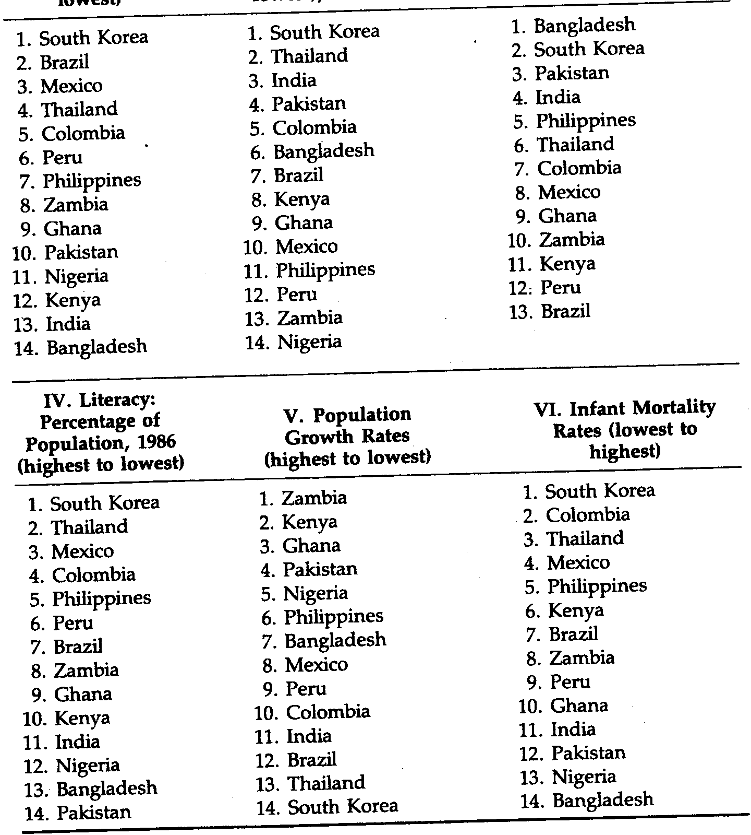
II. Per Capita Growt
Rates (highest to
lowest). 1965-1987

III. Income Distributiol
Ratio, Bottom 40% to
Top 20% of Population
(highest to lowest)
Table A2.5 Fourteen Third World Countries Ranked According to Various Indexes of Developpement, 1990-1992.
1. Per Capita
Income Levels
(highest to lowest)

