CHAPTER 2

Diverse Structures and
Common Characteristics of Developing Nations

Of course there must be differences between developing countries [but] to maintain that no common ground exists is to make any discussion outside or across the frontiers of a single country meaningless.
Julian West, Oxford University

The Third World is important because of the massiveness of its poverty.
Padma Desai, Columbia University

It is hazardous to try to generalize too much about the 145 member countries of the United Nations (U.N.) that constitute the Third World. While almost all are poor in money terms, they are diverse in culture, economic conditions, and social and political structures. Thus, for example, low-income countries include India, with over 900 million people and 17 states, as well as Grenada, with less than 100,000 people, fewer than most large towns in the United States. Large size entails complex problems of national cohesion and administration while offering the benefits of relatively large markets, a wide range of resources, and the potential for self-sufficiency and economic diversity. In contrast, for many small countries the situation is reversed, with problems including limited markets, shortages of skills, scarce physical resources, weak bargaining power, and little prospect of significant economic self-reliance.

In this chapter, we attempt to provide an overview of the great diversity of developing countries. Despite these variations, however. Third World nations share a common set of problems, both domestic and international—problems that in fact define their state of underdevelopment. But before analyzing this diversity and commonality, lets look briefly at various attempts to classify this broad group of nations that we call the Third World.

Some Classifications of Developing Countries
In attempting to classify countries, some analysts, using the U.N. classification system, prefer to distinguish among three major groups within the Third World: the 44 poorest countries designated by the United Nations as "least developed,"¹ the 88 non-oil-exporting "developing nations," ² and the 13 petroleum-rich members of the Organization of Petroleum Exporting Countries (OPEC), whose national incomes increased dramatically during the 1970s. Others follow the classification system established by the Organization for Economic Cooperation and Development (OECD) in Paris, which divides the Third World (including countries and territories not in the U.N. system) into 61 low-income countries (LICs) (those with a 1990 per capita income of less than $600, including 29 least developed countries, or LLDCs), 73 middle-income countries (MICs), 11 newly industrializing countries (NICs), and the 13 members of OPEC. Table 2.1 provides a complete listing of the 158 countries included in the OECD classification scheme. Figure 2.1 shows the geographic location of most of the less developed and developed nations.³ The former Soviet Union and Eastern Europe are represented by neutral shading to reflect their current transitional and uncertain economic status (see Chapter 18). You can locate a particular LDC from Table 2.1 on the map by noting the region indicated in parentheses (see footnote to Table 2.1).
Finally, the International Bank for Reconstruction and Development (IBRD), more commonly known as the World Bank, has its own classification system. It divides 125 countries (both developing and developed) with populations in excess of I million into four categories according to their per capita income levels: low-income, middle-income, upper-middle-income, and high-income economies. The first three groups comprise 101 mostly developing countries, while the last group, the high-income economies, consists of 24 countries, 19 of which are typically included in the First World and the other 5 (Hong Kong, Kuwait, Israel, Singapore, and the United Arab Emirates) of which are classified by the United Nations as developing.
Despite the obvious diversity of countries and classification schemes, however, most Third World nations share a set of common and well-defined goals. These include the reduction of poverty, inequality, and unemployment; the provision of minimum levels of education, health, housing, and food to every citizen; the broadening of economic and social opportunities; and the forging of a cohesive nation-state. Related to these economic, social, and political goals are the common problems shared in varying degrees by most developing countries: widespread and chronic absolute poverty; high and rising levels of unemployment and underemployment; wide and growing disparities in the distribution of income; low and stagnating levels of agricultural productivity; sizable and growing imbalances between urban and rural levels of living and economic opportunities; serious and worsening environmental decay; antiquated and inappropriate educational and health systems; severe balance of payments and international debt problems; and substantial and increasing dependence on foreign and often inappropriate technologies, institutions, and value systems. It is there

Table 2.1 Developing Countries and Territories by Income Group: Classification System of the Organization for Economic Cooperation and Developpement
LICs: 61 Low-income Countries MICs: 73 Middle-income Countries
Bahamas (LA)
Bahrain (ME)
Barbados (LA)
Belize (LA)
Bermuda (LA)
Botswana (AF)
Brunei (AS)
Chile (LA)
Colombia (LA)
Congo (AF)
Cook Islands (AS)
Costa Rica (LA)
Cuba (LA)
Cyprus (ME)
Dominican Republic (LA)
Falkland Islands (LA)
Fiji (AS)
Gibraltar (ME)
Guadeloupe (LA)
Guatemala (LA)
Guiana, French (LA)
Guyana (LA)
Israel (ME)
Ivory Coast (AF)
Jamaica (LA)
Jordan (ME)
Kiribati (AS)
Lebanon (ME)
Macao (AS)
Malaysia (AS)
Malta (ME)
Martinique (LA)
Mauritius (AF)
Morocco (AF)
Nauru (AS)
Netherlands Antilles (AS)
New Caledonia (AS)
Nicaragua (LA)
Niue (AS)
Oman (ME)
Pacific Islands (U.S.) (AS)
* LLDCs (29 least-developed countries).
NOTE: AF = Africa (and offshore islands); AS = Asia (including the Pacific); LA = Latin
America (including the Caribbean); ME = Middle East; E = Europe. Refer to Figure 2.1 for the
specific geographic location of these countries (not all territories are shown).
* Afghanistan (AS)
Angola (AF)
* Bangladesh (AS)
* Benin (AF)
* Bhutan (AS)
Bolivia (LA)
* Burkina Faso (AF)
* Burundi (AF)
* Cape Verde (LA)
* Central African Republic (AF)
* Chad (AF)
China (AS)
* Comoros (AF)
Djibouti (AF)
Egypt (AF/ME)
El Salvador (LA)
Equatorial Guinea (AF)
* Ethiopia (AF)
* Gambia (AF)
Ghana (AF)
* Guinea (AF)
* Guinea-Bissau (AF)
* Haiti (LA)
Honduras (LA)
India (AS)
Kampuchea (AS)
Kenya (AF)
* Laos (AS)
* Lesotho (AF)
Liberia (AF)
Madagascar (AF)
* Malawi (AF)
* Maldives (AS)
* Mali (AF)
Mauritania (AF)
Mayotte (AF)
Mozambique (AF)
Myanmor (AS)
* Nepal (AS)
* Niger (AF)
Pakistan (AS)
Table 2.1 (continued)
LICs: 61 Low-income Countries MICs: 73 Middle-income Countries
Panama (LA)
Papua New Guinea (AS)
Paraguay (LA)
Peru (LA)
Philippines (AS)
Polynesia, French (AS)
Reunion (AF)
Saint-Pierre and Miquelon (LA)
Seychelles (AF)
Surinam (LA)
Swaziland (AF)
Syria (ME)
Thailand (AS)
Trinidad and Tobago (LA)
Tunisia (AF)
Turkey (E)
Uruguay (LA)
Wallis and Futuna Islands (AS)
Western Samoa (AS)
West Indies (LA)\
Zimbabwe (AF)
* Rwanda (AF)
Saint Helena (LA)
Sac) Tome and Principe (AF
Senegal (AF)
Sierra Leone (AF)
Solomon Islands (Br.) (AS)
*Somalia (AF)
Sri Lanka (AS)
* Sudan (AF)
* Tanzania (AF)
Togo (AF)
Tokelau Islands (AS)
Tonga (AS)
Tuvalu (AS)
* Uganda (AF)
Vanuatu (AS)
Vietnam (AS)
* Yemen (ME)
Zaire (AF)
Zambia (AF)
OPEC: 13 Organization of
Petroleum Exporting Countries
Algeria (AF)
Ecuador (LA)
Gabon (AF)
Indonesia (AS)
Iran (ME)
Iraq (ME)
Kuwait (ME)
Libya (AF)
Nigeria (AF)
Qatar (ME)
Saudi Arabia (ME)
United Arab Emirates (ME)
Venezuela (LA)
Argentina (LA)
Brazil (LA)
Greece (E)
Hong Kong (AS)
Mexico (LA)
Portugal (E)
Singapore (AS)
South Korea (AS)
Spain (E)
Taiwan (AS)
Yugoslavia (E)

NICs: II Newly Industrializing
Countries

fore possible and useful to talk about the similarities of critical development problems and to analyze these problems in a broad Third World perspective. This will be our task in Parts II and III.
For the present, we will attempt to identify some of the most important structural differences among developing countries and then provide relevant data to delineate some of their most common characteristic features. In spite of obvious physical, demographic, historical, cultural, and structural differences, most Third World nations face very similar economic and social dilemmas.

The Structure of Third World Economies
Any portrayal of the structural diversity of developing nations requires an examination of seven critical components:
1. The size of the country (geographic area, population, and income)
2. Its historical and colonial background
3. Its endowments of physical and human resources
4. The relative importance of its public and private sectors
5. The nature of its industrial structure
6. Its degree of dependence on external economic and political forces
7. The distribution of power and the institutional and political structure within the nation
Let us briefly consider each component, focusing on some similarities and differences among countries in Africa, Asia, and Latin America.

Size and Income Level
Obviously, the sheer physical size of a country, the size of its population, and its level of national income per capita are important determinants of its economic potential and major factors differentiating one Third World nation from another. Of the 145 developing countries that are full members of the United Nations, 90 have fewer than 15 million people, 83 fewer than 5 million. Large and populated nations like Brazil, India, Egypt, and Nigeria exist side by side with small countries like Paraguay, Nepal, Jordan, and Chad. Large size usually presents advantages of diverse resource endowment, large potential markets, and a lesser dependence on foreign sources of materials and products. But it also creates problems of administrative control, national cohesion, and regional imbalances. As we shall see in Chapter 5, there is no necessary relationship between a country's size, its level of per capita national income, and the degree of equality or inequality in its distribution of that income. Even excluding the wealthy OPEC

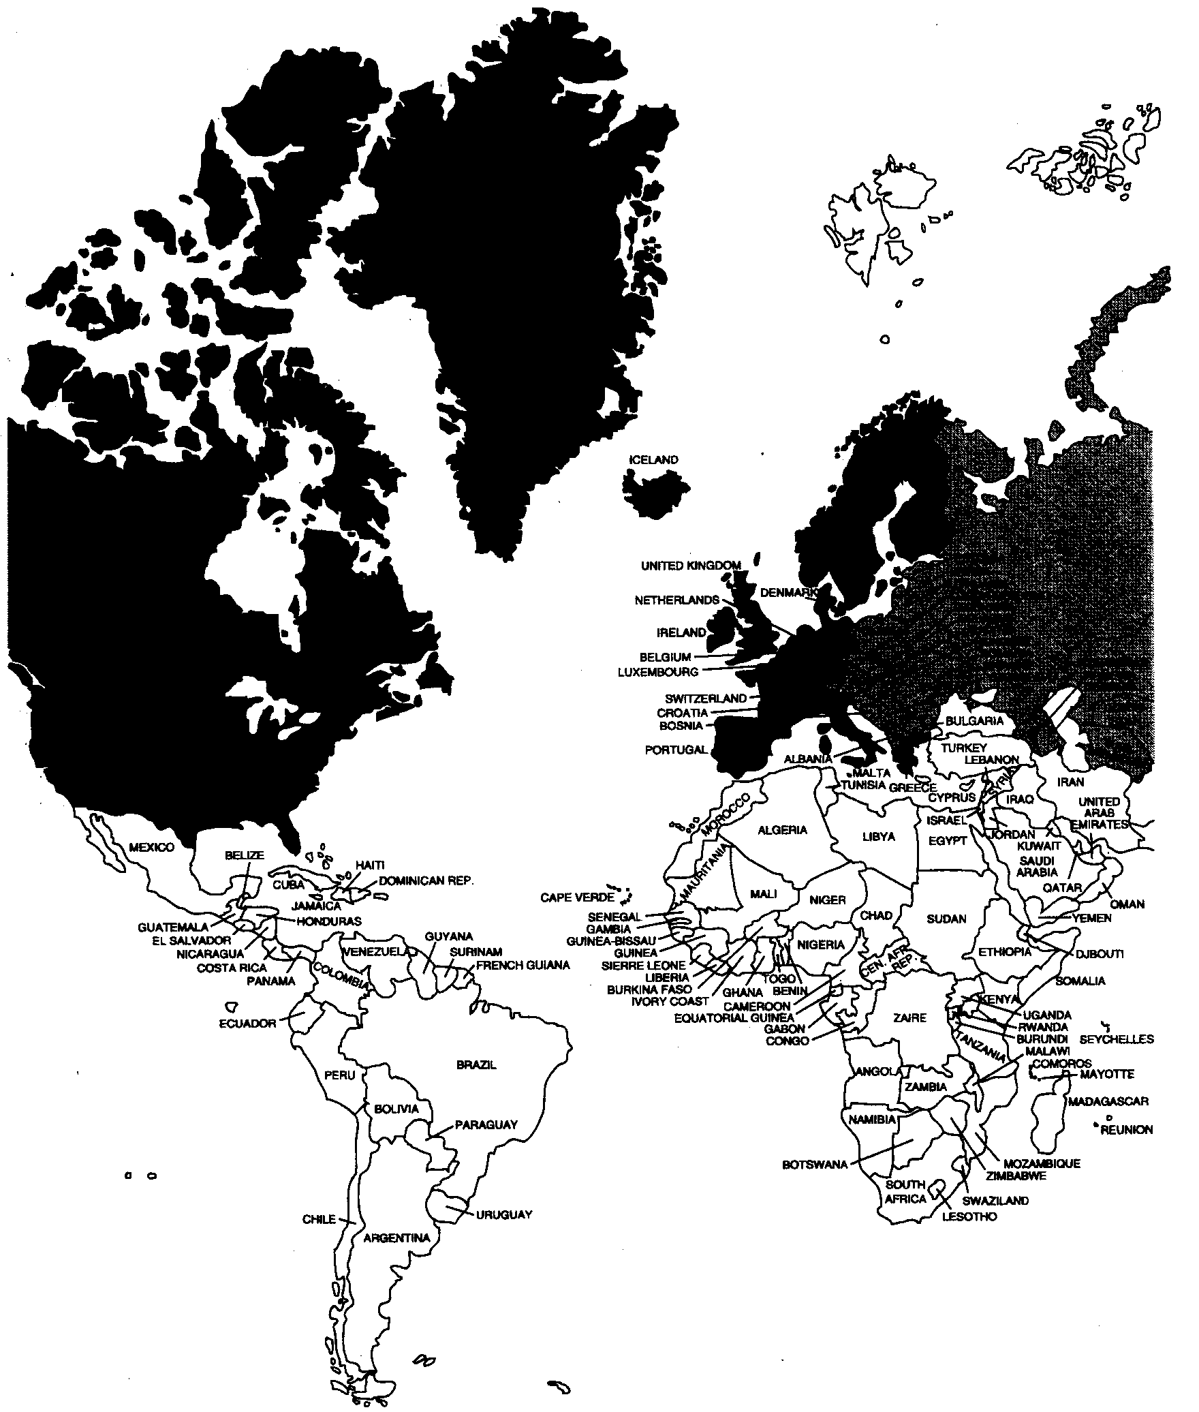

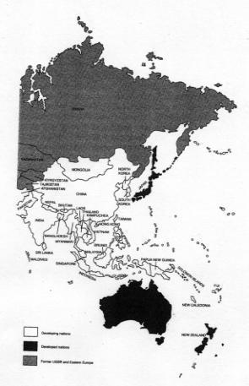

states, India, with a 1993 population of over 900 million, had a 1990 per capita income level of $350, while nearby Singapore, with fewer than 3 million people, had a 1990 per capita income of over $12,300.

Historical Background
Most African and Asian nations were at one time or another colonies of Western European countries, primarily Britain and France but also Belgium, the Netherlands, Germany, Portugal, and Spain. The economic structures of these nations, as well as their educational and social institutions, have typically been modeled on those of their former colonial rulers. Countries like those in Africa that only recently gained their independence are therefore likely to be more concerned with consolidating and evolving their own national economic and political structures than with simply promoting rapid economic development. Their policies (e.g., the rapid Africanization of former colonial-held civil service jobs) may consequently reflect a greater interest in these immediate political issues.
Perhaps more important, the European colonial powers had a dramatic and long-lasting impact on the economies and political and institutional structures of their African and Asian colonies by their introduction of three powerful and tradition-shattering ideas: private property, personal taxation, and the require- ment that taxes be paid in money rather than in kind. As we will discover later, these ideas combined to erode the autonomy of local communities and to expose their people to many new forms of potential exploitation.
In Latin America, a longer history of political independence plus a more shared colonial heritage (Spanish and Portuguese) has meant that in spite of geographic and demographic diversity, the countries possess relatively similar economic, social, and cultural institutions and face similar problems. In Asia, different colonial heritages and the diverse cultural traditions of the indigenous peoples have combined to create different institutional and social patterns in countries such as India (British), the Philippines (Spanish and American), Vietnam (French), and Indonesia (Dutch).

Physical and Human Resources
A country's potential for economic growth is greatly influenced by its endow- ments of physical resources (its land, minerals, and other raw materials) and human resources (both numbers of people and their level of skills). The extreme case of favorable physical resource endowment is the Persian Gulf oil states. At the other extreme are countries like Chad, Yemen, Haiti, and Bangladesh, where endowments of raw materials and minerals and even fertile land are relatively minimal.
In the realm of human resource endowments, not only are sheer numbers of people and their skill levels important, but so also are their cultural outlooks, attitudes toward work, and desire for self-improvement. Moreover, the level of administrative skills will often determine the ability of the public sector to alter the structure of production and the time it takes for such structural alteration to occur. This involves the whole complex of interrelationships between culture,
tradition, religion, and ethnic and tribal fragmentation or cohesion. Thus the nature and character of a country's human resources are important determinants of its economic structure (see Chapter II), and these clearly differ from one region to the next.

Relative Importance of the Public and Private Sectors
Most Third World countries have mixed economic systems, featuring both public and private ownership and use of resources. The division between the two and their relative importance are mostly a function of historical and political circumstances. Thus, in general, Latin American and Southeast Asian nations have larger private sectors than South Asian and African nations. The degree of foreign ownership in the private sector is another important variable to consider when differentiating among LDCs. A large foreign-owned private sector usually creates economic and political opportunities as well as problems not found in countries where foreign investors are less prevalent. Often countries like those in Africa with severe shortages of skilled human resources have tended to put greater emphasis on public-sector activities and state-run enterprises on the assumption that limited skilled manpower can be best used by coordinating rather than fragmenting administrative and enterpreneurial activities. The widespread economic failures and financial difficulties of many of these public concerns in countries such as Ghana, Senegal, Kenya, and Tanzania raise questions, however, about the validity of this assumption. As a result, these and other African nations have moved in recent years toward less public and more private enterprise.
Economic policies, such as those designed to promote more employment, will naturally be different for countries with large public sectors and ones with sizable private sectors. In economies dominated by the public sector, direct government investment projects and large rural works programs will take precedence, whereas in private-oriented economies, special tax allowances designed to induce private businesses to employ more workers might be more common. Although the problem of widespread unemployment mav be similar, the solution can differ in countries with significant differences in the relative importance of the public and private sectors.

Industrial Structure
The vast majority of developing countries are agrarian in economic, social, and cultural outlook. Agriculture, both subsistence and commercial, is the principal economic activity in terms of the occupational distribution of the labor force, if not in terms of proportionate contributions to the gross national product. As we shall see in Chapter 9, farming is not merely an occupation but a way of life for most people in Asia, Africa, and Latin America. Nevertheless, there are great differences between the structure of agrarian systems and patterns of land ownership in Latin America and Africa. Asian agrarian systems are somewhat closer to those of Latin America in terms of patterns of land ownership, but the similarities are lessened by substantial cultural differences.
It is in the relative importance of both the manufacturing and service sectors that we find the widest variation among developing nations. Most Latin American countries, having a longer history of independence and, in general, higher levels of national income than African or Asian nations, possess more advanced industrial sectors. But in the 1970s and 1980s, countries like Taiwan, South Korea, Hong Kong, and Singapore greatly accelerated the growth of their manufacturing output and are rapidly becoming industrialized states. In terms of sheer size, India has one of the largest manufacturing sectors in the Third World, but this sector is nevertheless small in relation to the nation's enormous rural population. Table 2.2 provides information on the distribution of labor force and gross domestic product (GDP) between agriculture and industry in 17 developing countries, the United States, and the United Kingdom. The contrasts among the industrial structures of these countries is striking, especially in terms of the relative importance of agriculture.
In spite of common problems, therefore. Third World development strategies may vary from one country to the next, depending on the nature, structure, and degree of interdependence among its primary, secondary, and tertiary industrial sectors. The primary sector consists of agriculture, forestry, and fishing; the secondary, mostly of manufacturing; and the tertiary, of commerce, finance, transport, and services.

External Dependence: Economic, Political, and Cultural
The degree to which a country is dependent on foreign economic, social, and political forces is related to its size, resource endowment, and political history. For most Third World countries, this dependence is substantial. In some cases, it touches almost every facet of life. Most small nations are highly dependent on foreign trade with the developed world (see Chapter 12). Almost all small nations are dependent on the importation of foreign and often inappropriate technologies of production (Chapter 8). This fact alone exerts an extraordinary influence on the character of the growth process in these dependent nations.
But even beyond the strictly economic manifestations of dependence in the form of the international transfer of goods and technologies is the international transmission of institutions (most notably systems of education and governance), values, patterns of consumption, and attitudes toward life, work, and self. Later chapters show that this transmission phenomenon brings mixed blessings to most LDCs, especially to those with the greatest potential for self-reliance. A country's ability to chart its own economic and social destiny is significantly affected by its degree of dependence on these and other external forces.

Political Structure, Power, and Interest Groups
In the final analysis, it is often not the correctness of economic policies alone that determines the outcome of national approaches to critical development problems. The political structure and the vested interests and allegiances of ruling elites (e.g., large landowners, urban industrialists, bankers, foreign manufacturers,
Table 2.2 : Industrial Structure in Seventeen Developing Countries, the United States,
and the United Kingdom, 1990

Percentage of Labor
Force

Percentage of Gross
Domestic Product
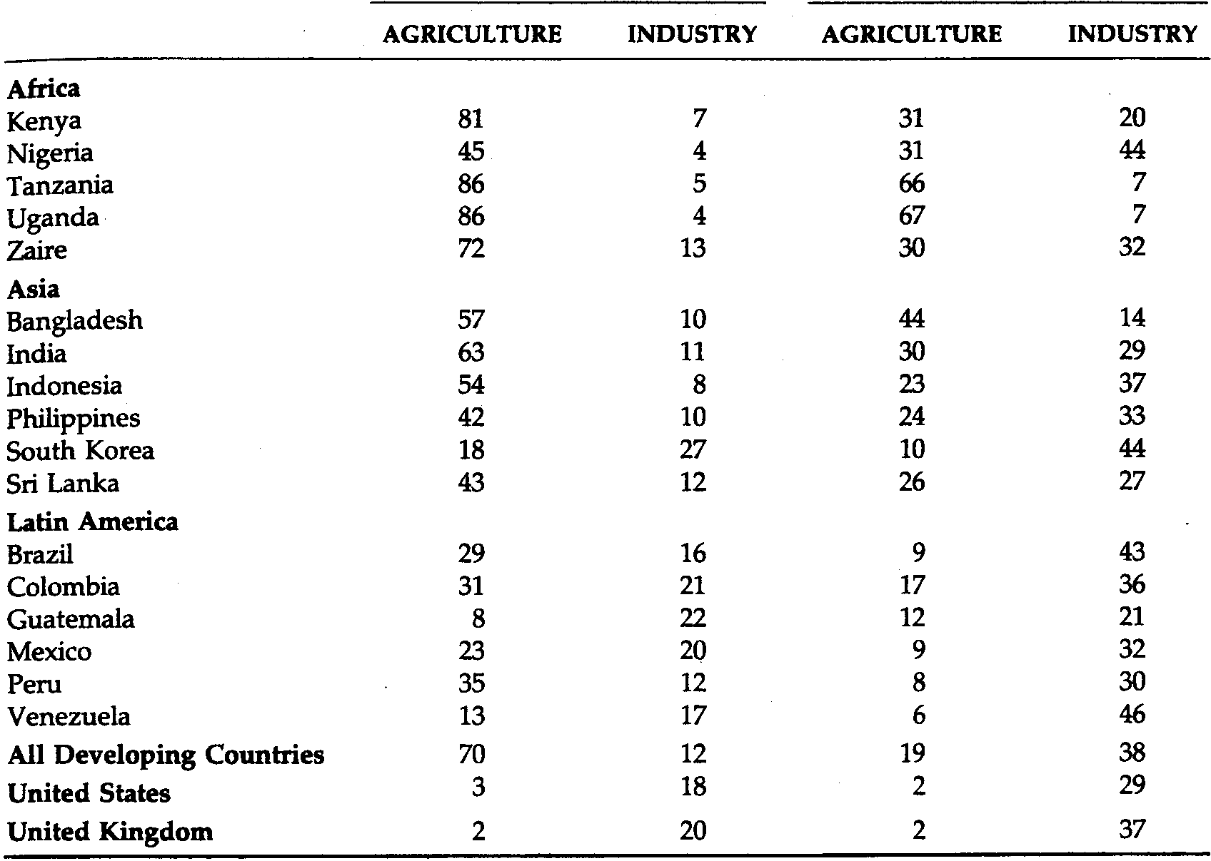

the military, trade unionists) will typically determine what strategies are possible and where the main roadblocks to effective economic and social change may lie.
SOURCES: World Bank, World Development Report, 1992: Development and the Environment
(New York: Oxford University Press, 1992), annex tab. 3; United Nations Development Program,
Human Development Report, 1992 (New York: Oxford University Press, 1992), tabs. 13 and 36.
The constellation of interests and power among different segments of the populations of most developing countries is itself the result of their economic, social, and political histories and is likely to differ from one country to the next. Nevertheless—whatever the specific distribution of power among the military, the industrialists, and the large landowners of Latin America; the politicians and high-level civil servants in Africa; the oil sheiks and financial moguls of the Middle East; or the landlords, moneylenders, and wealthy industrialists of Asia—most developing countries are ruled directly or indirectly by small and powerful elites to a greater extent than the developed nations are.
Effective social and economic change thus requires either that the support of elite groups be enlisted through persuasion or coercion or that the elites be pushed aside by more powerful forces. Either way, and this point will be repeated often throughout this book, economic and sodal development will often be impossible without corresponding changes in the sodal, political, and economic institutions of a nation (e.g., land tenure systems, forms of governance, educational structures, labor market relationships, property rights, the distribution and control of physical and financial assets, laws of taxation and inheritance, and provision of credit).

Common Characteristics of Developing Nations
The foregoing discussion should have demonstrated why it it is sometimes risky to generalize too much about such a diverse set of nations as those in Africa, Asia, and Latin America. Nevertheless, common economic features of developing countries permit us to view them in a broadly similar framework. We will attempt to identify these similarities and provide illustrative data to demonstrate their importance. For convenience, we can classify these common characteristics into six broad categories:
1. Low levels of living, comprising low incomes, high inequality, poor health and inadequate education
2. Low levels of productivity
3. High rates of population growth and dependency burdens
4. High and rising levels of unemployment and underemployment
5. Significant dependence on agricultural production and primary product exports
6. Dominance, dependence, and vulnerability in international relations

Low Levels of Living
In developing nations, general levels of living tend to be very low for the vast majority of people. This is true not only in relation to their counterparts in rich nations but often also in relation to small elite groups within their own societies. These low levels of living are manifested quantitatively and qualitatively in the form of low incomes (poverty), inadequate housing, poor health, limited or no education, high infant mortality, low life and work expectancy, and in many cases a general sense of malaise and hopelessness. Let us look at some recent statistics comparing certain aspects of life in the underdeveloped countries and in the more economically advanced nations. Although these statistics are national aggregates, often have substantial errors of measurement, and in some cases are not strictly comparable due to exchange rate variations, they do provide at least a summary indication of relative levels of living in different nations.

Per Capita National Income
The gross national product (GNP) per capita is often used as a summary index of the relative economic well-being of people in different nations. The GNP itself is the most commonly used measure of the overall level of economic activity. It is calculated as the total domestic and foreign value added claimed by a country's residents without making deductions for depreciation of the domestic capital stock. The gross domestic product (GDP) measures the total value for final use of output produced by an economy, by both residents and nonresidents. Thus GNP comprises GDP plus the difference between the income residents receive from abroad for factor services (labor and capital) less payments made to nonresidents who contribute to the domestic economy. Where there is a large nonresident population playing a major role in the domestic economy (such as foreign corporations), these differences can be significant (see Chapter 12). In 1990, the total national product of all the nations of the world was valued at more than U.S. $20 trillion, of which more than $16.6 trillion originated in the economically developed regions while less than $3.4 trillion was generated in the less developed nations. When one takes account of the distribution of world population, this means that approximately 83% of the world's total income is produced in the economically developed regions by less than 23% of the world's people. Thus more than three-fourths of the world's population is producing only 17% of total world output. More important, on the income side, the Third World, with almost 77% of the world's population, subsists on less than 20% of the world's income. The collective per capita incomes of the underdeveloped countries average less than one-twentieth the per capita incomes of rich nations.*
As an illustration of the per capita income gap between rich and poor nations, look at Figure 2.2. Notice that in 1990, Switzerland had more than 270 times the per capita income of one of the world's poorest countries, Ethiopia, and more than 93 times that of one of the world's largest nations, India. ⁵

Relative Growth Rates of National and Per Capita Income
In addition to having much lower levels of per capita income, many Third World countries have experienced slower GNP growth than the developed nations. Among all developing countries, for example, growth slowed considerably during the 1980s and, as shown in Figure 2.3, real per capita GDP actually declined by 0.2% in 1990 and again in 1991. Although Asian countries continued to grow at a slower pace during the 1980s, economic growth in Latin America and the Caribbean averaged -0.4% and in Africa -1.7%. Table 2.3 provides figures on growth rates of real GNP per capita for some representative countries during the 1980s. For them, it was clearly a "lost decade" for development. In fact, during the 1980s and early 1990s, the income gap between rich and poor nations widened at the fastest pace in more than three decades. The impact of this widening gap is striking. If, for example, we look at the income levels of the richest 20% of the world's population in comparison with the poorest 40%, we find that whereas in 1960 the income ratio was 30 to 1, at the end of the 1980s the rich were receiving almost 60 times the income of the poor!⁶ Table 2.3 provides
FIGURE 2.2 Per Capita Gross National Product in Selected Countries, 1990 (in U.S. dollars
at official exchange rates) Source: World Bank, World Development Report, 1992: Development
and the Environment (New York: Oxford University Press, 1992), tab. 1.

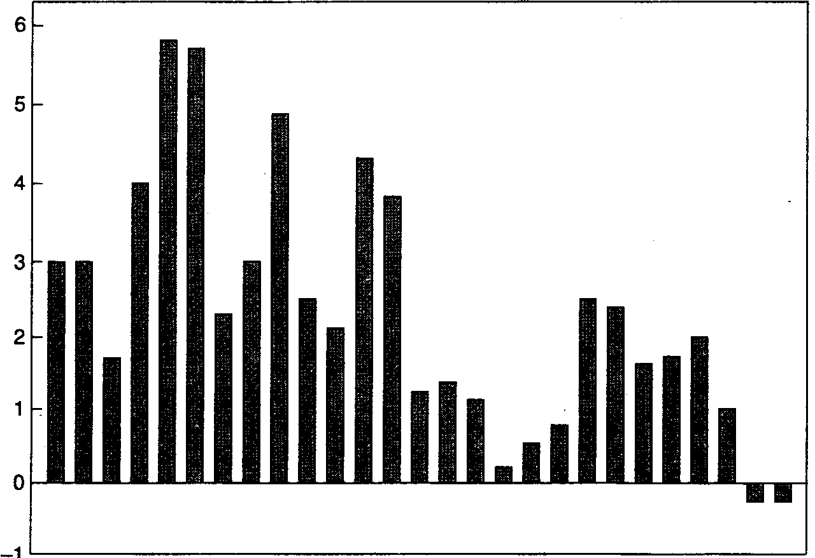
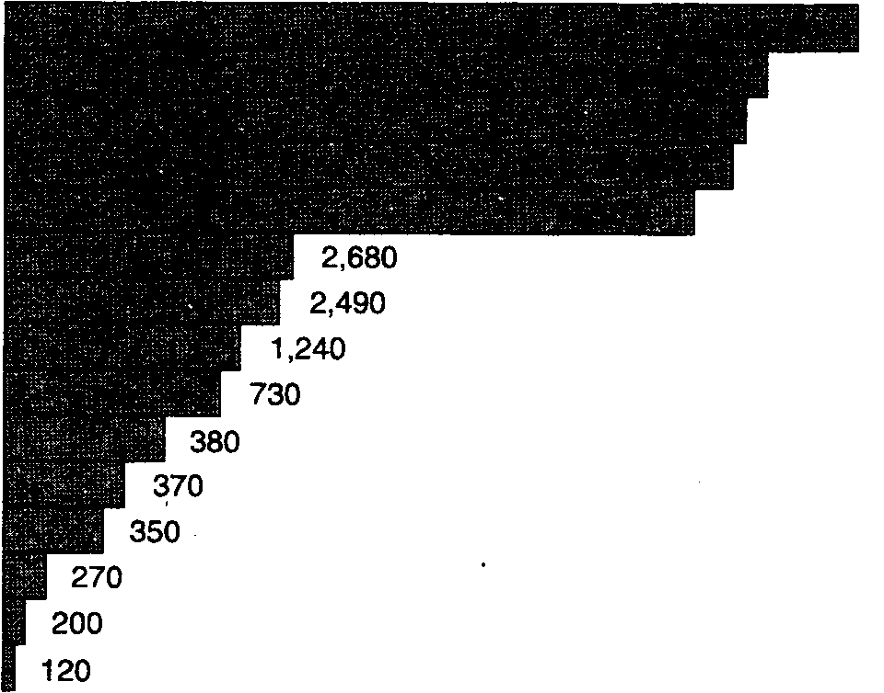
Switzerland
Japan
United States
Canada
United Kingdom
Brazil
Mexico
Colombia
Philippines
Pakistan
China
India
Nigeria
Bangladesh
Ethiopia

FIGURE 2.3 Growth Rate of Real Per Capita Gross Domestic Product in All Developing
Countries, 1965-1991 Source: New York Times, April 16, 1992, p. D-2.

Table 2.3 : Growth Rates of Real Gross National Product per Capita, percentage Average Annual Growth, 1980/1990.

Africa Asia Latin America
Kenya 0.3 Bangladesh 1.0 Brazil 0.6
Nigeria -3.0 India 3.2 Colombia I.I
Tanzania -0.7 Indonesia 4.1 Guatemala -2.1
Uganda 0.8 Philippines -1.5 Mexico -0.9
Zaire 1.5 South Korea 8.9 Peru -2.0
Sri Lanka 2.4 Venezuela -2.0

SOURCE: World Bank, The World Bank Atlas, 1991 (Washington, D.C.: World Bank, 1991), pp. 6-9.

The growing gap between per capita incomes in rich and poor nations is not the only manifestation of the widening economic disparity between the world's rich and poor. To appreciate the breadth and depth of Third World poverty, it is also necessary to look at the growing gap between rich and poor within individual LDCs. We discuss the question of income distribution and equity more fully in Chapter 5, but a few remarks at this point seem appropriate.
First, all nations of the world show some degree of income inequality. There are large disparities between incomes of the rich and poor in both developed and underdeveloped countries. Nevertheless, the gap between rich and poor is generally greater in less developed nations than in developed nations. For example, if we compare the share of national income that accrues to the poorest 40% of a country's population with that of the richest 20% as an arbitrary measure of the degree of inequality, we discover that countries like Brazil, Ecuador,

Table 2.4 : Global Income Disparity between the Richest and Poorest 20 Percent of the World‘s Population, 1960-1989.
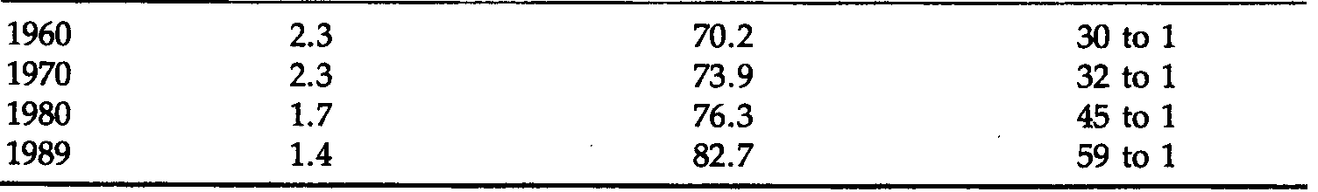

Percentage of Global Income Ratio of Income Shares

POOREST 20 PERCENT RICHEST 20 PERCENT RICHEST TO POOREST

SOURCE: United Nations Development Program, Human Development Report, 1992
(New York: Oxford University Press, 1992), p. 36.
Colombia, Jamaica, Mexico, Venezuela, Kenya, Sierra Leone, South Africa, and Guatemala have substantial income inequality; others like India, Tanzania, Chile, Malaysia, Costa Rica, and Libya have moderate inequality; and others like Taiwan, Hong Kong, Indonesia, Canada, Japan, Sweden, and South Korea have relatively lesser inequalities in overall income distribution. Moreover, there is no obvious relationship or correlation between levels of per capita income and degree of income inequality. Kenya, with the same low per capita income as India, has a much wider income disparity between the top 20% and bottom 40% of the population. Similarly, Kuwait, with almost the same high per capita income as Belgium, has a much lower percentage of its income distributed to the bottom 40% of its population. This phenomenon underlines the important point that economic development cannot be measured solely in terms of the level and growth of overall income or income per capita; one must also look at how that income is distributed among the population—at who benefits from development.

Extent of Poverty
The magnitude and extent of poverty in any country depend on two factors: (1) the average level of national income and (2) the degree of inequality in its distribution. Clearly, for any given level of national per capita income, the more unequal the distribution, the greater the incidence of poverty. Similarly, for any given distribution, the lower the average income level, the greater the incidence of poverty. But how is one to measure poverty in any meaningful quantitative sense?
During the 1970s, as interest in problems of poverty increased, development economists took the first step in measuring its magnitude within and across countries by attempting to establish a common poverty line. They went even further and devised the now widely used concept of absolute poverty. It is meant to represent a specific minimum level of income needed to satisfy the basic physical needs of food, clothing, and shelter in order to ensure continued survival. A problem, however, arises when one recognizes that these minimum subsistence levels will vary from country to country and region to region, reflecting different physiological as well as social and economic requirements. Economists have therefore tended to make conservative estimates of world poverty in order to avoid unsubstantiated exaggerations of the problem. One common methodology has been to establish an international poverty line at, say, a constant U.S. $370 (based, for example, on the value of the 1985 dollar) and then attempt to estimate the purchasing power equivalent of that sum of money in terms of a developing country's own currency.
Figure 2.4 provides a picture of both the extent of absolute poverty (the proportion of a country's population with real incomes below the international poverty line) and its numeric magnitude (the actual number of people who can be classified as "absolutely poor"). We see that in 1989, almost 1.25 billion people, or 23% of the world population, were living in absolute poverty. In terms of the proportion of Third World populations, the absolute poor comprised almost one out of every three persons. Looking at individual regions, we find
1,225 million
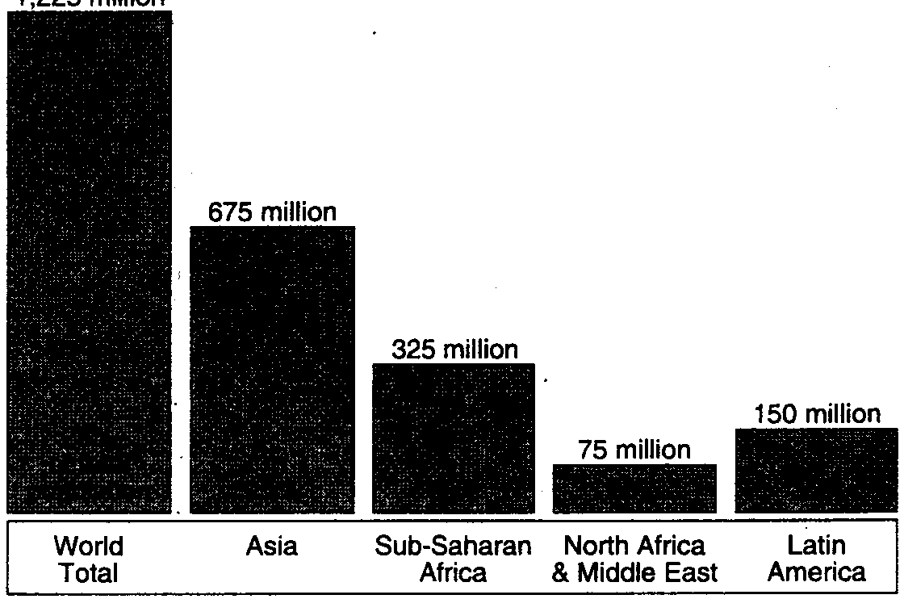

FIGURE 2.4 People Living in Absolute Poverty, 1989 (estimated) Source: United Nations Population Fund, Population, Resources, and the Environment: The Critical Challenge (New York: United Nations Population Fund, 1991), p. 16.

the highest poverty rate (62%) in sub-Saharan Africa and the greatest number of extremely poor in Asia (675 million). With the continuing deterioration of many of the LDC economies in the early 1990s—recall Figure 2.3—and the continued rapid increase in world population, it is safe to conclude that these numbers are still rising rapidly (we will look into this matter in greater detail in Chapter 5).

Health
In addition to struggling on low income, many people in Third World nations fight a constant battle against malnutrition, disease, and ill health. Although there have been some significant improvements since the 1960s, in the least developed countries of the world, life expectancy in 1992 still averaged only 52 years, compared to 61 years among other Third World countries and 75 years in developed nations. Infant mortality rates (the number of children who die before their first birthday out of every 1,000 live births) average about 99 in the least developed countries, compared with approximately 74 in other less developed countries and II in developed countries. The rates for some specific countries are shown in Figure 2.5. Tables 2.5 and 2.6 are even more revealing. In the mid-1970s, more than 1 billion people, almost half the population of the developing world (excluding China), were living on diets deficient in essential calories. One-third of them were children under 2 years of age. These people were concentrated in the poorest countries and, within these poor countries, in the lowest income groups. In the 1980s and early 1990s, the situation continued to deteriorate in sub-Saharan Africa, with deep declines in food consumption and widespread famine.

FIGURE 2.5 Infant Mortality Rates in Selected Countries, 1992 (per 1,000 live births)
Source: Population Reference Bureau, 1992 World Population Data Sheet
(Washington, D. C.: Population Reference Bureau, 1992).
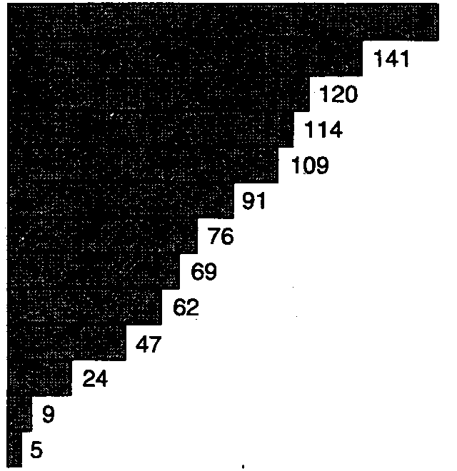
Afghanistan.
Central African Republic
Bangladesh
Nigeria
Pakistan
India
Zambia
Brazil
Kenya
Mexico
Venezuela
United States
Japan

In both Asia and Africa, over 60% of the population barely met minimum caloric requirements necessary to maintain adequate health. Moreover, it has been estimated that this caloric deficit amounted to less than 2% of the world cereal production. This contradicts the widely held view that malnutrition is the inevitable result of an imbalance between world population and world food supplies. The more likely explanation can be found in the enormous imbalance in world income distribution. Thus malnutrition and poor health in the developing world are perhaps even more a matter of poverty than of food production, even though the two factors are indirectly interrelated. Table 2.6 provides 1990 estimates of the extent of human deprivation in terms of some key health indicators. We see, for example, that more than one-third (1.45 billion) of people in poor countries are without access to health services, 1.33 billion do not have access to safe drinking water, a staggering 2.25 billion (more than half the population) live without

Table 2.5 : Population with Consumption below Caloric Requirements.

People Percentage of
Region (millions) (Population

Latin America 112 36
Asia 707 63
Middle East 61 33
Africa 193 61
Total 1.073 55

SOURCE: S. Reutlinger and M. Setowsky, Malnutrition and Poverty: Magnitude
and Policy Options (Baltimore, Md.: Johns Hopkins University Press, 1976),
Published for the World Bank by the Johns Hopkins University Press.
Table 2.6 : Human Health Deprivation in the Third World, 1990.
Nature of Health Deprivation Numbers Deprived

Without access to health services 1.45 billion
Without access to safe water 1.33 billion
Without access to sanitation 2.25 billion
Children dying before age 5 14 million
Malnourished children under age 5 180 million
SOURCE: United Nations Development Program, Human Development Repart, 1992 (New York: Oxford University Press, 1992), pp. 132-133.

sanitation facilities, and 180 million children under age 5 (those who managed to live that long) are malnourished. Another often used measure of malnutrition is per capita daily protein consumption, which can vary from as high as 97 grams per day in the United States to 63, 48, and 43 grams per day in Brazil, India, and Ghana, respectively. In terms of world grain consumption, in the 1980s average annual consumption per person was approximately 670 kilograms in developed countries, as contrasted with 185 kilograms in less developed countries.
The importance of access to clean drinking water, which is one of the most important measures of sanitation, cannot be overemphasized. Water-borne diseases such as typhoid fever, cholera, and a wide array of serious or fatal diarrheal diseases are responsible for more than 35% of the deaths of young children in Africa, Asia, and Latin America. Most of these diseases and resulting deaths would be quickly eliminated with safe water supplies.
Finally, medical care is an extremely scarce social service in many parts of the developing world. Recent data reveal that in 1990, the number of doctors per 100,000 people averaged only 4.8 in the least developed countries, compared with 210 in the developed countries. The ratio of hospital beds to population is similarly divergent between these two sets of nations. Moreover, when one realizes that most of the medical facilities in developing nations are concentrated in urban areas where only 25% of the population resides, the woefully inadequate provision of health care to the masses of poor people becomes strikingly clear. For example, in India, 80% of the doctors practice in urban areas where only 20% of the population resides. In Bolivia, only one-third of the population lives in cities, but 90% of the health facilities are found there. In Kenya, the population to-physician ratio is 672 to 1 for the capital city of Nairobi and 20,000 to 1 in the rural countryside where 87% of the Kenyan population lives. In terms of health expenditures, more than 75% of LDC government outlays are devoted to urban hospitals that provide expensive. Western-style curative care to a minority of the population. Reducing this amount to 50% and using the difference to train 1 million health workers could, according to a recent United Nations Children's Fund (UNICEF) study, provide much needed health services to the poorest I billion people in the Third World. ⁷

Education
As a final illustration of the very low levels of living that are pervasive in Third World nations, consider the spread of educational opportunities. The attempt to provide primary school educational opportunities has probably been the most significant of all LDC development efforts. In most countries, education takes the largest share of the government budget. Yet in spite of some impressive quantitative advances in school enrollments, literacy levels remain strikingly low compared with the developed nations. For example, among the least developed countries, literacy rates average only 45% of the population. The corresponding rates for other Third World nations and the developed countries are approximately 64% and 99%, respectively. Currently, it is estimated that more than 300 million children have dropped out of primary and secondary school, and of the estimated 1 billion illiterate adults, more than 60% are women. The education of children who do attend school regularly is often ill suited and irrelevant to the development needs of the nation.
Summarizing our discussion so far, we can list the following common characteristics of developing countries:
1. Low relative levels and, in many countries, slow growth rates of national income
2. Low levels and, in many countries, stagnating rates of real income per capita growth
3. Highly skewed patterns of income distribution, with the top 20% of the population receiving 5 to 10 times as much income as the bottom 40%
4. Consequently, great masses of Third World populations suffering from absolute poverty, with 1 billion to 1.3 billion people living on subsistence incomes of less than $370 per year
5. Large segments of the populations suffering from ill health, malnutrition and debilitating diseases, with infant mortality rates running as high as 10 times those in developed nations
6. In education, low levels of literacy, significant school dropout rates, and inadequate and often irrelevant educational curricula and facilities
Most important is the interaction of all six characteristics, which tends to reinforce and perpetuate the pervasive problems of "poverty, ignorance, and disease" that restrict the lives of so many people in the Third World.

Low Levels of Productivity
In addition to low levels of living, developing countries are characterized by relatively low levels of labor productivity. The concept of a production function systematically relating outputs to different combinations of factor inputs for a given technology is often used to describe the way in which societies go about providing for their material needs. But the technical engineering concept of a production function must be supplemented by a broader conceptualization that includes among its other inputs managerial competence, worker motivation, and institutional flexibility. Throughout the developing world, levels of labor productivity (output per worker) are extremely low compared with those in developed countries. This can be explained by a number of basic economic concepts.
For example, the principle of diminishing marginal productivity states that if increasing amounts of a variable factor (labor) are applied to fixed amounts of other factors (e.g., capital, land, materials), the extra or marginal product of the variable factor declines beyond a certain number. Low levels of labor productivity can therefore be explained by the absence or severe lack of "complementary" factor inputs such as physical capital or experienced management.
To raise productivity, according to this argument, domestic savings and foreign finance must be mobilized to generate new investment in physical capital goods and build up the stock of human capital (e.g., managerial skills) through investment in education and training. Institutional changes are also necessary to maximize the potential of this new physical and human investment. These changes might include such diverse activities as the reform of land tenure, corporate tax, credit, and banking structures; the creation or strengthening of an independent, honest, and efficient administrative service; and the restructuring of educational and training programs to make them more appropriate to the needs of the developing societies. These and other noneconomic inputs into the social production function must be taken into account if strategies to raise productivity are to succeed. An old proverb says that "you can lead a horse to water, but you cannot make him drink." In underdeveloped nations it is equally true that you can create the economic opportunities for self-improvement, but without the proper institutional and structural arrangements you cannot succeed.
One must also take into account the impact of worker and management attitudes toward self-improvement; people's degree of alertness, adaptability, ambition, and general willingness to innovate and experiment; and their attitudes toward manual work, discipline, authority, and exploitation. Added to all these must be the physical and mental capacity of the individual to do the job satisfactorily. The economic success stories of the four "Asian tigers"—South Korea, Singapore, Hong Kong, and Taiwan—are often attributed to the quality of their human resources, the organization of their production systems, and the institutional arrangements undertaken to accelerate their productivity growth.
The area of physical health most clearly reveals the close linkage that exists between low levels of income and low levels of productivity in developing nations. It is well known, for example, that poor nutrition in childhood can severely restrict the mental and the physical growth of individuals. ⁸ Poor dietary habits, inadequate foods, and low standards of personal hygiene in later years can cause further deterioration in a worker's health and can therefore adversely influence his or her attitudes toward the job and the people at work. The worker's low productivity may be due in large part to physical lethargy and the inability, both physical and emotional, to withstand the daily pressures of competitive work.
We may conclude, therefore, that low levels of living and low productivity are self-reinforcing social and economic phenomena in Third World countries and, as such, are the principal manifestations of and contributors to their underdevelopment. Myrdal's well-known theory of "circular and cumulative causation" in underdeveloped countries is based on these mutually reinforcing interactions between low living levels and low productivity.⁹

High Rates of Population Growth and Dependency Burdens
Of the world's population of approximately 5.5 billion people in 1993, more than three-fourths live in Third World countries and less than one-fourth in the more developed nations. Both birth and death rates are strikingly different between the two groups of countries. Birthrates in less developed countries are generally very high, on the order of 30 to 40 per 1,000, whereas those in the developed countries are less than half that figure. Indeed, as shown in Table 2.7, the crude birthrate (the yearly number of live births per 1,000 population) is probably one of the most efficient ways of distinguishing the less developed from the more developed countries. There are few less developed countries with a birthrate below 25 per 1,000 and no developed nations with a birthrate above it.
Death rates (the yearly number of deaths per 1,000 population) in Third World countries are also high relative to the more developed nations, but because of improved health conditions and the control of major infectious diseases, the

Table 2.7 : Crude Birthrates throughout the World, 1992.

Crude
Birthrate Country

- Niger, Mali, Tanzania, Zambia, Malawi, Yemen, Uganda, Rwanda
45 Zaire, Sierra Leone, Afghanistan, Sudan, Kenya, Mauritania, Iraq, Syria, Angola, Laos, Haiti
40 Lesotho, Saudi Arabia, Botswana, Cameroon, Chad, Pakistan,
Honduras, Iran, Nepal
35 El Salvador, Paraguay, Guatemala, Bolivia, Algeria, Bangladesh
30 Peru, Malaysia, Myanmar, Philippines, Kuwait, South Africa,
Egypt, Morocco, Venezuela
25 Brazil, Colombia, Panama, Indonesia, Costa Rica, Mexico, Turkey,
Jamaica
20 China, Sri Lanka, Chile, Argentina, Thailand
15 United States, Canada, Australia, Ireland, Cuba, South Korea,
Taiwan, Singapore
10 Switzerland, Austria, Germany, Hong Kong, Japan, Russia

SOURCE: Population Reference Bureau, 1992 World Population Data Sheet (Washington, D.C.: Population Reference Bureau, 1992). NOTE: Crude birthrate = yearly number of live births per 1,000 population.
differences are substantially smaller than the corresponding differences in birthrates. As a result, the average rate of population growth is now about 2.0% per year in Third World countries (2.3% excluding China), compared to population growth of 0.5% per year in the industrialized world.
A major implication of high LDC birthrates is that children under age 15 make up almost 40% of the total population in these countries, as opposed to less than 21% of the total population in the developed countries. Thus in most developing countries, the active labor force has to support proportionally almost twice as many children as it does in richer countries. By contrast, the proportion of people over the age of 65 is much greater in the developed nations. Older people as well as children are often referred to as an economic dependency burden in the sense that they are nonproductive members of society and therefore must be supported financially by a country's labor force (usually defined as citizens between the ages of 15 and 64). The overall dependency burden (i.e., both young and old) represents only about one-third of the populations of developed countries but almost 45% of the populations of the less developed nations. Moreover, in the latter countries, almost 90% of the dependents are children, whereas only 66% are children in the richer nations.
We may conclude, therefore, that not only are Third World countries characterized by higher rates of population growth, but they must also contend with greater dependency burdens than rich nations. The circumstances and conditions under which population growth becomes a deterrent to economic development is a critical issue and will be examined in Chapter 6.

High and Rising Levels of Unemployment and Underemployment
One of the principal manifestations of and factors contributing to the low levels of living in developing nations is their relatively inadequate or inefficient utilization of labor in comparison with the developed nations. Underutilization of labor is manifested in two forms. First, it occurs as underemployment—people, both rural and urban, who are working less than they could (daily, weekly, or seasonally). Underemployment also includes those who are normally working full-time but whose productivity is so low that a reduction in hours would have a negligible impact on total output. The second form is open unemployment—people who are able and often eager to work but for whom no suitable jobs are available.
Current rates of open unemployment in the Third World average from 10% to 15% of the labor force. But this is only part of the story. Unemployment among young people aged 15 to 24, many of whom have a substantial education, is typically almost twice as high as the overall average. Table 2.8 provides some estimates of open unemployment during the 1980s for 13 selected Third World countries. However, the data shown in the table represent only the tip of the iceberg of LDC labor underutilization. The problem is much more serious. When the underemployed are added to the openly unemployed and when "discouraged workers"—those who have given up looking for a job—are added in, almost 35% of the combined urban and rural labor forces in Third World nations is unutilized.
Table 2,8 : Unemployment Rates in Thirteen Less Developed Countries, 1980s
SOURCE: International Labor Organization, World Labor Report, 1989
(Geneva: ILO, 1989), tabs. 1.7 and 1.12; fig. 1.7.
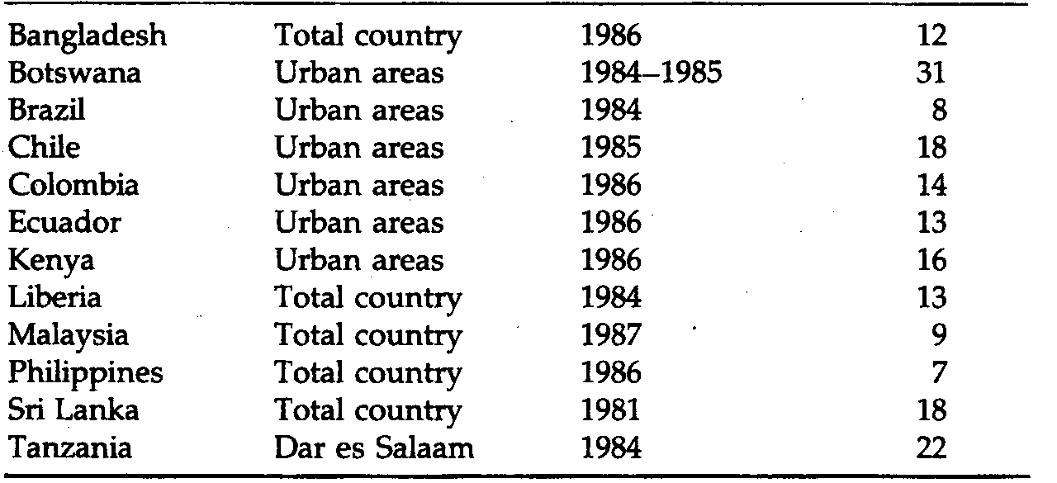
Given recent and current birthrates in most LDCs, their labor supply will be expanding rapidly for some time to come. This means that jobs will have to be created at equivalent rates simply to keep pace. Moreover, in urban areas where rural-to-urban migration is causing the labor force to grow at explosive annual rates of 5% to 7% in many countries (especially in Africa), the prospects for coping effectively with rising levels of unemployment and underemployment and for dealing with the frustrations and anxieties of an increasingly vocal and educated but unemployed youth are frighteningly poor. We will examine the dimensions and implications of the unemployment and migration problem further in Chapters 7 and 8.
Average
Percentage
Country Area Year Unemployed

Substantial Dependence on Agricultural Production and Primary Product Exports
The vast majority of people in Third World nations live and work in rural areas. Over 65% are rurally based, compared to less than 27% in economically developed countries. Similarly, 62% of the labor force is engaged in agriculture, compared to only 7% in developed nations. Agriculture contributes about 20% of the GNP of developing nations but only 3% of the GNP of developed nations.

Small-Scale Agriculture
Table 2.9. provides a breakdown of population, labor force, and agricultural production by regions of the developed and the less developed world. Note in particular the striking difference between the proportionate size of the agricultural population in Africa (75%) and South Asia (63%) versus North America (5%). In terms of actual numbers, there were almost 685 million agricultural
Table 2.9 : Population, Labor Force, and Production in Developed and
Less Developed Regions, 1992.
SOURCES: Population Reference Bureau, 1992 WorldPopulation Data Sheet (Washington, D.C.: Population Reference Bureau, 1992); World Bank, World Development Report, 1988 (New York: Oxford University Press, 1988), annex tabs 3 and 31; World Bank, World Development Report, 1992: Development and the Environment (New York: Oxford University Press, 1992), tab. 3.
Population Urban Rural Labor Force in Agricultural Share
(millions) (%) (%) Agriculture (%) of GNP (%)
NOTE: N.A. = not available.

labor force members in Asia and Africa producing an annual volume of output valued at U.S. $195 million in the late 1980s.¹⁰ By contrast, in North America, less than 1% of this total number of agricultural workers (4.5 million) produced almost one-third as much total output ($60 million). This means that the average productivity of agricultural labor expressed in U.S. dollars is almost 35 times greater in North America than in Asia and Africa combined. Although international comparative figures such as these are often of dubious quality regarding both precision and methods of measurements, they nevertheless give us rough orders of magnitude. Even adjusting them for, say, undervaluing Third World nonmarketed agricultural output, the differences in agricultural labor productivity would still be very sizable.
The basic reason for the concentration of people and production in agricultural and other primary production activities in developing countries is the simple fact that at low income levels, the first priorities of any person are food, clothing, and shelter. Agricultural productivity is low not only because of the large numbers of people in relation to available land but also because LDC agriculture is often characterized by primitive technologies, poor organization, and limited physical and human capital inputs. Technological backwardness persists because Third World agriculture is predominantly noncommercial peasant farming. In many parts of the world, especially in Asia and Latin America, it is characterized further by land-tenure arrangements in which peasants rent rather than own their small plots of land. As we shall see in Chapter 9, such land-tenure arrangements take away much of the economic incentive for output expansion and productivity improvement. Even where land is abundant, primitive techniques and the use of hand plows, drag harrows, and animal (oxen, buffalo, donkey)
or raw human power necessitate that typical family holdings be not more than 5 to 8 hectares (12 to 20 acres). In fact, in many countries, average holdings can be as low as 1 to 3 hectares. The number of people that this land must support both directly (through on-the-farm consumption) and indirectly (through production for urban and nonfarm rural food consumption) often runs as high as 10 to 15 people per hectare. It is no wonder that efforts to improve the efficiency of agricultural production and increase the average yields of rice, wheat, maize (corn), soybeans, and millet are now and will continue to be top-priority development objectives.

Dependence on Primary Exports
Most economies of less developed countries are oriented toward the production of primary products (agriculture, fuel, forestry, and raw materials) as opposed to secondary (manufacturing) and tertiary (service) activities. These primary commodities form their main exports to other nations (both developed and less developed). For example, as Figure 2.6 shows, in 1990, for all non-Asian Third World countries, these primary products accounted for over 70% of exports. Except in those countries blessed with abundant supplies of petroleum and other valuable mineral resources and a few leading exporters of manufactured goods, most LDC exports consist of basic foodstuffs, nonfood cash crops, and raw materials. In sub-Saharan Africa, for example, primary products account for over 92% of total export earnings.
As we shall see in Chapter 15, most poor countries need to obtain foreign exchange in addition to domestic savings in order to finance priority development projects. Although private foreign investment and foreign aid are a significant but rapidly declining source of foreign exchange, exports of primary products typically account for 60% to 70% of the annual flow of foreign currency into the developing world. Unfortunately for many debt-ridden LDCs, much of the foreign exchange earned through exports in the 1980s went to pay the interest on earlier borrowing. In fact, during recent years, these countries have witnessed a negative international flow of capital, with more foreign currency flowing out of the LDCs than they actually received!
Developing
Countries
Developing
Countries
0 10 20 30 40 50 60 70 80
Share of exports (%)

FIGURE 2.6 Composition of World Exports, 1990 (percentages of primary and manufactured products) Source: World Bank, World Bank Development Report, 1992: Development and the Environment (New York: Oxford University Press, 1992), tab. 16.
Even though exports are so important to many developing nations, Third World export growth (excluding oil exports) has barely kept pace with that of developed countries. Consequently, even in their best years, most non-oil-exporting developing nations have been losing ground in terms of their share of total world trade to the more developed countries. In 1950, for example, their share was nearly 33%. It has fallen in almost every year since and by 1990 had reached 22%. Countries with the poorest 20% of the world's population did even worse: By 1990, their share of world trade had fallen to 1.4%, while countries with the richest 20% had captured 82.7% of world trade. ¹¹ Most of the success in export promotion since 1970 has been captured by a few OPEC countries in the 1970s and the four Asian tigers, along with a few other NICs in the 1980s. The majority of LDCs have experienced a continuing decline in their share of world trade (see Chapter 12).
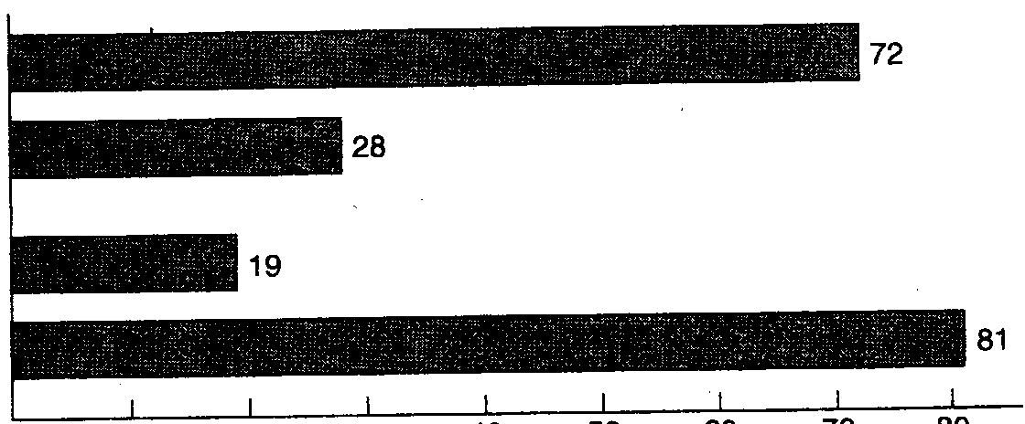
Primary commodities
Manufactures

Primary commodities
Manufactures

The LDCs' dependence on rich-country economies for flows of foreign exchange in the form of export earnings, foreign loans, and foreign aid brings us to the last major common characteristic of Third World nations, their dependence on and occasional dominance by rich nations in the world economy.

Dominance, Dependence, and Vulnerability in International Relations
For many less developed countries, a significant factor contributing to the persistence of low levels of living, rising unemployment, and growing income inequality is the highly unequal distribution of economic and political power between rich and poor nations. As we shall see later, these unequal strengths are manifested not only in the dominant power of rich nations to control the pattern of international trade but also in their ability often to dictate the terms whereby technology, foreign aid, and private capital are transferred to developing countries.
Other equally important aspects of the international transfer process serve to inhibit the development of poor nations. One subtle but nonetheless significant factor contributing to the persistence of underdevelopment has been the transfer of First World values, attitudes, institutions, and standards of behavior to Third World nations. Examples include the colonial transfer of often inappropriate educational structures, curricula, and school systems; the formation of Westernstyle trade unions; the organization and orientation of health services in accordance with the Western curative rather than preventive model; and the importation of inappropriate structures and procedures for public bureaucratic and administrative systems. Of even greater potential significance may be the influence of rich-country social and economic standards on developing-country salary scales, elite life-styles, and general attitudes toward the private accumulation of wealth. Such attitudes can often breed corruption and economic plunder by a privileged minority. Finally, the penetration of rich-country attitudes, values, and standards also contributes to a problem widely recognized and referred to as the international brain drain—the migration of professional and skilled personnel, who were often educated in the developing country at great expense
to the various developed nations. Examples include doctors, nurses, engineers, and economists.
The net effect of all these factors is to create a situation of vulnerability among Third World nations in which forces largely outside their control can have decisive and dominating influences on their economic and social well-being. Many countries—most of the 42 least developed certainly—are small, and their economies are dependent, with very little prospect for self-reliance. Their withdrawal from the world economy is virtually impossible. But as we shall see in Chapter 14, hope can be found in their joining forces economically to promote some form of collective self-reliance. Such cooperation can also strengthen the joint bargaining power of small nations and enable them to scrutinize more carefully and be more selective about foreign investment and technical assistance.
For Third World nations that possess greater assets and relatively more bargaining power, the phenomenon of dominance becomes manifested more in the general tendency of the rich to get richer, often at the expense of the poor. But as mentioned, this is not simply a matter of rich nations growing at a faster pace than poor nations. It is also a matter of rich and dominating sectors or groups within the LDC economy (e.g., the modern industrial or agricultural sector; landlords, trade union leaders, industrialists, politicians, bureaucrats, and civil servants in positions of power) growing richer, often at the expense of the much larger but politically and economically less powerful masses of poor people. This dual process of rich nations and powerful groups within poor nations prospering while others stagnate is by no means an isolated phenomenon. We shall see that it is a rather common characteristic of international economic relations.

Conclusion
The phenomenon of underdevelopment must be viewed in both a national and an international context. Problems of poverty, low productivity, population growth, unemployment, primary product export dependence, and international vulnerability have both domestic and global origins and potential solutions. Economic and social forces, both internal and external, are therefore responsible for the poverty, inequality, and low productivity that characterize most Third World nations. The successful pursuit of economic and social development will require not only the formulation of appropriate strategies within the Third World but also a modification of the present international economic order to make it more responsive to the development needs of poor nations.
Although the picture of life in much of the Third World painted throughout our review is rather bleak, it should be remembered that many countries have succeeded in raising incomes, lowering infant mortality, improving educational access, and increasing life expectancy. By pursuing appropriate economic and social policies both at home and abroad and with effective assistance from developed nations, poor countries do indeed have the means to realize their development aspirations. Parts II, III, and IV will discuss the ways in which these hopes and objectives can be attained.
Developing
Countries
Developing
Countries

