InternetSim
The simulation software for an Internet environment from CD-ROM
Center of Information Technology – Ministry of Education and Training (CIT)
Introduction
In the time that IT applications are developing and their influence spread over the life and the society and that we are in the period of preparation for an economics of knowledge, the popularization of knowledge about the Internet and the creation of condition for reaching the Internet environment and information resources in schools is now very necessary. However, because of the limited budget, especially for the regular access to the Internet at the schools, at least for teachers, is not yet possible.
Facing to need of the practice, the CIT have researched and developed InternetSim, the software simulating an Internet accessing environment with websites preloaded on CD-ROM and its users can access these preloaded websites from common web browsers without any difference from accessing them on the Internet.
The main advantage of this software: pupils and students can learn to use Internet; teachers can see how lessons could be written and organized on the Internet without fee.
Required configurations:
To use this software we need a configuration necessary to run common web browsers:
Hardware minimum: Pentium 100MHz; RAM 16MB; free HDD space 10MB; CD-ROM drive.
Operating System: Windows 9x, Windows NT, Windows ME and Windows 2K.
Software: To use the Internet simulation environment, at least one web browser must be installed: Netscape Communicator, Internet Explorer…
Features
The InternetSim software has the following characteristics:
- Creating an Internet simulation environment that allows its users accessing website preloaded.

- There’s no effect with the real Internet accessing environment when the program finished.
- Users can build their own collections of websites by loading websites from the Internet with common utilities.
Installation
- Put the CD InternetSim in to the CD-ROM drive.
- Run Setup.exe on the CD.
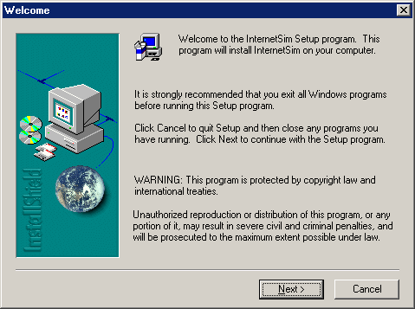
- Follow the installation instruction:
- In the Welcome Dialog Box, click the Next button.
- In the Chose Destination Location Dialog Box, keep the default Destination Folder and click the Next button.
- In the Select Program Folder Dialog Box, keep the default folder and click the Next button.
- Wait until the installation program finished the copying progress.
- In the Setup Complete Dialog box, click the Finish button.
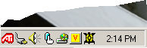
How to use
- Put the CD InternetSim into the CD-ROM drive.
- Run the InternetSim program by choosing: Menu Start | Programs | InternetSim folder | InternetSim. The program will start and update the information about websites preloaded on the CD. The turtle icon on the Windows System Tray signals that the simulation environment is activated.
- Run a web browser (Netscape or Internet Explorer).
- Enter the URLs of websites to access on the location bar of the web browser to browse the website. Example http://kidmath.about.com (on the CD InternetSim Kidmath) or http://www.illusionworks.com/index.html (on the CD InternetSim Physics).
In the case that there’re more than one CD-ROM drive or website’s data are built by users and put in a folder, there’s an option that allow to set the CD-ROM drive or the folder containing data:
- Right click on the Turtle icon on the Windows System Tray, a menu will appear.
- Select Options
- In the Options Dialog Box, deselect AutoDetect; Enter the CD-ROM drive letter of the name of the folder containing websites’ data.
- Click OK to finish.
In the case that user want to turn on or turn off the simulation environment without quitting the program, user can click on the Turtle icon in the Windows System Tray or right click on this icon and select On/ Off, the icon will change to present the state of the simulation environment.
If the users want to quit the program, just right click on the program’s icon in the Windows System Tray and select Exit. The hold simulation environment will be removed.

How to build CD-ROM containing websites for the simulation
Users can download themselves the websites by using common download utilities like Teleport Pro… from the Internet to hard disk or CD-ROM with a suitable structure. Then users can set the option for CD-ROM drive or data folder and users can create their own simulation environment with websites needed.
More precise, websites downloaded must be put in folders having the name of the website and the collection of websites must be put on a folder named data. For example:
D:\ - data\
---kidsmath.about.com\
---www.math.com\
--- …

Conclusions
Up to now, there’s a method of storing websites’ data after downloading on hard disk or CD-ROM and then read them from browser by opening files stored. However, with this method, users cannot reach many concept of the Internet and they must know the place of files stored. This becomes a big disadvantage when accessing a great number of websites and hyper documents.
The InternetSim software can help to overcome partially the difficulty in reaching the information resources on the Internet with the limited budget. Besides helping users to get used to concepts, methods, ideas on the Internet (how to design lessons, to organize the information…), InternetSim software can help users to change easily to the right Internet environment. All the Internet addresses used are the right addresses of websites.
In the CIT, we are using this software in some Internet training courses. We have now a CD-ROM containing a collection of websites on math for children (CD InternetSim Kidsmath) and a CD-ROM of websites on physics (CD InternetSim Physics). We hope to continue to build CD-ROMs on others subjects: chemistry, astronomy, and literature…

