Global Transformations – Introduction

by David Held, Anthony McGrew, David Goldblatt and Jonathan Perraton

Globalization is an idea whose time has come. From obscure origins in French and American writings in the 1960s, the concept of globalization finds expression today in all the world's major languages (cf. Modelski, 1972). Yet, it lacks precise definition. Indeed, globalization is in danger of becoming, if it has not already become, the cliché of our times: the big idea which encompasses everything from global financial markets to the Internet but which delivers little substantive insight into the contemporary human condition.
Clichés, nevertheless, often capture elements of the lived experience of an epoch. In this respect, globalization reflects a widespread perception that the world is rapidly being moulded into a shared social space by economic and technological forces and that developments in one region of the world can have profound consequences for the life chances of individuals or communities on the other side of the globe. For many, globalization is also associated with a sense of political fatalism and chronic insecurity in that the sheer scale of contemporary social and economic change appears to outstrip the capacity of national governments or citizens to control, contest or resist that change. The limits to national politics, in other words, are forcefully suggested by globalization.
Although the popular rhetoric of globalization may capture aspects of the contemporary zeitgeist, there is a burgeoning academic debate as to whether globalization, as an analytical construct, delivers any added value in the search for a coherent understanding of the historical forces which, at the dawn of the new millennium, are shaping the socio-political realities of everyday life. Despite a vast and expanding literature there is, somewhat surprisingly, no cogent theory of globalization nor even a systematic analysis of its primary features. Moreover, few studies of globalization proffer a coherent historical narrative which distinguishes between those events that are transitory or immediate and those developments that signal the emergence of a new conjuncture; that is, a transformation of the nature, form and prospects of human communities. In acknowledging the deficiencies of existing approaches, this volume seeks to develop a distinctive account of globalization which is both historically grounded and informed by a rigorous analytical framework. The framework is explicated in this introduction, while subsequent chapters use it to tell the story of globalization and to assess its implications for the governance and politics of nation-states today. In this respect, the introduction provides the intellectual foundation for addressing the central questions which animate the entire study:

- What is globalization? How should it be conceptualized?
- Does contemporary globalization represent a novel condition?

2

- is globalization associated with the demise, the resurgence or the transformation of state power?
- Does contemporary globalization impose new limits to politics? How can globalization
be 'civilized' and democratized?

As will soon become apparent, these questions are at the root of the many controversies and debates which find expression in contemporary discussions about globalization and its consequences. The subsequent pages offer a way of thinking about how these questions might be addressed.

The Globalization Debate

Globalization may be thought of initially as the widening, deepening and speeding up of worldwide interconnectedness in all aspects of contemporary social life, from the cultural to the criminal, the financial to the spiritual. That computer programmers in India now deliver services in real time to their employers in Europe and the USA, while the cultivation of poppies in Burma can be linked to drug abuse in Berlin or Belfast, illustrate the ways in which contemporary globalization connects communities in one region of the world to developments in another continent. But beyond a general acknowledgement of a real or perceived intensification of global interconnectedness there is substantial disagreement as to how globalization is best conceptualized, how one should think about its causal dynamics, and how one should characterize its structural consequences, if any. A vibrant debate on these issues has developed in which it is possible to distinguish three broad schools of thought, which we will refer to as the hyperglobalizers, the sceptics and the transformationalists. In essence each of these schools may be said to represent a distinctive account of globalization - an attempt to
understand and explain this social phenomenon.
For the hyperglobalizers, such as Ohmae, contemporary globalization defines a new era in which peoples everywhere are increasingly subject to the disciplines of the global marketplace (1990; 1995). By contrast the sceptics, such as Hirst and Thompson, argue that globalization is essentially a myth which conceals the reality of an international economy increasingly segmented into three major regional blocs in which national governments remain very powerful (1996a; 1996b). Finally, for the transformationalists, chief among them being Rosenau and Giddens contemporary patterns of globalization are conceived as historically unprecedented such that states and societies across the globe are experiencing a process of profound change as they try to adapt to a more interconnected but highly uncertain world (Giddens, 1990, 1996; Rosenau, 1997).
Interestingly, none of these three schools map directly on to traditional ideological positions or worldviews. Within the globalist's camp orthodox neoliberal accounts of globalization can be found alongside Marxist accounts, while among the sceptics conservative as well as radical accounts share similar conceptions of, and conclusions about, the nature of contemporary globalization. Moreover, none of the great traditions of social enquiry - liberal, conservative and Marxist - has-an-agreed perspective on globalization as a socio-economic
phenomenon. Among Marxists globalization is understood in quite incompatible ways as for instance, the extension of monopoly capitalist imperialism or, alternatively, as a radically new form of globalized capitalism

3

(Callinicos et al., 1994; Gill, 1995; Amin, 1997). Similarly, despite their broadly orthodox neoliberal starting points, Ohmae and Redwood produce very different accounts of, and conclusions about, the dynamics of contemporary globalization (Ohmae, 1995; Redwood, 1993). Among the hyperglobalizers, sceptics and transformationalists there is a rich diversity of intellectual approaches and normative convictions. Yet, despite this diversity, each of the perspectives reflects a general set of arguments and conclusions about globalization with respect to its

- conceptualization
- causal dynamics
- socio-economic consequences
- implications for state power and governance
- and historical trajectory.

It is useful to dwell on the pattern of argument within and between approaches since this will shed light on the fundamental issues at stake in the globalization debate.

The hyperglobalist thesis

For the hyperglobalizers, globalization defines a new epoch of human history in which 'traditional nation-states have become unnatural, even impossible business units in a global economy' (Ohmae, 1995, p. 5; cf. Wriston, 1992; Guéhenno, 1995). Such a view of globalization generally privileges an economic logic and, in its neoliberal variant, celebrates the emergence f a single global market and the principle of global competition as the harbingers of human progress. Hyperglobalizers argue that economic globalization is bringing about a 'denationalization' of economies through the establishment of transnational networks of production, trade and finance. In this 'borderless' economy, national governments are relegated to little more than transmission belts for global capital or, ultimately, simple intermediate institutions sandwiched between increasingly powerful local, regional and global mechanisms of governance. As Strange puts it, 'the impersonal forces of world markets ... are now more powerful than the states to whom ultimate political authority over society and economy is supposed to belong ... the declining authority of states is reflected in a growing diffusion of authority to other institutions and associations, and to local and regional bodies' (1996, p. 4; cf. Reich, 1991). In this respect, many hyperglobalizers share a conviction that economic globalization is constructing new forms of social organization that are supplanting, or that will eventually supplant, traditional nation-states as the primary economic and political units of world society.
Within this framework there is considerable normative divergence between, on the one hand, the neoliberals who welcome the triumph of individual autonomy and the market principle over state power, and the radicals or neo-Marxists for whom

4

contemporary globalization represents the triumph of an oppressive global capitalism (cf. Ohmae, 1995; Greider, 1997). But despite divergent ideological conviction there exists a shared set of beliefs that globalization is primarily an economic phenomenon; that an increasingly integrated global economy exists today; that the needs of global capital impose a neoliberal economic discipline on all governments such that politics is no longer the 'art of the possible' but rather the practice of 'sound economic management'.
Furthermore, the hyperglobalizers claim that economic globalization is generating a new pattern of winners as well as losers in the global economy. The old North-South division is argued to be an increasing anachronism as a new global division of labour replaces the traditional core-periphery structure with a more complex architecture of economic power. Against this background, governments have to 'manage' the social
consequences of globalization, or those who 'having been left behind, want not so much a chance to move forward as to hold others back' (Ohmae, 1995, p. 64). However, they also have to manage increasingly in a context in which the constraints of global financial and competitive disciplines make social democratic models of social protection untenable and spell the demise of associated welfare state policies (J. Gray, 1998). Globalization may be linked with a growing polarization between winners and losers in the global economy. But this need not be so, for, at least in the neoliberal view, global economic competition does not necessarily produce zero-sum outcomes. While particular groups within a country may be made worse off as a result of global competition, nearly all countries have a comparative advantage in producing certain goods which can be exploited in the long run. Neo-Marxists and radicals regard such an „optimistic view“ as unjustified, believing that global capitalism creates and reinforces structural patterns of inequality within and between countries. But they agree at least with their neoliberal counterparts that traditional welfare options for social protection are looking increasingly threadbare and difficult to sustain.
Among the elites and 'knowledge workers' of the new global economy tacit transnational 'class' allegiances have evolved, cemented by an ideological attachment to a neoliberal economic orthodoxy. For those who are currently marginalized, the worldwide diffusion of a consumerist ideology also imposes a new sense of identity, displacing traditional cultures and ways of life. The global spread of liberal democracy further reinforces the sense of an emerging global civilization defined by universal standards of economic and political organization. This 'global civilization' is also replete with its own mechanisms of global governance, whether it be the IMF or the disciplines of the world market, such that states and peoples are increasingly the subjects of new public and private global or regional authorities (Gill, 1995; Ohmae, 1995; Strange, 1996; Cox, 1997). Accordingly, for many neoliberals, globalization is considered as the harbinger of the first truly global civilization, while for many radicals it represents the first global 'market civilization' (Perlmutter, 1991; Gill, 1995; Greider, 1997).
In this hyperglobalist account the rise of the global economy, the emergence of institutions of global governance, and the global diffusion and hybridization of cultures are interpreted as evidence of a radically, new world order, an order which prefigures the demise of the nation-state.(Luard, 1990; Ohmae, 1995; Albrow, 1996). Since the national economy is increasingly a site of transnational and global flows, as opposed to the primary container of national socio-economic activity, the authority and legitimacy of the nation-state are challenged: national governments become increasingly unable either to control what transpires within their own borders or to fulfil by themselves the

5

demands of their own citizens. Moreover, as institutions of global and regional governance acquire a bigger role, the sovereignty and autonomy of the state are further eroded. On the other hand, the conditions facilitating transnational cooperation between peoples, given global infrastructures of communication and increasing awareness of many common interests, have never been so propitious. In this regard, there is evidence of an emerging 'global civil society'.
Economic power and political power, in this hyperglobalist view, are becoming effectively denationalized and diffused such that nation-states, whatever the claims of national politicians, are increasingly becoming 'a transitional mode of organization for managing economic affairs' (Ohmae, 1995, p. 149). Whether issuing from a liberal or radical/socialist perspective, the hyperglobalist thesis represents globalization as embodying nothing less than the fundamental reconfiguration of the 'framework of human action' (Albrow, 1996, p. 85).

The sceptical thesis

By comparison the sceptics, drawing on statistical evidence of world flows of trade, investment and labour from the nineteenth century, maintain that contemporary levels of economic interdependence are by no means historically unprecedented. Rather than globalization, which to the sceptics necessarily implies a perfectly integrated worldwide economy in which the 'law of one price' prevails, the historical evidence at best confirms only heightened levels of internationalization, that is, interactions between predominantly national economies (Hirst and Thompson, 1996b). In arguing that globalization is a myth, the sceptics rely on a wholly economistic conception of globalization, equating it primarily with a perfectly integrated global market. By contending that levels of economic integration fall short of this 'ideal type' and that such integration as there is remains much less significant than in the late nineteenth century (the era of the classical Gold Standard), the sceptics are free to conclude that the extent of contemporary ‘globalization’ is wholly exaggerated (Hirst, 1997). In this respect, the
sceptics consider the hyperglobalist thesis as fundamentally flawed and also politically naive since it underestimates the enduring power of national governments to regulate international economic activity. Rather than being out of control, the forces of internationalization themselves depend on the regulatory power of national governments to ensure continuing economic liberalization.
For most sceptics, if the current evidence demonstrates anything it is that economic activity is undergoing a significant 'regionalization' as the world economy evolves in the direction of three major financial and trading blocs, that is, Europe, Asia-Pacific and North America (Ruigrok and Tulder, 1995; Boyer and Drache, 1996; Hirst and Thompson, 1996b). In comparison with the classical Gold Standard era. the world economy is therefore significantly less integrated than it once was (Boyer and Drache, 1996; Hirst and Thompson, 1996a). Among the sceptics, globalization and regionalization are conceived as contradictory tendencies. As both Gordon and Weiss conclude, in comparison with the age of world empires, the international economy has become considerably less global in its geographical embrace (Gordon, 1988; Weiss, 1998).
Sceptics tend also to discount the presumption that internationalization prefigures the emergence of a new, less state-centric world order. Far from considering national

6

governments as becoming immobilized by international imperatives, they point to their growing centrality in the regulation and active promotion of cross-border economic activity. Governments are not the passive victims of internationalization but, on the contrary, its primary architects. Indeed, Gilpin considers internationalization largely a by-product of the US-initiated multilateral economic order, which, in the aftermath of the Second World War, created the impetus for the liberalization of national econ. omies (Gilpin, 1987). From a very different perspective, Callinicos and others explain the recent intensification of worldwide trade and foreign investment as a new phase of Western imperialism in which national governments, as the agents of monopoly capital, are deeply implicated (Callinicos et al., 1994).
However, despite such differences of emphasis, there is a convergence of opinion within the sceptical camp that, whatever its exact driving forces, internationalization has not been accompanied by an erosion of North-South inequalities but, on the contrary, by the growing economic marginalization of many 'Third World States' as trade and investment flows within the rich North intensify to the exclusion of much of the rest of the globe. (Hirst and Thompson, 1996b). Moreover, Krugman questions the popular belief that a new international division of labour is emerging in which deindustrialization in the North can be traced to the operation of multinational corporations exporting jobs to the South (Krugman, 1996). Similarly Ruigrok and Tulder, and Thompson and Allen seek to demolish the 'myth' of the 'global corporation', highlighting the fact that foreign investment flows are concentrated among the advanced capitalist states and that most multinationals remain primarily creatures of their home states or regions (Ruigrok and Tulder, 1995; Thompson and Allen, 1997).

Accordingly, the sceptical thesis is generally dismissive of the notion that internationalization is bringing about a profound or even significant restructuring of global economic relations. In this respect, the sceptical position is an acknowledgement of the deeply rooted patterns of inequality and hierarchy in the world economy, which in structural terms have changed only marginally over the last century.
Such inequality, in the view of many sceptics, contributes to the advance of both fundamentalism and aggressive nationalism such that rather than the emergence of a global civilization, as the hyperglobalizers predict, the world is fragmenting into civilizational blocs and cultural and ethnic enclaves (Huntington, 1996). The notion of cultural homogenization and a global culture are thus further myths which fall victim to the sceptical argument. In addition, the deepening of global inequalities, the realpolitik of international relations and the 'clash of civilizations' expose the illusory nature of ,global governance' in so far as the management of world order remains, as it has since the last century, overwhelmingly the preserve of Western states. In this respect, the sceptical argument tends to conceive of global governance and economic internationalization as primarily Western projects, the main object of which is to sustain the primacy of the West in world affairs. As E. H. Carr once observed: 'international order and "international solidarity" will always be slogans of those who feel strong enough to impose them on others' (1981, p. 87).
In general the sceptics take issue with all of the primary claims of the hyperglobalizers pointing to the comparatively greater levels of economic interdependence and the more extensive geographical reach of the world economy at the beginning of the twentieth century. They reject the popular 'myth' that the power of national governments or state sovereignty is being undermined today by economic internationalization or global

7

governance (Krasner, 1993, 1995). Some argue that 'globalization' more often than not reflects a politically convenient rationale for implementing unpopular orthodox neoliberal economic strategies. (Hirst, 1997). Weiss, Scharpf and Armingeon, among others, argue that the available evidence contradicts the popular belief that there has been a convergence of macroeconomic and welfare policies across the globe (Weiss, 1998; Scharpf, 1991; Armingeon, 1997). While international economic conditions may constrain what governments can do, governments are by no means immobilized. The internationalization of capital may, as Weiss argues, 'not merely restrict policy choices, but expand them as well' (1998, pp. 184ff.). Rather than the world becoming more interdependent, as the hyperglobalizers assume, the sceptics seek to expose the myths which sustain the globalization thesis.

The transformationalist thesis

At the heart of the transformationalists thesis is a conviction that, at the dawn of a new millennium, globalization is a central driving force behind the rapid social, political and economic changes that are reshaping modern societies and world order (Giddens, 1990; Scholte, 1993; Castells, 1996). According to the proponents of this view, contemporary processes of globalization are historically unprecedented such that governments and societies across the globe are having to adjust to a world in which there is no longer a clear distinction between international and domestic, external and internal affairs (Rosenau, 1990; Cammilleri and Falk, 1992, Ruggie, 1993; Linklater and MacMillan, 1995; Sassen, 1996). For Rosenau, the growth of 'intermestic' affairs define a 'new frontier', the expanding political, economic and social space in which the fate of societies and communities is decided (1997, pp. 4-5). In this respect, globalization is conceived as a powerful transformative force which is responsible for a 'massive shake-out' of societies, economies, institutions of governance and world order (Giddens, 1996).
In the transformationalist account, however, the direction of this 'shake-out' remains uncertain, since globalization is conceived as an essentially contingent historical process replete with contradictions (Mann, 1997). At issue is a dynamic and open-ended conception of where globalization might be leading and the kind of world order which it might prefigure. In comparison with the sceptical and hyperglobalist accounts, the transformationalists make no claims about the future trajectory of globalization; nor do they seek to evaluate the present in relation to some single, fixed ideal-type 'globalized world', whether a global market or a global civilization. Rather, transformationalist accounts emphasize globalization as a long-term historical process which is inscribed with contradictions and which is significantly shaped by conjunctural factors.
Such caution about the exact future of globalization is matched, nonetheless, by the conviction that contemporary patterns of global economic, military, technological, ecological, migratory, political and cultural flows are historically unprecedented. As Nierop puts it, 'virtually all countries in the world, if not all parts of their territory and all segments of their society, are now functionally part of that larger [global] system in one or more respects' (1994, p. 171). But the existence of a single global system is not taken as evidence of global convergence or of the arrival of single world society. On the contrary, for the transformationalists, globalization is associated with new patterns

8

of global stratification in which some states, societies and communities are becoming increasingly enmeshed in the global order while others are becoming increasingly marginalized. A new configuration of global power relations is held to be crystallizing as the North-South division rapidly gives way to a new international division of labour such that the 'familiar pyramid of the core-periphery hierarchy is no longer a geographic but a social division of the world economy' (Hoogvelt, 1997, p. xii). To talk of North and South, of First World and Third World, is to overlook the ways in which globalization has recast traditional patterns of inclusion and exclusion between countries by forging new hierarchies which cut across and penetrate all societies and regions of the world. North and South, First World and Third World, are no longer 'out there' but nestled together within all the world's major cities. Rather than the traditional pyramid analogy of the world social structure, with a tiny top echelon and spreading mass base, the global social structure can be envisaged as a three-tier Arrangement of concentric circles, each cutting across national boundaries, representing respectively the elites, the contented and the marginalized (Hoogvelt, 1997.). The recasting of patterns of global stratification is linked with the growing deterritorialization of economic activity as production and finance increasingly acquire a global and transnational dimension. From somewhat different starting points, Castells and Ruggie, among others, argue that national economies are being reorganized by processes of economic globalization such that national economic space no longer coincides with national territorial borders (Castells, 1996; Ruggie, 1996). In this globalizing economy, systems of transnational production, exchange and finance weave together ever more tightly the fortunes of communities and households on different continents.
At the core of the transformationalist case is a belief that contemporary globalization is reconstituting or 're-engineering' the power, functions and authority of national governments. While not disputing that states still retain the ultimate legal claim to 'effective supremacy over what occurs within their own territories', the transformationalists argue that this is juxtaposed, to varying degrees, with the expanding jurisdiction of institutions of international governance and the constraints of, as well as the obligations derived from, international law. This is especially evident in the EU, where sovereign power is divided between international, national and local authorities, but it is also evident in the operation of the World Trade Organization (WTO) (Goodman, 1997). However, even where- sovereignty still appears intact, states no longer, if they ever did, retain sole command of what transpires within their own territorial boundaries. Complex global systems, from the financial to the ecological, connect the fate of communities in one locale to the fate of communities in distant regions of the world. Furthermore, global infrastructures of communication and Transport support new forms of economic and social organization which transcend national boundaries without any consequent diminution of efficiency or control. Sites of power and the subjects of power may be literally, as well as metaphorically, oceans apart. In these circumstances, the notion of the nation-state as a self-governing, autonomous unit appears to be more a normative claim than a descriptive statement. The modern institution of territorially circumscribed sovereign rule appears somewhat anomalous juxtaposed with the transnational organization of many aspects of contemporary economic and social life (Sandel, 1996). Globalization, in this account, is therefore associated with a transformation or, to use Ruggie's term, an 'unbundling' of the relationship between sovereignty, territoriality and state power (Ruggie, 1993; Sassen, 1996).

9

Of course, few states have ever exercised complete or absolute sovereignty within their own territorial boundaries, as the practice of diplomatic immunity highlights (Sassen, 1996). Indeed the practice, as opposed to the doctrine, of sovereign statehood has always readily adapted to changing historical realities (Murphy, 1996). In arguing that globalization is transforming or reconstituting the power and authority of national governments, the transformationalists reject both the hyperglobalist rhetoric of the end of the sovereign nation-state and the sceptics' claim that 'nothing much has changed.' Instead, they assert that a new 'sovereignty regime' is displacing traditional conceptions of statehood as an absolute, indivisible, territorially exclusive and zero-sum form of , public power (Held, 1991). Accordingly, sovereignty today is, they suggest, best understood 'less as a territorially defined barrier than a bargaining resource for a politics characterized by complex transnational networks' (Keohane, 1995).
This is not to argue that territorial boundaries retain no political, military or symbolic significance but rather to acknowledge that, conceived as the primary spatial markers of modern life, they have become increasingly problematic in an era of intensified globalization. Sovereignty, state power and territoriality thus stand today in a more complex relationship than in the epoch during which the modern nation-state was being forged. Indeed, the argument of the transformationalists is that globalization is associated not only with a new 'sovereignty regime' but also with the emergence of powerful new non-territorial forms of economic and political organization in the global domain, such as multinational corporations, transnational social movements, international regulatory agencies, etc. In this sense, world order can no longer be conceived as purely state-centric or even primarily state governed, as authority has become increasingly diffused among public and private agencies at the local, national, regional and global levels. Nation-states are no longer the sole centres or the principal forms of governance or authority in the world (Rosenau, 1997).
Given this changing global order, the form and functions of the state are having to adapt as governments seek coherent strategies of engaging with a globalizing world. Distinctive strategies are being followed from the model of the neoliberal minimal state to the models of the developmental state (government as the central promoter of economic expansion) and the catalytic state (government as facilitator of coordinated and collective action). In addition, governments have become increasingly outward looking as they seek to pursue cooperative strategies and to construct international regulatory regimes to manage more effectively the growing array of cross-border issues which regularly surface on national agendas. Rather than globalization bringing about the 'end of the state', it has encouraged a spectrum of adjustment strategies and, in certain respects, a more activist state. Accordingly, the power of national governments is not necessarily diminished by globalization but on the contrary is being reconstituted and restructured in response to the growing complexity of processes of governance in a more interconnected world (Rosenau, 1997).

The three dominant tendencies in the globalization debate are summarized in table I.1. To move beyond the debate between these three approaches requires a framework of enquiry through which the principal claims of each might be assessed. But to construct such a framework demands, as an initial condition, some understanding of the primary fault-lines around which the debate itself revolves. Identifying the critical issues in the debate cr6ates. an intellectual foundation for thinking about how globalization might

10

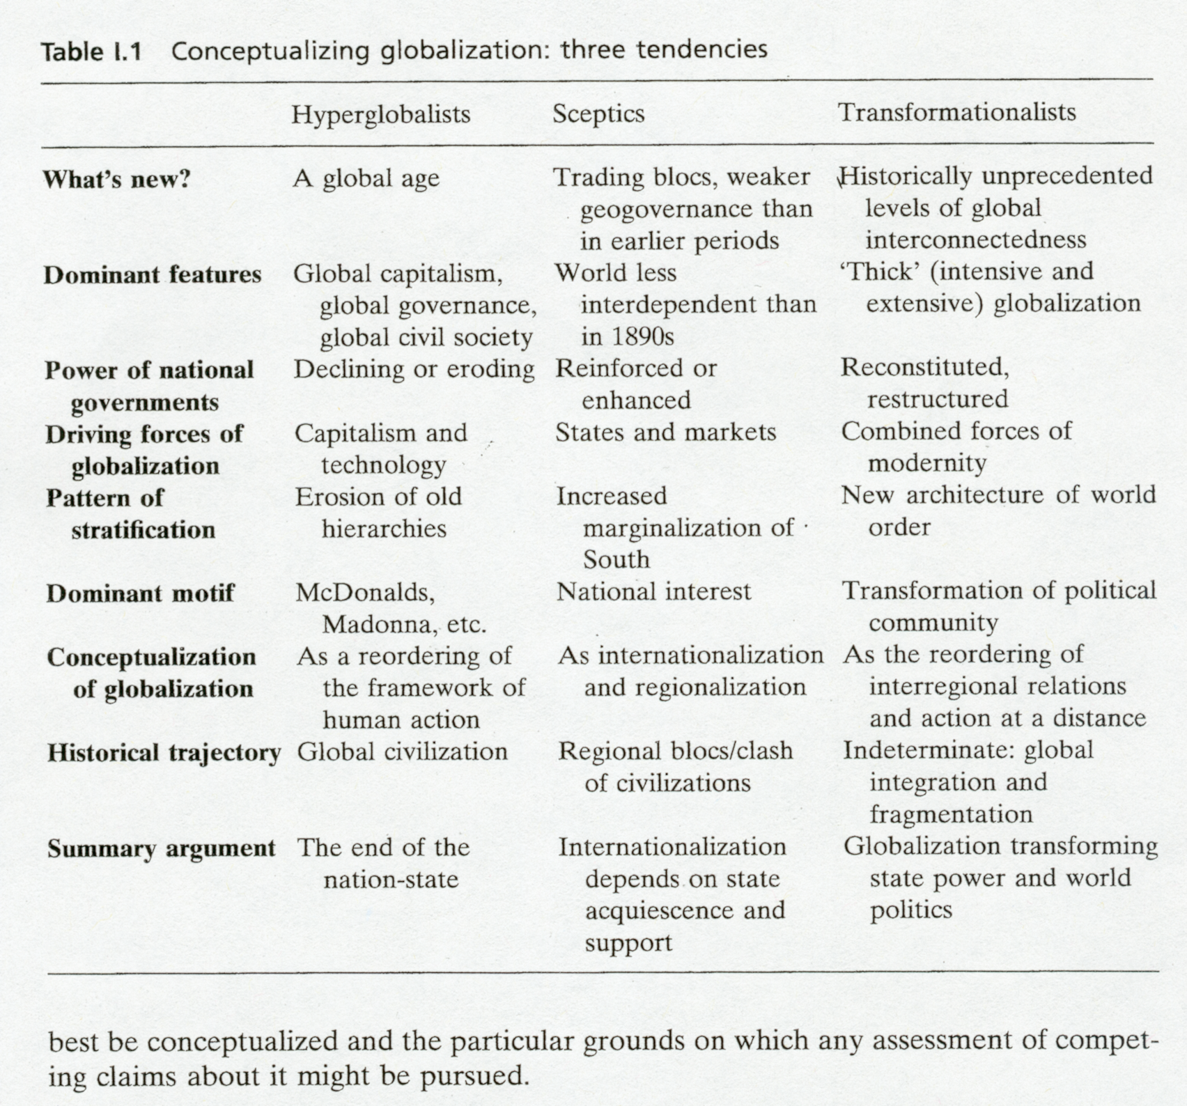
best be conceptualized and the particular grounds on which any assessment of competing claims about it might be pursued.

Sources of Contention in the Globalization Debate

Five principal issues constitute the major sources of contention among existing approaches to globalization. These concern matters of

- conceptualization
- causation
- periodization
- impacts
- and the trajectories of globalization.

In exploring each of these in turn a cumulative picture will develop of the requirements of a rigorous account of globalization, a picture which will help move us beyond the debate between the three approaches outlined above.

11

Conceptualization

Among both the sceptics and hyperglobalizers there is a tendency to conceptualize globalization as prefiguring a singular condition or end-state, that is, a fully integrated global market with price and interest rate equalization. Accordingly, contemporary patterns of economic globalization are assessed, as previously noted, in relation to how far they match up to this ideal type (Berger and Dore, 1995; Hirst and Thompson, 1996b). But even on its own terms this approach is flawed, since there is no a priori reason to assume global markets need to be 'perfectly competitive' any more than national markets have ever been. National markets may well fall short of perfect competition but this does not prevent economists from characterizing them as markets, albeit markets with various forms of 'imperfections'. Global markets, as with domestic markets, can be problematic.
In addition, this 'ideal type' approach is both unacceptably teleological and empiricist: unacceptably teleological in so far as the present is (and apparently should be) interpreted as the stepping stone in some linear progression towards a given future end-state, although there is no logical or empirical reason to assume that globalization - any more than industrialization or democratization - has one fixed end condition; and unacceptably empiricist in that the statistical evidence of global trends is taken by itself to confirm, qualify or reject the globalization thesis, even though such a methodology can generate considerable difficulties (Ohmae, 1990; R. J. B. Jones, 1995; Hirst and Thompson, 1996b). For instance, the fact that more people in the world speak (dialects of) Chinese than English as a first language does not necessarily confirm the thesis that Chinese is a global language. Likewise, even if it could be shown that trade GDP ratios for Western states in the 1890s were similar to, or even higher than, those for the 1990s, this evidence by itself would reveal little about the social and political impacts of trade in either period. Caution and theoretical care are needed in drawing conclusions from seemingly clear global trends. Any convincing account of globalization must weigh the significance of relevant qualitative evidence and interpretative issues.
In comparison, socio-historical approaches to the study of globalization regard it as a process which has no single fixed or determinate historical 'destination', whether understood in terms of a perfectly integrated global market, a global society or a global civilization (Giddens, 1990; Geyer and Bright, 1995; Rosenau, 1997). There is no a priori reason to assume that globalization must simply evolve in a single direction or that it can only be understood in relation to a single ideal condition (perfect global markets). Accordingly, for these transformationalists, globalization is conceived in terms of a more contingent and open-ended historical process which does not fit with orthodox linear models of social change (cf. Graham, 1997). Moreover, these accounts tend also to be sceptical of the view that quantitative evidence alone can confirm or deny the reality' of globalization since they are interested in those qualitative shifts which it may engender in the nature of societies and the exercise of power; shifts which are rarely completely captured by statistical data.
Linked to the issue of globalization as a historical process is the related matter of whether globalization should be understood in singular or differentiated terms. Much Of the sceptical and hyperglobalist literature tends to conceive globalization as a largely

12

singular process equated, more often than not, with economic or cultural interconnectedness (Ohmae, 1990; Robertson, 1992; Krasner, 1993; Boyer and Drache, 1996; Cox, 1996; Hirst and Thompson, 1996b; Huntington, 1996; Strange, 1996; Burbach et al., 1997). Yet to conceive it thus ignores the distinctive patterns of globalization in different aspects of social life, from the political to the cultural. In ' this respect, globalization might be better conceived as a highly differentiated process which finds expression in all the key domains of social activity (including the political, the military, the legal, the ecological, the criminal, etc.). It is by no means clear why it should be assumed that it is a purely economic or cultural phenomenon (Giddens, 1991; Axford, 1995; Albrow, 1996). Accordingly, accounts of globalization which acknowledge this differentiation may be more satisfactory in explaining its form and dynamics than those which overlook it.

Causation

One of the central contentions in the globalization debate concerns the issue of causation: what is driving this process? In offering an answer to this question existing accounts tend to cluster around two distinct sets of explanations: those which identify a single or primary imperative, such as capitalism or technological change; and those which explain globalization as the product of a combination of factors, including technological change, market forces, ideology and political decisions. Put simply, the distinction is effectively between monocausal and multicausal accounts of globalization. Though the tendency in much of the existing literature is to conflate globalization with the expansionary imperatives of markets or capitalism this has drawn substantial criticism on the grounds that such an explanation is far too reductionist. In response, there are a number of significant attempts to develop a more comprehensive explanation of globalization which highlights the complex intersection between a multiplicity of driving forces, embracing economic, technological, cultural and political change (Giddens, 1990; Robertson, 1992; Scholte, 1993; Axford, 1995; Albrow, 1996; Rosenau, 1990, 1997). Any convincing analysis of contemporary globalization has to come to terms with the central question of causation and, in so doing, offer a coherent view.
But the controversy about the underlying causes of globalization is connected to a wider debate about modernity (Giddens, 1991; Robertson, 1992; Albrow, 1996; Connolly, 1996). For some, globalization can be understood simply as the global diffusion of Western modernity, that is, Westernization. World systems theory, for instance, equates globalization with the spread of Western capitalism and Western institutions (Amin, 1996; Benton, 1996). By contrast, others draw a distinction between Westernization and globalization and reject the idea that the latter is synonymous with the former (Giddens, 1990). At stake in this debate is a rather fundamental issue: whether globalization today has to be understood as something more than simply the expanding-reach of Western power and influence. No cogent analysis of globalization can avoid confronting this issue.

Periodization

Simply seeking to describe the 'shape' of contemporary globalization necessarily relies (implicitly or explicitly) on some kind of historical narrative. Such narratives, whether

13

they issue from grand civilizational studies or world historical studies, have significant implications for what conclusions are reached about the historically unique or distinctive features of contemporary globalization (Mazlish and Buultjens, 1993; Geyer and Bright, 1995). In particular, how world history is periodized is central to the kinds of conclusions which are deduced from any historical analysis, most especially, of course, with respect to the question of what's new about contemporary globalization. Clearly, in answering such a question, it makes a significant difference whether contemporary globalization is defined as the entire postwar era, the post-1970s era, or the twentieth century in general.
Recent historical studies of world systems and of patterns of civilizational interaction bring into question the commonly accepted view that globalization is primarily a phenomenon of the modern age (McNeill, 1995; Roudometof and Robertson, 1995; Bentley, 1996; Frank and Gills, 1996). The existence of world religions and the trade networks of the medieval era encourage a greater sensitivity to the idea that globalization is a process which has a long history. This implies the need to look beyond the modern era in any attempt to offer an explanation of the novel features of contemporary globalization. But to do so requires some kind of analytical framework offering a platform for contrasting and comparing different phases or historical forms of globalization over what the French historian Braudel refers to as the longue durge - that is, the passage of centuries rather than decades (Helleiner, 1997).

Impacts

There is an extensive literature implicating economic globalization in the demise of social democracy and the modern welfare state (Garrett and Lange, 1991; Banuri and Schor, 1992; Gill, 1995; Amin, 1996; J. Gray, 1996; Cox, 1997). Global competitive pressures have forced governments, according to this view, to curtail state spending and interventions; for, despite different partisan commitments, all governments have been pressed in the same direction. Underlying this thesis is a rather deterministic conception of globalization as an 'iron cage' which imposes a global financial discipline on governments, severely constraining the scope for progressive policies and underlining the social bargain on which the post-Second World War welfare state rested. Thus there has apparently been a growing convergence of economic and welfare strategies among Western states, irrespective of the ideology of incumbent governments.
This thesis is contested vociferously by a plethora of recent studies which cast serious doubt on the idea that globalization effectively 'immobilizes' national governments in the conduct of economic policy (Scharpf, 1991; R. J. B. Jones, 1995; Ruigrok and Tulder, 1995; Hirst and Thompson, 1996b). As Milner and Keohane observe, 'the impact of the world economy on countries that are open to its influence does not appear to be uniform' (1996, p. 14). Such studies have delivered significant insights into how the social and political impact of globalization is mediated by domestic institutional structures, state strategies and a country's location in the global pecking order (Hurrell and Woods, 1995; Frieden and Rogowski, 1996; Garrett and Lange, 1996). A number of authors have also contributed to a greater awareness of the ways in which globalization is contested and resisted by states and peoples (Geyer and Bright, 1995; Frieden and Rogowski, 1996; Burbach et al., 1997). In so doing, such studies suggest

14

the need for a sophisticated typology of how globalization impacts on national economies and national communities which acknowledges its differential consequences and the signal importance of the forms in which it is managed, contested and resisted (Axford, 1995).

Trajectories

Each of the three 'schools' in the globalization debate has a particular conception of the dynamics and direction of global change. This imposes an overall shape on patterns of globalization and, in so doing, presents a distinctive account of globalization as a historical process. In this respect, the hyperglobalizers tend to represent globalization as a secular process of global integration (Ohmae, 1995; R. P. Clark, 1997). The latter is often associated with a linear view of historical change; globalization is elided with the relatively smooth unfolding of human progress. By comparison, the sceptical thesis tends to a view of globalization which emphasizes its distinct phases as well as its recurrent features. This, in part, accounts for the sceptics' preoccupation with evaluating contemporary globalization in relation to prior historical epochs, but most especially in relation to the supposedly 'golden age' of global interdependence (the latter decades of the nineteenth century) (R. J. B. Jones, 1995; Hirst and Thompson, 1996b). , Neither of these models of historical change finds much support within the transformationalist camp. For the transformationalists tend to conceive history as a process punctuated by dramatic upheavals or discontinuities. Such a view stresses the contingency of history and how epochal change arises out of the confluence of particular historical conditions and social forces. And it informs the transformationalist tendency to describe the process of globalization as contingent and contradictory. For, according to this thesis, globalization pulls and pushes societies in opposing directions; it fragments as it integrates, engenders cooperation as well as conflict, and universalizes while it particularizes. Thus the trajectory of global change is largely indeterminate and uncertain (Rosenau, 1997).

Clearly, a convincing attempt to construct an analytical framework which moves the globalization debate beyond its present intellectual limits has to address the five major points of contention described above. For any satisfactory account of globalization has to offer: a coherent conceptualization; a justified account of causal logic; some clear propositions about historical periodization; a robust specification of impacts; and some sound reflections about the trajectory of the process itself. Confronting these tasks is central to devising and constructing fresh ways of thinking about globalization.

The five tasks inform the chapters that follow, and we return to them again in the conclusion. What follows immediately is an attempt to address the first of the concerns the nature and form of globalization.

Rethinking Globalization: an Analytical Framework

What is globalization? Although in its simplest sense globalization refers to the widening, deepening and speeding up of global interconnectedness, such a definition begs

15

further elaboration. Despite a proliferation of definitions in contemporary discussion - among them 'accelerating interdependence', 'action at a distance' and 'time-space compression' ² (see, respectively, Ohmae, 1990; Giddens, 1990; Harvey, 1989) - there is scant evidence in the existing literature of any attempt to specify precisely what is 'global' about globalization. For instance, all the above definitions are quite compatible with far more spatially confined processes such as the spread of national or regional interconnections. In seeking to remedy this conceptual difficulty, this study commences from an understanding of globalization which acknowledges its distinctive spatial Attributes and the way these unfold over time.
Globalization can be located on a continuum with the local, national and regional.[3] At the one end of the continuum lie social and economic relations and networks which are organized on a local and/or national basis; at the other end lie social and economic relations and networks which crystallize on the wider scale of regional and global interactions. Globalization can be taken to refer to those spatio-temporal processes of change which underpin a transformation in the organization of human affairs by linking together and expanding human activity across regions and continents. Without reference to such expansive spatial connections, there can be no clear or coherent formulation of this term.
Accordingly, the concept of globalization implies, first and foremost, a stretching of social, political and economic activities across frontiers such that events, decisions and activities in one region of the world can come to have significance for individuals and communities in distant regions of the globe. In this sense, it embodies transregional interconnectedness, the widening reach of networks of social activity and power, and the possibility of action at a distance. Beyond this, globalization implies that connections across frontiers are not just occasional or random, but rather are regularized such that there is a detectable intensification, or growing magnitude, of interconnectedness, patterns of interaction and flows which transcend the constituent societies and states of the world order. Furthermore, @rowing extensity and intensity of global interconnectedness may also imply a speeding up of global interactions and processes as the development of worldwide systems of Transport and communication increases the Potential velocity of the global diffusion of ideas, goods, information, capital and people. And the growing extensity, intensity and velocity of global interactions may also be associated with a deepening 'enmeshment of the local and global such that the impact of distant events is magnified while even the most local developments may come to have enormous global consequences. In this sense, the boundaries between domestic matters and global affairs may be blurred. A satisfactory definition of globalization must capture each of these elements: extensity (stretching), intensity, velocity and impact. And

2 By 'accelerating interdependence' is understood the growing intensity of international enmeshment among national economies and societies such that developments in one country impact directly on other countries. 'Action at a distance' refers to the way in which, under conditions of contemporary globalization, the actions of social agents (individuals, collectivities, corporations, etc.) in one locale can come to have significant intended or unintended consequences for the behaviour of 'distant others'. Finally, 'time-space compression' refers. to the manner in which globalization appears to shrink geographical distance and time; in a world of instantaneous communication, distance and time no longer seem to be a major constraint on patterns of human social organization or interaction.
3 Regions refer here to the geographical or functional clustering of states or societies. Such regional clusters can be identified in terms of their shared characteristics (cultural, religious, ideological, economic, etc.) and high level of patterned interaction relative to the outside world (Buzan, 1998).

16

a satisfactory account of globalization must examine them thoroughly. We shall refer to these four elements henceforth as the 'spatio-temporal' dimensions of globalization.
By acknowledging these dimensions a more precise definition of globalization can be offered. Accordingly, globalization can be thought of as

a process (or set of processes) which embodies a transformation in the spatial organization of social relations and transactions - assessed in terms of their extensity, intensity, velocity and impact - generating transcontinental or interregional flows and networks of activity, interaction, and the exercise of power.

In this context, flows refer to the movements of physical artefacts, people, symbols, tokens and information across space and time, while networks refer to regularized or patterned interactions between independent agents, nodes of activity, or sites of power (Modelski, 1972; Mann, 1986; Castells, 1996).
This formulation helps address the failure of existing approaches to differentiate globalization from more spatially delimited processes - what we can call 'localization', 'nationalization', 'regionalization' and 'internationalization'. For as it is defined above, globalization can be distinguished from more restricted social developments. Localization simply refers to the consolidation of flows and networks within a specific locale. Nationalization is the process whereby social relations and transactions are developed within the framework of fixed territorial borders. Regionalization can be denoted by a clustering of transactions, flows, networks and interactions between functional or geographical groupings of states or societies, while internationalization can be taken to refer to patterns of interaction and interconnectedness between two or more nation-states irrespective of their specific geographical location (see Nierop, 1994; Buzan, 1998). Thus contemporary globalization describes, for example, the flows of trade and finance between the major regions in the world economy, while equivalent flows within them can be differentiated in terms of local, national and regional clusters.
In offering a more precise definition of these concepts it is crucial to signal that globalization is not conceived here in opposition to more spatially delimited processes but, on the contrary, as standing in a complex and dynamic relationship with them. On the one hand, processes such as regionalization can create the necessary kinds of economic, social and physical infrastructures which facilitate and complement the deepening of globalization. In this regard, for example, economic regionalization (for instance, the European Union) has not been a barrier to the globalization of trade and production but a spur. On the other hand, such processes can impose limits to globalization, if not encouraging a process of deglobalization. However, there is no a priori reason to assume that localization or regionalization exist in an oppositional or contradictory relationship to globalization. Precisely how these processes interrelate in economic and other domains is more an empirical matter, and one which is dealt with in subsequent chapters.

Historical forms of globalization

Sceptics of the globalization thesis alert us to the fact that international or global interconnectedness is by no means a novel phenomenon; yet they overlook the possibility

17

that the particular form taken by globalization may differ between historical eras. To distinguish the novel features of globalization in any epoch requires some kind of analytical framework for organizing such comparative historical enquiry. For without such a framework it would be difficult to identify the most significant features, continuities or differences between epochs. Thus the approach developed here centres on the idea of historical forms of globalization as the basis for constructing a systematic comparative analysis of globalization over time. Utilizing this notion helps provide a mechanism for capturing and systematizing relevant differences and similarities. In this context, historical forms of globalization refer to

the spatio-temporal and organizational attributes of global interconnectedness in discrete historical epochs.

To say anything meaningful about either the unique Attributes or the dominant features of contemporary globalization requires clear analytical categories from which such descriptions can be constructed. Building directly on our earlier distinctions, historical forms of globalization can be described and compared initially in respect of the four spatio-temporal dimensions:

- the extensity of global networks
- the intensity of global interconnectedness
- the velocity of global flows
- the impact propensity of global interconnectedness.

Such a framework provides the basis for both a quantitative and a qualitative assessment of historical patterns of globalization. For it is possible to analyse (1) the extensiveness of networks of relations and connections; (2) the intensity of flows and levels of activity within these networks; (3) the velocity or speed of interchanges; and (4) the impact of these phenomena on particular communities. A systematic assessment of how these phenomena have evolved provides insights into the changing historical forms of globalization; and it offers the possibility of a sharper identification and comparison of the key Attributes of, and the major disjunctures between, distinctive forms of globalization in different epochs. Such a historical approach to globalization avoids the current tendency to presume either that globalization is fundamentally new, or that there is nothing novel about contemporary levels of global economic and social interconnectedness since they appear to resemble those of prior periods.
Of course, the very notion of historical forms of globalization assumes that it is feasible to map, in an empirical sense, the extensity, intensity, velocity and impact propensity of global flows, networks and transactions across time. In subsequent chapters we seek to operationalize each of these dimensions by using various statistical and other indicators to assess, for instance, the geographical scope of trade flows - their magnitude, velocity, impact and so on. But one particular dimension of globalization is especially difficult to operationalize: the impact propensity of global flows, networks and transactions. Yet without some clear understanding of the nature of impact, the notion of globalization would remain imprecise. How should impact propensity be conceived?

18

For the purpose of this study, we distinguish between four analytically distinct types of impacts: decisional, institutional, distributive and structural. Decisional impacts refer to the degree to which the relative costs and benefits of the policy choices confronting governments, corporations, collectivities and households are influenced by global forces and conditions. Thus globalization may make some policy options or courses of action more or less costly and, in so doing, condition the outcome of individual or organizational decision-making. Depending on decision-makers' and collectivities' sensitivity or vulnerability to global conditions, their policy choices will be constrained or facilitated to a greater or lesser degree.[4] Decisional impacts can be' assessed in terms of high impact (where globalization fundamentally alters policy preferences by transforming the costs and benefits of different courses of action) and low impact (where policy preferences are only marginally affected).
But the impact of globalization may not always be best understood in terms of decisions taken or forgone, since it may operate less transparently by reconfiguring the agenda of decision-making itself and, consequently, the available choices which agents may or may not realistically make. In other words, globalization may be associated with what Schattschneider referred to as the 'mobilization of bias' in so far as the agenda and choices which governments, households and corporations confront are set by global conditions (1960, p. 71). Thus, while the notion of decisional impacts focuses attention on how globalization directly influences the preferences and choices of decision-makers, the notion of institutional impact highlights the ways in which organizational and collective agendas reflect the effective choices or range of choices available as a result of globalization. In this respect, it offers insights into why certain choices may never even be considered as options at all.
Beyond such considerations, globalization may have considerable consequences for the distribution of power and wealth within and between countries. Distributional impacts refer to the ways in which globalization shapes the configuration of social forces (groups, classes, collectivities) within societies and across them. Thus, for instance, trade may undermine the prosperity of some workers while enhancing that of others. In this context, some groups and societies may be more vulnerable to globalization than others.
Finally, globalization may have discernible structural impacts in so far as it conditions patterns of domestic social, economic and political organization and behaviour. Accordingly, globalization may be inscribed within the institutions and everyday functioning of societies (Axford, 1995). For instance, the spread of Western conceptions of the modern state and capitalist markets have conditioned the development of the majority of societies and civilizations across the globe. They have forced or stimulated the adaptation of traditional patterns of power and authority, generating new forms of rule and resource allocation. The structural consequences of globalization may be visible over both the short and the long term in the ways in which states and societies accommodate themselves to global forces. But such accommodation is, of course, far

4 'Sensitivity involves degrees of responsiveness within a policy-framework - how quickly do changes in one country bring costly changes in another and how great are the costly effects ... Vulnerability can be defined as an actor's liability to suffer costs imposed by external events even after policies have been altered' (Keohane and Nye, 1977, p. 12).

19

from automatic. For globalization is mediated, managed, contested and resisted by governments, agencies and peoples. States and societies may display varying degrees of sensitivity or vulnerability to global processes such that patterns of domestic structural adjustment will vary in terms of their degree and duration.
In assessing the impact of globalization on states and communities, it is useful to emphasize that the four types of impact can have a direct bearing on them, altering their form and modus operandi, or an indirect bearing, changing the context and balance of forces with which states have to contend. Decisional and institutional impacts tend to be direct in this regard, although they can have consequences for the economic and social circumstances in which states operate. Distributional and structural impacts tend to be indirect but, of course, none the less significant for that.
There are other important features of historical forms of globalization which should be distinguished. In addition to the spatio-temporal dimensions which sketch the broad shape of globalization, there are four dimensions which map its specific organizational profile: infrastructures, institutionalization, stratification and modes of interaction. Mapping the extensity, intensity, velocity and impact propensity of networks of global interconnectedness necessarily involves mapping the infrastructures which facilitate or carry global flows, networks and relations. Networks cannot exist without some kind of infrastructure support. Infrastructures may be physical, regulative/legal, or symbolic, for instance, a transportation infrastructure, the law governing war, or mathematics as the common language of science. But in most domains infrastructures are constituted by some combination of all these types of facility. For example, in the financial realm there is a worldwide information system for banking settlements, regulated by a regime of common rules, norms and procedures, and working through its own technical language via which its members communicate.
Infrastructures may facilitate or constrain the extensity and intensity of global connectedness in any single domain. This is because they mediate flows and connectivity: infrastructures influence the overall level of interaction capacity in every sector and thus the Potential magnitude of global interconnectedness. Interaction capacity, understood as the Potential scale of interaction defined by existing technical capabilities, is determined primarily, but not exclusively, by technological capacity and communications technology (see Buzan et al., 1993, p. 86). For instance, the interaction capacity of the medieval world system, constrained as it was by limited means of communication, among other things, was considerably less than that of the contemporary era, in which satellites and the Internet facilitate instant and almost real-time global communication (Deibert, 1997). Thus changes in infrastructure have important consequences for the development and evolution of global interaction capacity.
Infrastructural conditions also facilitate the institutionalization of global networks, flows and relations. Institutionalization comprises the regularization of patterns of interaction and, consequently, their reproduction across space and time. To think in terms of the institutionalization of patterns of global connections (trade, alliances, etc.) is to acknowledge the ways in which global networks and relations become regularized and embedded in the practices and operations of the agencies (states, collectivities, households, individuals) in each social domain, from the cultural to the criminal (see Giddens, 1979, p. 80). Institutionalization, therefore, constitutes a further significant Dimension of historical forms of globalization.

20
Discussion of infrastructures and institutionalization links directly to the issue of power. By power is meant the capacity of social agents, agencies and institutions to maintain or transform their circumstances, social or physical; and it concerns the resources which underpin this capacity and the forces that shape and influence its exercise. Accordingly, power is a phenomenon found in and between all groups, institutions and societies, cutting across public and private life. While 'power', thus understood, raises a number of complicated issues, it usefully highlights the nature of power as a universal dimension of human life, independent of any specific site or set of institutions (see Held, 1989, 1995).
But the power of an agent or agency or institution, wherever it is located, never exists in isolation. Power is always exercised, and political outcomes are always determined, in the context of the relative capabilities of parties. Power has to be understood as a relational phenomenon (Giddens, 1979, ch. 2; Rosenau, 1980, ch. 3). Hence, power expresses at one and the same time the intentions and purposes of agencies and institutions and the relative balance of resources they can deploy with respect to each other. However, power cannot simply be conceived in terms of what agents or agencies do or do not do. For power is also a structural phenomenon, shaped by and in turn shaping the socially structured and culturally patterned behaviour of groups and the practices of organizations (Lukes, 1974, p. 22). Any organization or institution can condition and @t the behaviour of its members. The rules and resources which such organizations and institutions embody rarely constitute a neutral framework for action, for they establish patterns of power and authority and confer the right to take decisions on some and not on others; in effect, they institutionalize a power relationship between 'rulers' and 'ruled', 'subjects' and 'governors' (McGrew, 1988, pp. 18-19).
Globalization transforms the organization, distribution and exercise of power. In this respect, globalization. in different epochs may be associated with distinctive patterns of global stratification. In mapping historical forms of globalization, specific attention needs to be paid to patterns of stratification. In this context, stratification has both a social and a spatial dimension: hierarchy and unevenness, respectively (see Falk, 1990, pp. 2-12). Hierarchy refers to asymmetries in the control of, access to and enmeshment in global networks and infrastructures, while unevenness denotes the asymmetrical effects of processes of globalization on the life chances and well-being of peoples, classes, ethnic groupings and the sexes. These categories provide a mechanism for identifying the distinctive relations of global domination and control in different historical periods.
There are important differences too in the dominant modes of interaction within each epoch of globalization. It is possible to distinguish crudely between the dominant types of interaction - imperial or coercive, cooperative, competitive, conflictual - and the primary instruments of power, for example, military vs economic instruments. Thus, arguably, in the late nineteenth-century era of Western expansion, imperialism and military power were the dominant modes and instruments of globalization, whereas in the late twentieth century economic instruments, competition and cooperation appear to take precedence over military force (Morse, 1976).
All in all, historical forms of globalization can be analysed in terms of eight dimensions: see box 1.1. Collectively, they determine the shape of globalization in each epoch.

21
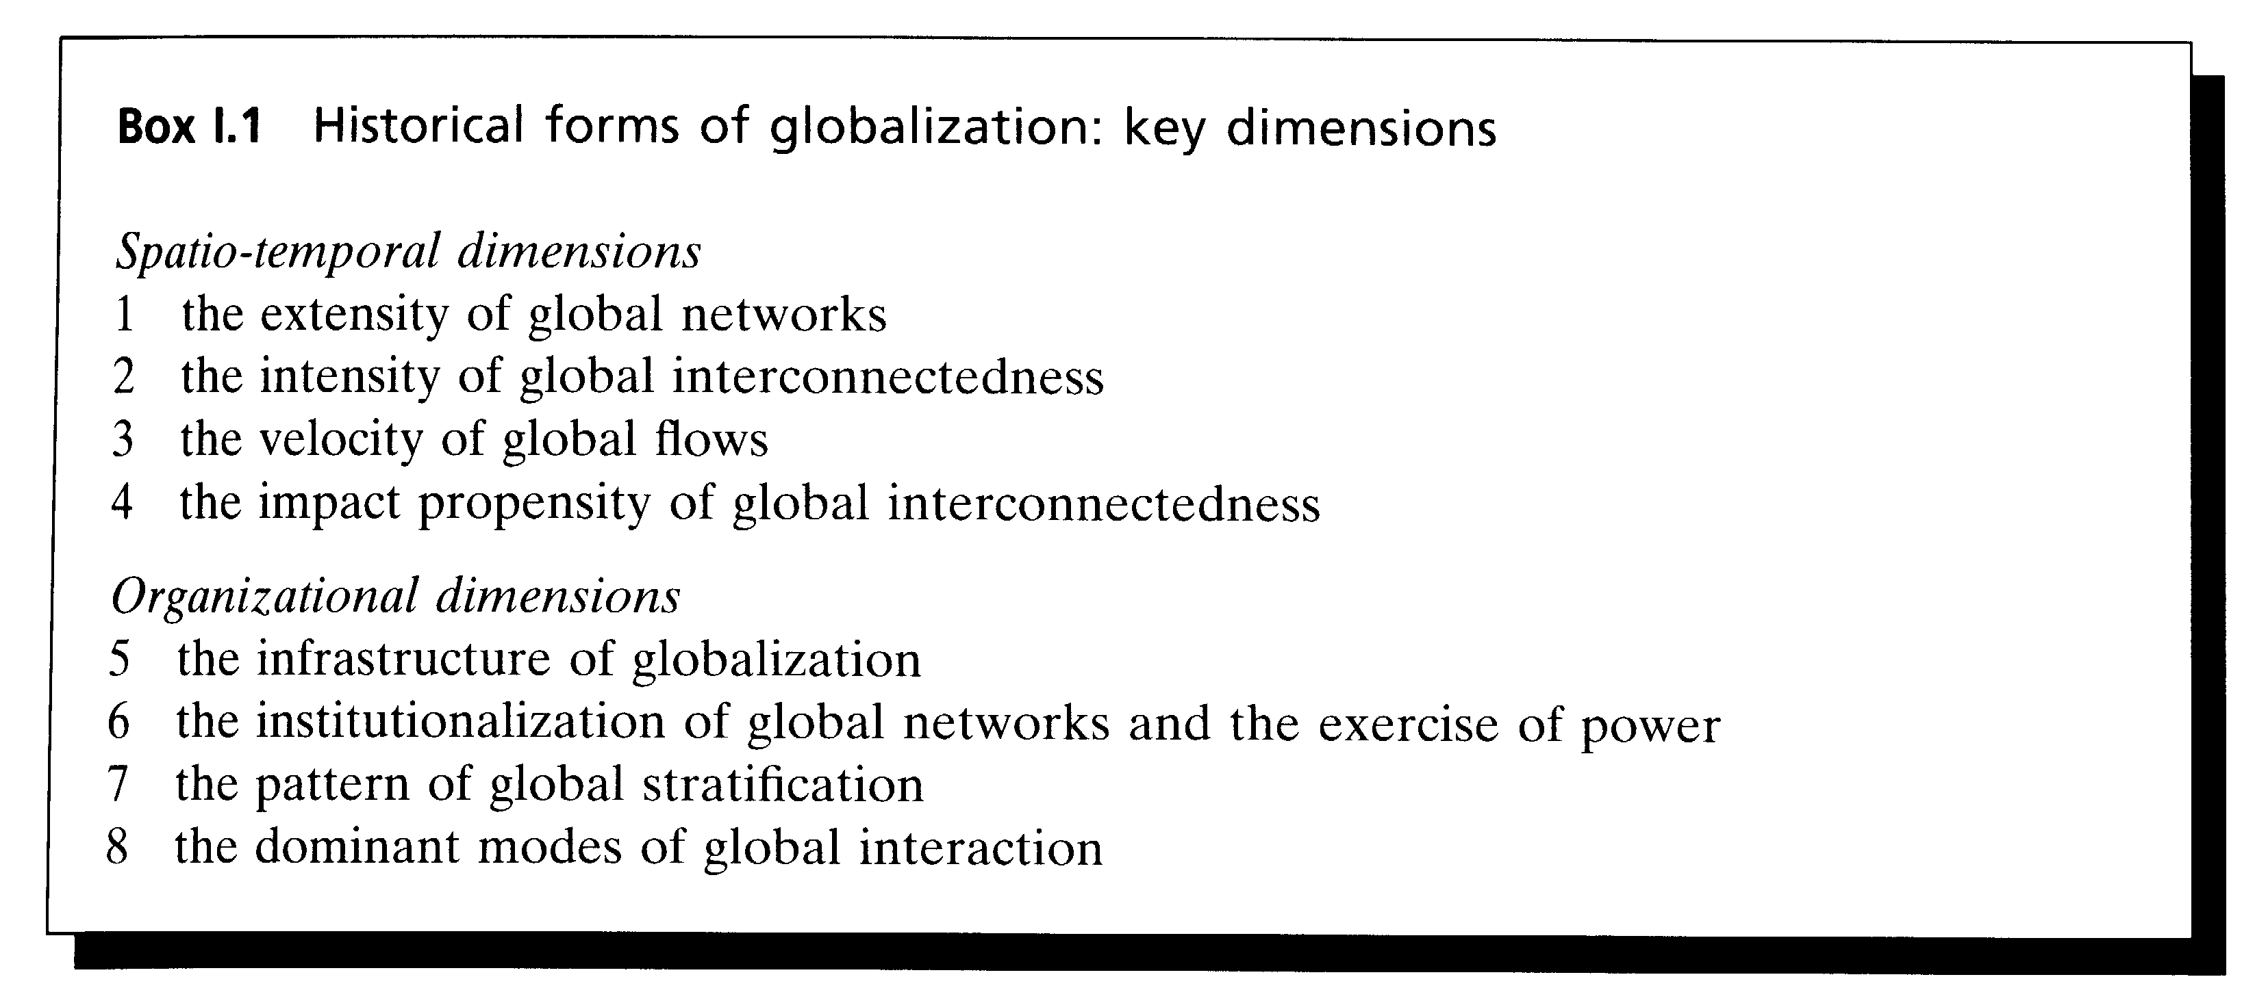

Determining the Shape of Contemporary Globalization

Building on the framework above, a typology of globalization can be constructed. Global flows, networks and relations can be mapped in relation to their fundamental spatio-temporal dimensions: extensity, intensity, velocity and impact propensity. Figures 1.1 and 1.2 set out the relations between these four dimensions. In these figures high extensity refers to interregional/intercontinental networks and flows, and low extensity denotes localized networks and transactions. Accordingly, as figure 1.3 indicates, there are different possible configurations of these dimensions; the four uppermost quadrants in this figure represent, at one spatial extreme, different types of globalized worlds (that is, different configurations of high extensity, intensity, velocity and impact) while the lower quadrants represent, at the other spatial extreme, different configurations of localized networks. This simple exercise delivers the groundwork for devising a more systematic typology of globalization which moves the debate beyond the economistic ideal type and 'one world' models of the sceptics and hyperglobalizers. For the four upper quadrants of figure 1.3 suggest that there are a multiplicity of logical shapes which globalization might take since high extensity can be combined with different possible values for intensity, velocity and impact.
Four of these potential shapes are of particular interest since they represent the outer limits of this typological exercise, combining high extensity with the most extreme values of intensity,- velocity and impact. In this regard, figure 1.4 identifies four discrete logical types of globalization which reflect very different patterns of interregional flows, networks and interactions. They constitute a simple typology of globalization which shows that it has no necessarily fixed form:

- Type 1 represents a world in which the extensive reach of global networks is matched by their high intensity, high velocity and high impact propensity across all the domains or facets of social life from the economic to the cultural. This might be labelled thick globalization. For some sceptics the late nineteenth-century era of

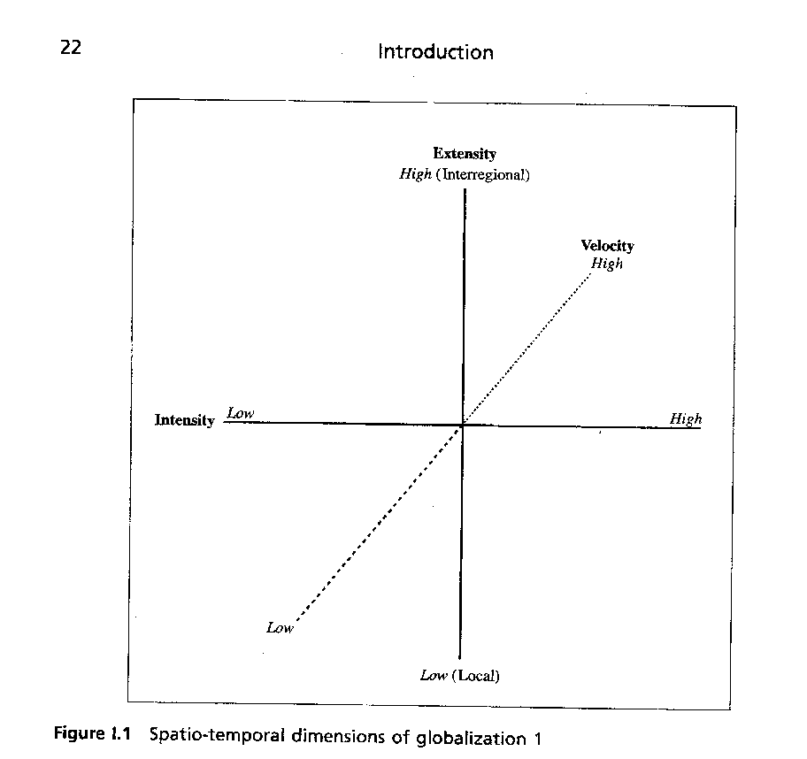
global empires comes close to this type. But, as figure I.4 indicates, there are other Potential shapes to globalization, among which this is only one.

- Type 2 refers to global networks which combine high extensity with high intensity and high velocity but in which impact propensity is low. This might be labelled diffused globalization in so far as its impacts are highly mediated and regulated. While it has no historical equivalents, it is a state of affairs which, normatively speaking, many of those critical of the excesses of contemporary economic globalization might find desirable.

- Type 3 is characterized by the high extensity of global interconnectedness combined with low intensity, low velocity but high impact propensity. This might be labelled expansive globalization; for it is defined more by its reach and impact than the velocity of flows. The early modern period of Western imperial expansion in which European empires had acquired a tentative global reach with considerable intercivilizational impacts comes closest to this type.

- Type 4 captures what might be labelled thin globalization in so far as the high extensity of global networks is not matched by a similar intensity, velocity or impact, for these all remain low. The early silk and luxury trade circuits connecting Europe with China and the East have close parallels with this type.

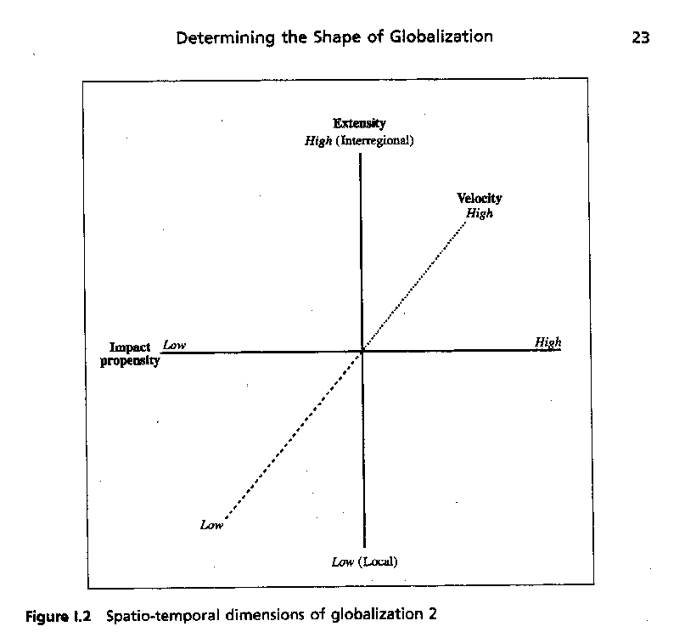

The typology presents four alternative ways of conceiving of globalization, but there are many other possible configurations. The 'thought experiment' which generates these four types can yield a range of other possible outcomes, depending on the values given tot each spatio-temporal dimension. Which (if any) type most appropriately describes actual historical forms of globalization is the task of subsequent chapters to pursue.
Globalization is, we have sought to argue, neither a singular condition nor a linear process. Moreover, it is best thought of as a highly differentiated phenomenon involving domains of activity and interaction as diverse as the political, military, economic, cultural, migratory and environmental. Each of these domains involves different patterns of relations and activities. These can be thought of as 'sites of power' - interaction contexts or organizational milieux in and through which power operates to shape the action capacities of peoples and communities; that is, to mould and circumscribe their effective opportunities, life chances and resource bases. Elements of the interaction context of a particular site may operate largely autonomously; that is to say, the relations and structures of power on that site may be internally created and applied. Examples of this include aspects of military organization in which internal hierarchies can generate resources, entrench authority and develop clear powers of intervention

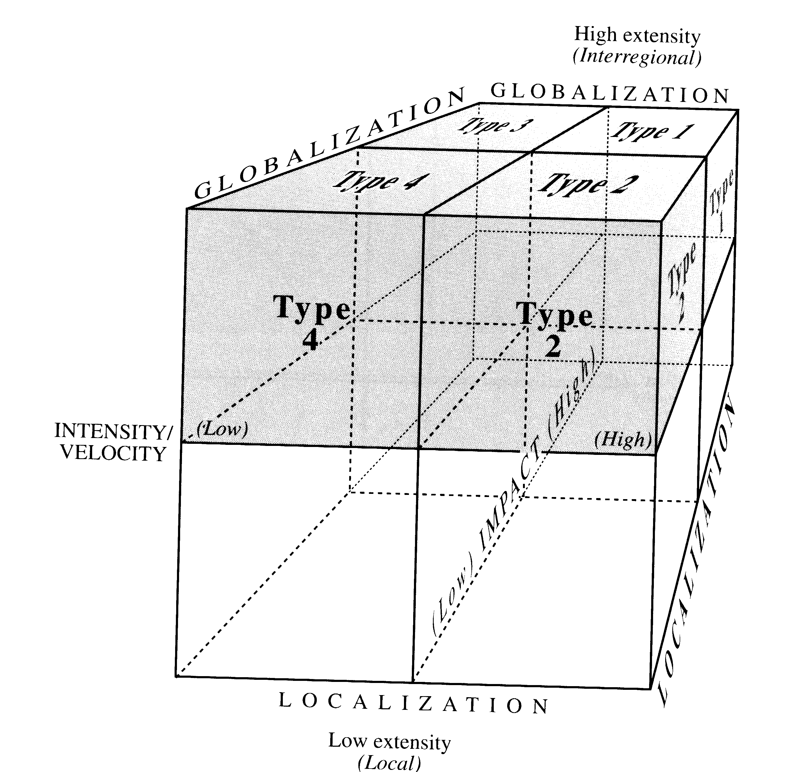

Figure 1.3 Logical types of globalization

in tightly circumscribed realms. However, some sites of power may generate pressures and forces which extend beyond their boundaries, and shape and limit other sites. Certain networks of interaction have greater capacity than others for organizing intensive and extensive, authoritative and diffused social relations (see Mann, 1986, ch. 1). These sites of power become to a degree the sources of power for other sites. The reach
of the medieval church into economic life, or the influence of powerful corporations, productive and financial, on governments in the contemporary era are cases in point.
The political, military, economic and cultural domains and those of labour and migratory movements and of the environment are the central sites of power that will be explored below. We do not claim that this is a definitive set of possible sites or sources of power (cf. Mann, 1986-, Held, 1995, pt 3). It clearly excludes a singular focus on areas which could be a key part of the narrative of the book, for instance, technology. But it is our claim here that the domains we cover are necessary and indispensable to an account of the development of globalization; other domains, including technology, will be threaded through the story we present, but they will not be the focus of individual

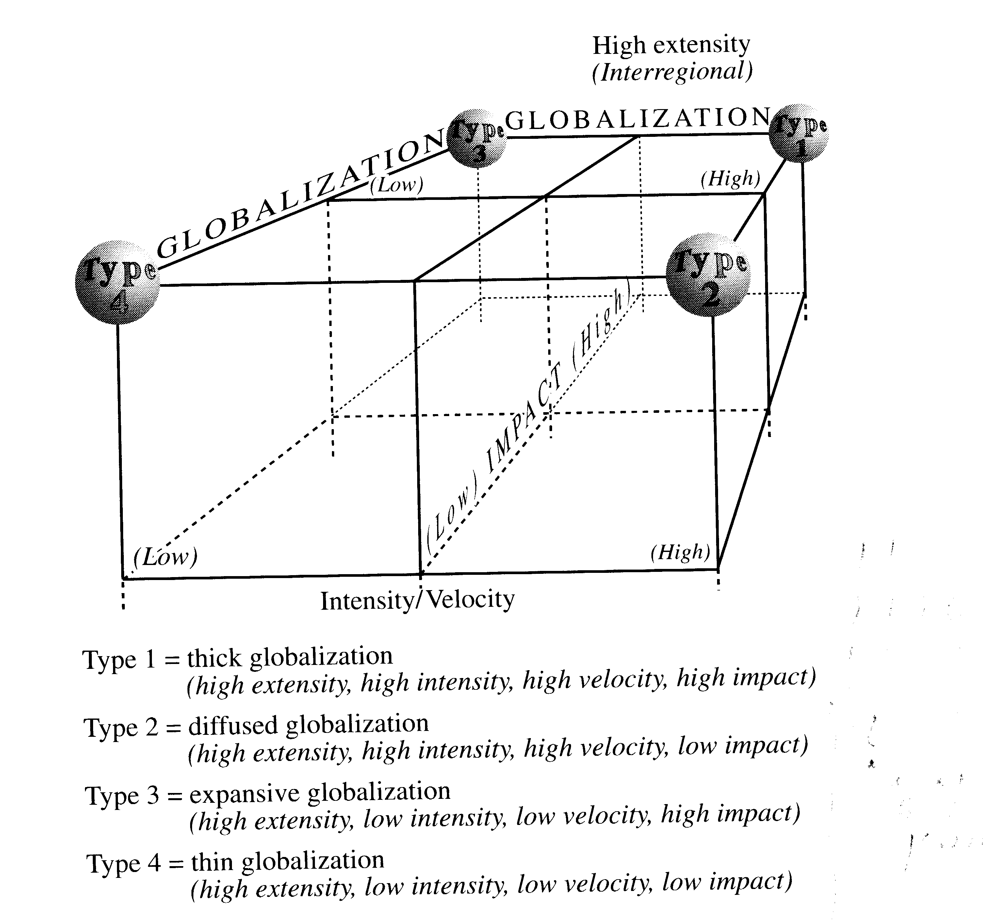
Figure 1.4 A typology of globalization

chapters. The main point to emphasize is the necessity of examining globalization through a series of central domains of human activity, and to recognize that a general account of globalization cannot simply read off or predict from one domain what has occurred or might occur in another. To date, the debate about globalization has too often been weakened by contributions which take, for instance, changes in the world economy (in relation to global financial markets or global competitive forces), or in the interstate system (in relation to changing patterns of regional and global governance), or in the environment (in relation to global warming) as typical of changes occurring across other domains of human interaction. But there is no justified reason to assume that any one domain can necessarily exemplify activities and patterns of change in others. It is extremely important to keep these distinctive domains separate and to construct an account of globalization and its impact from an understanding of what is

happening in each and every one of them.
This book, then, analyses processes of globalization in terms of a theoretical model based on examining a number of deeply embedded processes of change taking place in different domains and in different historical
periods. It does not collapse these into a single process, but treats them as different processes, working according to different

26

possible historical time-scales, whose interaction needs careful consideration, for it can lead to variable and contingent outcomes. The stress is on processes, factors and distinctive causal patterns, rather than on the presumption of a monocausal explanation. We return to the implications of this differentiated and multicausal approach later in the volume, and sum up its significance in the conclusion.
The typology of globalization (figures 1.1-4) delivers a method for describing globalization which avoids both the simplicity of sceptical and hyperglobalist accounts and also the pitfalls of more speculative analysis about the direction of global trends. In this respect the typology acknowledges the complexity of globalization as well as its historical contingency. But while such a typology helps create a basis for understanding contemporary globalization, it will only make full sense in the context of - and after systematic comparative enquiry into the historical forms of globalization.
Subsequent chapters utilize the broad elements of this framework for describing and explaining the historical patterns of globalization in each of the key domains of human activity. They do so by comparing four great epochs of globalization: the pre-modern period; the early modern period of western expansion; the modern industrial era; and the contemporary period from 1945 to the present. The leading processes of globalization, it will be seen, unfolded across several centuries in a slow and uneven manner, and it is difficult, if not impossible, to identify any single starting point. There are interesting continuities across different historical periods as well as breaks, ruptures and reversals. Different processes of globalization have developed at different times, followed different trajectories and tempos. This is reflected in somewhat different periodizations used in each chapter of this book. For example, chapter 1 takes the history of political globalization back to the ancient empires. Chapter 2 on organized violence and the military begins by reflecting on key changes in the early modern period. Chapters 3-5 also start from the early modern period, exploring the globalization of trade, finance and production. Chapter 6 on migration begins with the earliest migratory movements which peopled the planet, but examines, in particular, movements which followed from the expansion of Europe. Chapter 7 starts with the globalization of culture from the spread of the Roman Empire and world religions, while it puts special emphasis on developments from the late nineteenth century. And chapter 8 focuses on environmental degradation in the second half of the twentieth century, although earlier significant periods are mentioned. The conclusion pulls these different historical narratives together, examining disjunctures and confluences of change across earlier periods and domains. It brings the story of the different temporalities together, exploring some of their main connections and articulations. The latter is an important exercise since the Potential synergy between processes of globalization in each domain may produce its own systemic logic. While it is essential to map globalization in each domain it is also crucial not to neglect the ways in which the totality of these flows, networks, interactions and interconnections generates its own imperatives. The conclusion will, therefore, seek to integrate the narratives of globalization in each domain into a more comprehensive comparison of the main historical forms of globalization.
It is important to stress that it is only after the mapping of historical forms of globalization, with respect to the key domains of human activity, that it is possible to identify the extent to which there is a clustering of patterns of global interconnectedness

27

across all these areas. Only from an analysis of such clustering will it be feasible to deduce the overall shape of contemporary globalization; that is, whether contemporary patterns of global change can most appropriately be described as thick, thin, expansive, diffused, or by some other Potential shape.

In sum

The account of globalization developed in subsequent chapters reflects and builds on a number of points made so far in the introduction:

- Globalization can best be understood as a process or set of processes rather than a singular condition. It does not reflect a simple linear developmental logic, nor does it prefigure a world society or a world community. Rather, it reflects the emergence of interregional networks and systems of interaction and exchange. In this respect, the enmeshment of national and societal systems in wider global processes has to be distinguished from any notion of global integration.
- The spatial reach and density of global and transnational interconnectedness weave complex webs and networks of relations between communities, states, international institutions, non-governmental organizations and multinational corporations which make up the global order. These overlapping and interacting networks define an evolving structure which both imposes constraints on and empowers communities, states and social forces. In this respect, globalization is 'akin to a process of structuration' in so far as it is a product of both the individual actions of, and the cumulative interactions between, countless agencies and institutions across the globe (Giddens, 1981; Buzan et al., 1993; Nierop, 1994; Jervis, 1997). Globalization is associated with an evolving dynamic global structure of enablement and constraint. But it is also a highly stratified structure since globalization is profoundly uneven: it both reflects existing patterns of inequality and hierarchy while also generating new patterns of inclusion and exclusion, new winners and losers (Hurrell and Woods, 1995). Globalization, thus, can be understood as embodying processes of structuration and stratification.
- Few areas of social life escape the reach of processes of globalization. These processes are reflected in all socialdomains from the cultural through the economic, the political, the legal, the military and the environmental. Globalization is best understood as a multifaceted or differentiated social phenomenon. It cannot be conceived as a singular condition but instead refers to patterns of growing global interconnectedness within all the key domains of social activity. To understand the dynamics and consequences of , globalization, therefore, demands some knowledge of the differential patterns of global interconnectedness in each of these domains. For instance, patterns of global ecological interconnectedness are quite different from the patterns of global cultural or military interaction. Any general account of the processes of globalization must acknowledge that, far from being a singular condition, it is best conceived as a differentiated and multifaceted process.
- By cutting through and across political frontiers globalization is associated with both the deterritorialization and reterritorialization of socio-economic and political

28

space. As economic, social and political activities are increasingly 'stretched' across the globe they become in a significant sense no longer primarily or solely organized according to a territorial principle. They may be rooted in particular locales but territorially disembedded. Under conditions of globalization, 'local', 'national' or even 'continental' political, social and economic space is re-formed such that it is no longer necessarily coterminous with established legal and territorial boundaries. On the other hand, as globalization intensifies it generates pressures towards a reterritorialization of socio-economic activity in the form of subnational, regional and supranational economic zones, mechanisms of governance and cultural complexes. It may also reinforce the 'localization' and 'nationalization' of societies. Accordingly, globalization involves a complex deterritorialization and reterritorialization of political and economic power. In this respect, it is best described as being aterritorial.
- Globalization concerns the expanding scale on which power is organized and exercised, that is, the extensive spatial reach of networks and circuits of power. Indeed, power is a fundamental Attribute of globalization. In an increasingly interconnected global system, the exercise of power through the decisions, actions, or inactions, of agencies on one continent can have significant consequences for nations, communities and households on other continents. Power relations are deeply inscribed in the very processes of globalization. In fact, the stretching of power relations means that sites of power and the exercise of power become increasingly distant from the subjects or locales which experience their consequences. In this regard, globalization involves the structuring and restructuring of power relations at a distance. Patterns of global stratification mediate access to sites of power, while the consequences of globalization are unevenly experienced. Political and economic elites in the world's major metropolitan areas are much more tightly integrated into, and have much greater control over, global networks than do the subsistence farmers of Burundi.

The points set out above help clarify the meaning of globalization in very specific
ways. In particular, they draw attention to the dangers of eliding globalization with concepts such as interdependence, integration, universalism and convergence. Whereas the concept of interdependence assumes symmetrical power relations between social or political actors, the concept of globalization leaves open the possibility of hierarchy and unevenness; that is, a process of global stratification. Integration too has a very specific meaning since it refers to processes of economic and political unification which prefigure a sense of community, shared fortunes and shared institutions of governance. As previously noted, the notion of globalization as the precursor to a single world society or community is deeply flawed. So too is the association of globalization with 'universalism' for clearly the global is not a synonym for the universal; global interconnectedness is not experienced by all peoples or communities to the same extent or even in the same way. In this respect, it is also to be distinguished from convergence since it does not presume growing homogeneity or harmony. On the contrary, as both Bull and Buzan have argued, growing interconnectedness may be both a source of intense conflict (rather than cooperation) as well as a product of shared fears and deeply held animosities (Bull, 1977; Buzan, 1991).

29

The Book Ahead
The volume begins by exploring political globalization (see chapter 1). There are several reasons for this starting point. In the first instance, expansionist states and empires have been active in creating regional and global links and they are important elements of the changing historical forms of globalization. Second, different types of states have created distinctive forms of territorial space - from loose frontiers to tightly organized boundaries - which have shaped and mediated patterns of regional and global relations, networks and flows. Third, one particular form of political rule - the modern and contemporary nation-state - profoundly altered the nature, form and prospects of globalization; for it was with the development of the modern nation-state that the focal point of rule became national governments and their claim to sovereignty, autonomy and distinctive forms of accountability within a bounded territory. It is worth dwelling on this latter point for a moment.
Modern nation-states, as will be seen from chapters 1 and 2, distinguish themselves from previous forms of political rule by claiming a proper symmetry and correspondence between sovereignty, territory, legitimacy and, with the passage of the nineteenth and twentieth centuries, democracy. The concept of sovereignty lodges a distinctive claim to the rightful exercise of political power over a circumscribed realm (see Skinner, 1978, vol. 2; Held, 1995, ch. 2). It seeks to specify the political authority within a community which has the right to determine the framework of rules, regulations and policies within a given territory and to govern accordingly. However, in thinking about the impact of globalization on the modern nation-state, one needs to distinguish the claim to sovereignty - the entitlement to rule over a bounded territory - from state autonomy - the actual power the nation-state possesses to articulate and achieve policy goals independently. In effect, state autonomy refers to the capacity of state representatives, managers and agencies to articulate and pursue their policy preferences even though these may on occasion clash with the dictates of domestic and international social forces and conditions (Nordlinger, 1981). Moreover, to the extent that modern nation-states are democratic, sovereignty and autonomy are assumed to be embedded within, and congruent with, the territorially organized framework of liberal democratic government: 'the rulers' - elected representatives - are accountable to 'the ruled' - the citizenry - within a delimited territory. There is, in effect, a 'national community of fate', whereby membership of the political community is defined in terms of the peoples within the territorial borders of the nation-state; this community becomes the proper locus and home of democratic politics.
For many of those involved in the debate about globalization and its consequences, the sheer density and scale of contemporary economic, social and political activity appear to make territorial forms of politics increasingly impotent. Within Western societies this perception is linked to anxieties about the declining effectiveness of government, the growing fragmentation of civic communities and, despite the end of the Cold War, growing personal insecurity. Whether real or imagined, these anxieties reflect a 'fear that, individually and collectively, we are losing control of the forces that govern our lives' (Sandel, 1996, p. 3). Thus it is argued by hyperglobalizers and transformationalists that globalization weaves together, in highly complex and abstract

30

systems, the fate of households, communities and peoples in distant regions of the globe such that 'communities of fate' cannot be identified in exclusively national or territorial terms. The implication is that, under conditions of globalization, one cannot understand the nature and possibilities of political community by referring merely to national structures.
Of course, it is essential to recognize that sovereignty, particularly in its legal sense, is eroded only when it is displaced by forms of independent and/or 'higher' legal or juridical authority which curtail the rightful basis of decision-making within a national polity. But for the hyperglobalizers and transformationalists, the very idea of the sovereign state as an independent unit which governs itself and directs its own future sits uneasily alongside the globalization of economic production and exchange, the growing significance of international regimes, legal interaction and global institutions, the internationalization of domestic policy and the domestication of international policy. Globalization poses the question as to whether global and regional patterns of enmeshment are displacing 'notions of sovereignty as an illimitable, indivisible and exclusive form of public power' such that 'sovereignty itself has to be conceived today as already divided among a number of agencies - national, regional and international and limited by the very nature of this plurality' (Held, 1991, p. 222).
However, while globalization may constrain what governments can do, governments are, the sceptics retort, by no means necessarily immobilized nor is their sovereignty necessarily eroded. Moreover, globalization has differential impacts; its political consequences vary considerably between different states as well as across different policy sectors. Whether globalization entails a general diminution, an enhancement or a transformation of the sovereignty and autonomy of states remains a controversial matter. Subsequent chapters will, therefore, return repeatedly to this theme.
Mapping the shape and political consequences of globalization is the key objective of the chapters that follow. But the range of states which will be considered will be ,restricted first and foremost to states in advanced capitalist societies (SIACS). There are two justifications for narrowing the enquiry in this way. First, if globalization does impact on sovereign statehood it is the SIACS, as the principal model and locus of modern statehood, which provide the strongest test of its political ramifications. Second, in the globalization debate the hyperglobalizers, the transformationalists and the sceptics make radically different claims about the fate of SIACS. This study seeks to evaluate these competing claims. However, it does so by concentrating the enquiry on six specific SIACS, namely the US, UK, Sweden, France, Germany and Japan. This particular configuration of states has been selected because of the differences and commonalities between them along a range of variables including their positions in the interstate hierarchy, domestic political structures and cultures, foreign and defence policy postures, levels of global enmeshment, industrial and economic structures and performance and strategies for adjusting to globalization (see the Methodological Appendix). Accordingly' the penultimate and concluding sections of subsequent chapters will seek to relate the analysis of the shape and history of globalization in each domain to the fate of the six SIACS. This will involve a specific exploration of their differential levels of global enmeshment in each domain and an examination of its implications for state sovereignty and autonomy. The primary purpose of this analysis is to deliver a more systematic understanding of the nature and differential political consequences of contemporary globalization. For comparative purposes, other individual

31

states - particularly those with developing economies - will be referred to and discussed only where relevant.

The threads of the volume will be drawn together in the last chapter, which will seek, as noted previously, to deliver a systematic description and assessment of the shape of contemporary globalization. This chapter will conclude with an assessment of the implications of globalization for the sovereignty and autonomy of SIACS. But it will also take the globalization debate into normative territory in exploring some of the key intellectual, institutional and political challenges it generates. In particular, it will confront directly the political fatalism which surrounds much discussion of contemporary globalization with a ' normative agenda which elaborates the possibilities for democratizing and civilizing the unfolding 'global transformation'.

The approaches set out below present General summaries of different ways of thinking about globalization: they do not represent fully the particular positions and many differences among the individual theorists mentioned. The aim of the presentation is to highlight the main trends and faultlines in the current debate and literature.

