Sen, A. (1999). Development as freedom. Oxford: Oxford University Press. Chapter 2
CHAPTER 2
THE ENDS AND THE MEANS OF DEVELOPMENT
Let me start off with a distinction between two general attitudes to the process of development that can be found both in professional economic analysis and in public discussions and debates. One view sees development as a "fierce" process, with much "blood, sweat and tears" - a world in which wisdom demands toughness. In particular, it demands calculated neglect of various concerns that are seen as 46 "soft-headed" (even if the critics are often too polite to call them that). Depending on what the author's favorite poison is, the temptations to be resisted can include having social safety nets that protect the very poor, providing social services for the population at large, departing from rugged institutional guidelines in response to identified hardship, and favoring-"much too early" - political and civil rights and the "luxury" of democracy. These things, it is argued in this austere attitudinal mode, could be supported later on, when the development process has borne enough fruit: what is needed here and now is "toughness and discipline." The different theories that share this general outlook diverge from one another in pointing to distinct areas of softness that are particularly to be avoided, varying from financial softness to political relaxation, from plentiful social expenditures to complaisant poverty relief.
This hard-knocks attitude contrasts with an alternative outlook that sees development as essentially a "friendly" process. Depending on the particular version of this attitude, the congeniality of the process is seen, as exemplified by such things as mutually beneficial exchanges (of which Adam Smith spoke eloquently), or by the working of social safety nets, or of political liberties, or of social development-or some combination or other of these supportive activities.
CONSTITUTIVE AND INSTRUMFNTAL ROLES OF FKEEDOM
The approach of this book is much more compatible with the. latter approach than with the former. It is mainly an attempt to see development as a process of expanding the real freedoms that people enjoy. In this approach, expansion of freedom is viewed as both (1) the primary end and (2) the principal means of development. They can be called respectively the "constitutive role" and the "instrumental role" of freedom in development. The constitutive role of freedom relates to the importance of substantive freedom in enriching human life. The substantive freedoms include elementary capabilities like being able to avoid such deprivations as starvation, undernourishment, escapable morbidity and premature mortality, as well as the freedoms that are associated with being literate and numerate, enjoying political participation and uncensored speech and so on. In this constitutive perspective, development involves expansion of these and other basic freedoms. Development, in this view, is the process of expanding human freedoms, and the assessment of development has to be informed by this consideration.
Let me refer here to an example that was briefly discussed in the introduction (and which involves an often raised question in the development literature) in order to illustrate how the recognition of the "constitutive" role of freedom can alter developmental analysis. Within the narrower views of development (in terms of, say, GNP growth or industrialization) it is often asked whether the freedom of political participation and dissent is or is not "conducive to development." In the light of the foundational view of development as freedom, this question would seem to be defectively formulated, since it misses the crucial understanding that political participation and dissent are constitutive parts of development itself. Even a very rich person who is prevented from speaking freely, or from participating in public debates and decisions, is deprived of something that she has reason to value. The process of development, when judged by the enhancement of human freedom, has to include the removal of this person's deprivation. Even if she had no immediate interest in exercising the freedom to speak or to participate, it would still be a deprivation of her freedoms if she were to be left with no choice on these matters. Development seen as enhancement of freedom cannot but address such deprivations. The relevance of the deprivation of basic political freedoms or civil rights, for an adequate understanding of development, does not have to be established through their indirect contribution to other features of development (such as the growth of GNP or the Promotion of industrialization). These freedoms are part and parcel of enriching the process of development.
This fundamental point is distinct from the "instrumental" argument that these freedoms and rights may also be very effective in contributing to economic progress. That instrumental connection is important as well (and will be discussed particularly in chapters 5 and 6), but the significance of the instrumental role of political freedom as means to development does not in any way reduce the evaluative importance of freedom as an end of development.
The intrinsic importance of human freedom as the preeminent objective of development has to be distinguished from the instrumental effectiveness of freedom of different kinds to promote human freedom. Since the focus of the last chapter was mainly on the intrinsic importance of freedom, I shall now concentrate more on the effectiveness of freedom as means - not just as end. The instrumental role of freedom concerns the way different kinds of rights, opportunities, and entitlements contribute to the expansion of human freedom in general, and thus to promoting development. This relates not merely to the obvious connection that expansion of freedom of each kind must contribute to development since development itself can be seen as a process of enlargement of human freedom in general. There is much more in the instrumental connection than this constitutive linkage. The effectiveness of freedom as an instrument lies in the fact that different kinds of freedom interrelate with one another, and freedom of one type may greatly help in advancing freedom of other types. The two roles are thus linked by empirical connections, relating freedom of one kind to freedom of other kinds.
INSTRUMENTAL FREEDOMS
In presenting empirical studies in this work, 1 shall have the occasion to discuss a number of instrumental freedoms that contribute, directly or indirectly, to the overall freedom people have to live the way they would like to live. The diversities of the instruments involved are quite extensive. However, it may be convenient to identify five distinct types of freedom that may be particularly worth emphasizing in this instrumental perspective. This is by no means an exhaustive list, but it may help to focus on some particular policy issues that demand special attention at this time.
In particular, I shall consider the following types of instrumental freedoms: (1) political freedoms, (2) economic facilities, (3) social opportunities, (4) transparency guarantees and (5) protective security. These instrumental freedoms tend to contribute to the general capability of a person to live more freely, but they also serve to complement one another. While development analysis must, on the one hand, be concerned with the objectives and aims that make these instrumental freedoms consequentially important, it must also take note of the empirical linkages that tie the distinct types of freedom together, strengthening their joint importance. Indeed, these connections are central to a fuller understanding of the instrumental role of freedom. The claim that freedom is not only the primary object of development but also its principal means relates particularly to these linkages.
Let me comment a little on each of these instrumental freedoms. Political freedoms, broadly conceived (including what are called civil rights), refer to the opportunities that people have to determine who should govern and on what principles, and also include the possibility to scrutinize and criticize authorities, to have freedom of political expression and an uncensored press, to enjoy the freedom to choose between different political parties, and so on. They include the political entitlements associated with democracies in the broadest sense (encompassing opportunities of political dialogue, dissent and critique as well as voting rights and participatory selection of legislators and executives).
Economic facilities refer to the opportunities that individuals respectively enjoy to utilize economic resources for the purpose of consumption, or production, or exchange. The economic entitlements that a person has will depend on the resources owned or available for use as well as on conditions of exchange, such as relative prices and the working of the markets. Insofar as the process of economic development increases the income and wealth of a country, they are reflected in corresponding enhancement of economic entitlements of the population. It should be obvious that in the relation between national income and wealth, on the one hand, and the economic entitlements of individuals (or families), on the other, distributional considerations are important, in addition to aggregative ones. How the additional incomes generated are distributed will clearly, make a difference.
The availability and access to finance can be a crucial influence on the economic entitlements that economic agents are practically able to secure. This applies all the way from large enterprises (in which hundreds of thousands of people may work) to tiny establishments that are run on micro credit. A credit crunch, for example, can severely affect the economic entitlements that rely on such credit.
Social opportunities refer to the arrangements that society makes for education, health care and so on, which influence the individual's substantive freedom to live better. These facilities are important not only for the conduct of private lives (such as living a healthy life and avoiding preventable morbidity and premature mortality), but also for more effective participation in economic and political activities. For example, illiteracy can be a major barrier to participation in economic activities that require production according to specification or demand strict quality control (as globalized trade increasingly does). Similarly, political participation may be hindered by the inability to read newspapers or to communicate in writing with others involved in political activities.
I turn now to the fourth category. In social interactions, individuals deal with one another on the basis of some presumption of what they are being offered and what they can expect to. get. In this sense, the society operates on some basic presumption of trust. Transparency guarantees deal with the need for openness that people can expect. the freedom to deal with one another under guarantees of disclosure and lucidity. When that trust is seriously violated, the lives of many people-both direct parties and third parties-may be adversely affected by the lack of openness. Transparency guarantees (including the right to disclosure) can thus be an important category of instrumental freedom. These guarantees have a clear instrumental role in preventing corruption, financial irresponsibility and underhand dealings.
Finally, no matter how well an economic system operates, some people can be typically on the verge of vulnerability and can actually succumb to great deprivation as a result of material changes that adversely affect their lives. Protective security is needed to provide a social safety net for preventing the affected population from being reduced to abject misery, and in some cases even starvation and death. The domain of protective security includes fixed institutional arrangements such as unemployment benefits and statutory income supplements to the indigent as well as ad hoc arrangements such as famine relief or emergency public employment to generate income for destitutes.
INTERCONNECTIONS AND COMPLEMENTARITY
These instrumental freedoms directly enhance the capabilities of; people, but they also supplement one another, and can furthermore reinforce one another. These interlinkages are particularly important to seize in considering development policies. The fact that the entitlement to economic transactions tends to be typically a great engine of economic growth has been widely accepted. But many other connections remain underrecognized, and they have to be seized more fully in policy analysis. Economic growth can help not only in raising private incomes but also in making it possible for the state to finance social insurance and active public intervention. Thus the contribution of economic growth has to be judged not merely by the increase in private incomes, but also by the expansion of social services (including, in many cases, social safety nets) that economic growth may make possible.
Similarly, the creation of social opportunities, through such services as public education, health care, and the development of a free and energetic press, can contribute both to economic development and to significant reductions in mortality rates. Reduction of mortality rates, in turn, can help to reduce birth rates, reinforcing the influence of basic education - especially female literacy and schooling - on fertility behavior.
The pioneering example of enhancing economic growth through social opportunity, especially in basic education, is of course Japan. It is sometimes forgotten that Japan had a higher rate of literacy than Europe had even at the time of the Meiji restoration in the mid-nineteenth century, when industrialization had not yet occurred there but had gone on for many decades in Europe. Japan's economic development was clearly much helped by the human resource development related to the social opportunities that were generated. The so-called East Asian miracle involving other countries in East Asia was, to a great extent, based on similar causal connections.
This approach goes against-and to a great extent undermines- the belief that has been so dominant in many policy circles that "human development" (as the process of expanding education, healthcare and other conditions of human life is often called) is really a kind of luxury that only richer countries can 'afford. Perhaps the most important impact of the type of success that the East Asian economies, beginning with Japan, have had is the total undermining of that implicit prejudice. These economies went comparatively early for massive expansion of education, and later also of health care, and this they did, in many cases, before they broke the restraints of general poverty. And they have reaped as they have sown. Indeed, as Hiromitsu Ishi has pointed out, the priority to human resource development applies particularly to the early history of Japanese economic development, beginning with the Meiji era (1868-1911), and that focus has not intensified with economic affluence as Japan has grown richer and much more opulent.
DIFFERENT ASPECTS OF CHINA-INDIA CONTRAST
The central role of individual freedoms in the process of development makes it particularly important to examine their determinants. Substantial attention has to be paid to the social influences, including state actions, that help to determine the nature and reach of individual freedoms. Social arrangements may be decisively important in securing and expanding the freedom of the individual. Individual freedoms are influenced, on one side, by the social safeguarding of liberties, tolerance, and the possibility of exchange and transactions. They are also influenced, on the other side, by substantive public support in the provision of those facilities (such as basic health care or essential education) that are crucial for the formation and - use of human capabilities. There is need to pay attention to both types of determinants of individual freedoms.
The contrast between India and China has some illustrative - importance in this context. The governments of both China and India have been making efforts for some time now (China from I979 and India from 1991) to move toward a more open, internationally active, market-oriented economy. While Indian efforts have slowly met with some success, the kind of massive results that China has seen has failed to occur in India. An important factor in this contrast lies in the fact that from the standpoint of social preparedness, China is a great deal ahead of India in being able to make use of the market economy. While pre-reform China was deeply skeptical of markets, it was not skeptical of basic education and widely shared health care. When China turned to marketization in I979, it already had a highly literate people, especially the young, with good schooling facilities across the bulk of the country. In this respect, China was not very far. from the basic educational situation in South Korea or Taiwan, where too an educated population had played a major role in seizing the economic opportunities offered by a supportive market system. In contrast, India had a half-illiterate adult population when it turned to marketization in 1991, and the situation is not much improved today.
The health conditions in China were also much better than in India because of the social commitment of the pre-reform regime to health care as well as education. Oddly enough, that commitment, while totally unrelated to its helpful role in market-oriented economic growth, created social opportunities that could be brought into dynamic use after the country moved toward marketization. The social backwardness of India, with its elitist concentration on higher education and massive negligence of school education and its substantial neglect of basic health care, left that country poorly prepared for a widely shared economic expansion. The contrast between India and China does, of course, have many other aspects (including the differences in their respective political systems, and the much greater variation within India of social opportunities such as literacy and health care); these issues will be addressed later. But the relevance of the radically different levels of social preparedness in China and India for wide-spread market-oriented development is worth noting even at this preliminary stage of the analysis.
It must, however, also be noted that there are real handicaps that China experiences compared with India because it lacks democratic freedoms. This is particularly so when it comes to flexibility of economic policy and the responsiveness of public action to social crisis and unforeseen disasters. The most prominent contrast lies perhaps in the fact that China has had what is almost certainly the largest recorded famine in history (when thirty million people died in the famine that followed the failure of the Great Leap Forward in 1958 - 1961), whereas India has not had a famine since independence in 1947. When things go well, the protective power of democracy may be less missed, but dangers can lie round the corner (as indeed the recent experiences of some of the East Asian and Southeast Asian economies bring out.) This issue too will have to be discussed more fully later on in this book.
There are very many different interconnections between distinct instrumental freedoms. Their respective roles and their specific influences on one another are important aspects of the process of development. In the chapter to follow, there will be opportunities to discuss a number of these interconnections and their extensive reach. However, to illustrate how these interconnections work, let me here go a little into the diverse influences on longevity and life expectancy at birth - capabilities that people value almost universally.
GROWTH-MEDIATED SOCIAL ARRANGEMENTS
The impact of social arrangements on the freedom to survive can be very strong and may be influenced by quite different instrumental connections. The point is sometimes made that this is not a separate consideration from economic growth ( in the form of raising the level of per capita income) since there is a close relation between income per head and longevity. Indeed, it has been argued that it is a mistake to worry about the discord between income achievements and survival chances, since - in general - the statistical connection between them is observed to be quite close. As a point about intercountry statistical connections, seen in isolation, this is indeed correct, but this statistical relation needs further scrutiny before it can be seen as a convincing ground for dismissing the relevance of social arrangements (going beyond income-based opulence).
It is interesting, in this context, to refer to some statistical analyses that have recently been presented by Sudhir Anand and Martin Ravallion. On the basis of intercountry comparisons, they find that life expectancy does indeed have a significantly positive correlation with GNP per head, but that this relationship works mainly through the impact of GNP on (1) the incomes specifically of the poor and (2) public expenditure particularly in health care. In fact, once these two variables are included on their own in the statistical exercise, little extra explanation can be obtained from including GNP per head as an additional causal influence. Indeed, with poverty and public expenditure on health as explanatory variables on their own, the connection between GNP per head and life expectancy appears (in the Anand-Ravallion analysis) to vanish altogether.
It is important to emphasize that this result, if vindicated by other empirical studies as well, would not show that life expectancy is not enhanced by the growth of GNP per head, but it would indicate that the connection tends to work particularly through public expenditure on health care, and through the success of poverty removal. The basic point is that the impact of economic growth depends much on how the fruits of economic growth are used. This also helps to explain why some economies, such as South Korea and Taiwan, have been able to raise life expectancy so rapidly through economic growth.
The achievements of the East Asian economies have come under critical scrutiny-and some fire-in recent years, partly because of the nature and severity of what is called "the Asian economic crisis." That crisis is indeed serious, and points to particular failures of economies that were earlier seen-mistakenly-as being comprehensively successful. I shall have the opportunity of considering the special problems and specific failures involved in the Asian economic crisis (particularly in chapters 6 and 7). But it would be an error not to see the great achievements of the East Asian and Southeast Asian' economies over several decades, which have transformed the lives and longevities of people in the countries involved. The problems that these countries now face (and have potentially harbored for a long time), which demand attention (including the overall need for political freedoms and open participation as well as for protective security), should not induce us to ignore these countries' achievements in the fields in which they have done remarkably well.
For a variety of historical reasons, including a focus on basic education and basic health care, and early completion of effective land reforms, widespread economic participation was easier to achieve in many of the East Asian and Southeast Asian economies in a way it has not been possible in, say, Brazil or India or Pakistan, where the creation of social opportunities has been much slower and that slowness has acted as a barrier to economic development. The expansion of social opportunities has served to facilitate high-employment economic development and has also created favorable circumstances of reduction of mortality rates and for expansion of life-expectancy. the contrast is sharp with some other high-growth countries - such as Brazil - which have had almost comparable growth of GNP per head, but also have quite a history of severe social inequality, unemployment and neglect of public health care. The longevity achievements of these other high-growth economies have moved more slowly.
These are two interesting - and interrelated - contrasts here:
- for high economic growth economies, the contrast between:
  - those with great success in raising in length and quality of life (such as South Korea and Taiwan), and
  - those without comparable success in these other fields (such as Brazil);
- for economies with high success in raising in length and quality of life, in contrast between:
2.1) those with great success in high economic growth (such as South Korea and Taiwan), and
2.2) those without much success in achieving high economic growth ( such as Sri Lanka, pre- reform China, the Indian state of Kerala).
I have already commented on the first contrast (between, say, South Korea and Brazil), but the second contrast too deserves policy attention. In our book Hunger and Public Action, Jean Drèze and I have distinguished between two types of success in the rapid reduction of mortality, which we called respectively "growth-mediated" and "support-led" processes. The former process works through fast economic growth, and its success depends on the growth process being wide-based and economically broad (strong employment orientation has much to do with this), and also on utilization of the enhanced economic prosperity to expand the relevant social services, including health care, education and social security. In contrast with the growth-mediated mechanism, the support-led process does not operate through fast economic growth, but works through a program of skillful social support of health care, education and other relevant social arrangements. This process is well exemplified by the experiences of economies such as Sri Lanka, pre-reform China, Costa Rica or Kerala, which have had very rapid reductions in mortality rates and enhancement of living conditions, without much economic growth.
PUBLIC PROVISIONING, LOW INCOMES AND RELATIVE COSTS
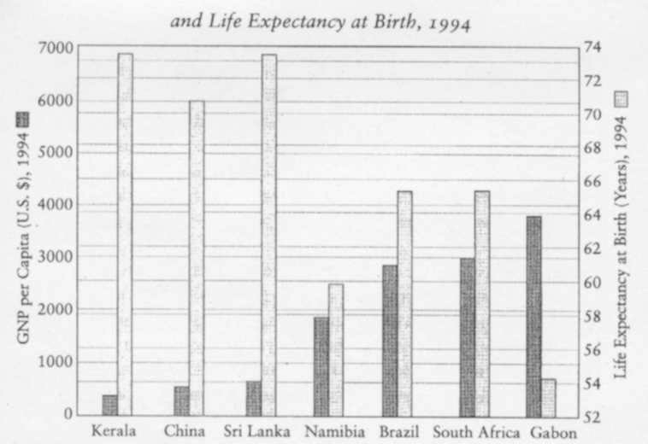
The support-led process does not wait for dramatic increases in per capita levels of real income, and it works through priority being given to providing social services (particularly health care and basic education) that reduce mortality and enhance the quality of life. Some examples of this relationship are shown in figure 2.1, which presents the GNP per head and life expectancy at birth of six countries (China, Sri Lanka, Namibia, Brazil, South Africa and Gabon) and one sizable state (Kerala) with thirty million people, within a country (India). Despite their very low levels of income, the people of Kerala, or China, or Sri Lanka enjoy enormously higher levels of life expectancy than do much richer populations of Brazil, South Africa and Namibia, not to mention Gabon. Even the direction of the inequality points opposite when we compare Kerala, China and Sri Lanka, on one side, with Brazil, South Africa, Namibia and Gabon, on the other. Since life expectancy variations relate to a variety of social opportunities that are central -to development (including epidemiological policies, health care, educational facilities and so on), an income-centered view is in serious need of supplementation, in order a fuller understanding of the process of development. These contrasts are of considerable policy relevance, and bring out the importance of the support-led process.
Figure 2.1: GNP per Capita (U.S. Dollars) and Life Expectancy at Birth, 1994
Sources: Country data, 1994, World Bank, World Development Report 1996; Kerala data, Life expectancy, 1989 - 1993, sample Registration System cited in Government of India 81997), Department of Education, Women in India: A Statistical Profile; Domestic product per capita, 1992 - 1993, Government of India (1997), Ministry of Finance, Economic Survey, 1996 - 1997.
Surprise may well be expressed about the possibility of financing support-led processes in poor countries, since resources are surely needed to expand public services, including health care and education. In fact, the need for resources is frequently presented as an argument for postponing socially important investments until a country is already richer. Where (as the famous rhetorical question goes) are the poor countries going to find the means for "supporting" these services? This is indeed a good question, but it also has a good answer, which lies very considerably in the economics of relative costs. The viability of this support-led process is dependent on the fact that the relevant social services (such as health care and basic education) are very labor intensive, and thus are relatively inexpensive in poor and low-wage-economies. A poor economy may have less money to spend on health care and education, but it also needs less money to spend to provide the same services, which would cost much m-ore in the richer countries. Relative prices and costs are important parameters in determining what a country can afford. Given an appropriate social commitment, the need to take note of the variability of relative costs is particularly important for social services in health and education.
It is obvious that the growth-mediated process has an advantage over its support-led alternative; it may, ultimately, offer more, since there are more deprivations - other than premature mortality, or high morbidity, or illiteracy-that are very directly connected with the lowness of incomes (such as being inadequately clothed and sheltered). It is clearly better to have high income as well as high longevity (and other standard indicators of quality of life), rather than only the latter. This is a point worth emphasizing, since there is some danger of being "overconvinced" by the statistics of life expectancy and other such basic indicators of quality of life.
For example, the fact that the Indian state of Kerala has achieved impressively high life expectancy, low fertility, high literacy and so on despite its low income level per head is certainly an achievement worth celebrating and learning from. And yet the question remains as to why Kerala has not been able to build on its successes in human development to raise its income levels as well, which would have mode its success more complete; it can scarcely serve as a "model" case, as some have tried to claim. From a policy point of view this requires a critical scrutiny of Kerala's economic policies regarding incentives and investments ("economic facilities" in general), despite its unusual success in raising life expectancy and the quality of life. Support-led success does, in this sense, remain shorter in achievement than growth-mediated success where the increase in economic opulence and the enhancement of quality of life tend to move together.
On the other hand, the success of the support-led process, as a route does indicate that a country need not wait until it is much richer (through what may be a long period of economic growth) before embarking on rapid expansion of basic education and health care. The quality of life can be vastly raised, despite low incomes, through an adequate program of social services. The fact that education and health care are also productive in raising economic growth adds to the argument for putting major emphasis on these social arrangements in poor economies, without having to wait for "getting rich" first. The support-led process is a recipe for rapid achievement of higher quality of life, and this has great policy importance, but there remains an excellent case for moving on from there to broader achievements that include economic growth as well as the raising of the standard features of quality of life.
MORTALITY REDUCTION IN TWENTIETH-CENTURY BRITAIN
In this context, it is also instructive to reexamine the time pattern of mortality reduction and of the increase in life expectancy in the advanced industrial economies. The role of public provision of health care and nutrition, and generally of social arrangements, in mortality reduction in Europe and the United States over the last few centuries has been well analyzed by Robert Fogel, Samuel Preston and others. The time pattern of the expansion of life expectancy in this century itself is of particular interest, bearing in mind that at the turn of the last century, even Britain-then the leading capitalist market economy still had a life expectancy at birth that was lower than the average life expectancy for low-income countries today. However, longevity in Britain did rise rapidly over the century, influenced partly by strategies of social programs, and the time pattern of this increase is of some interest.
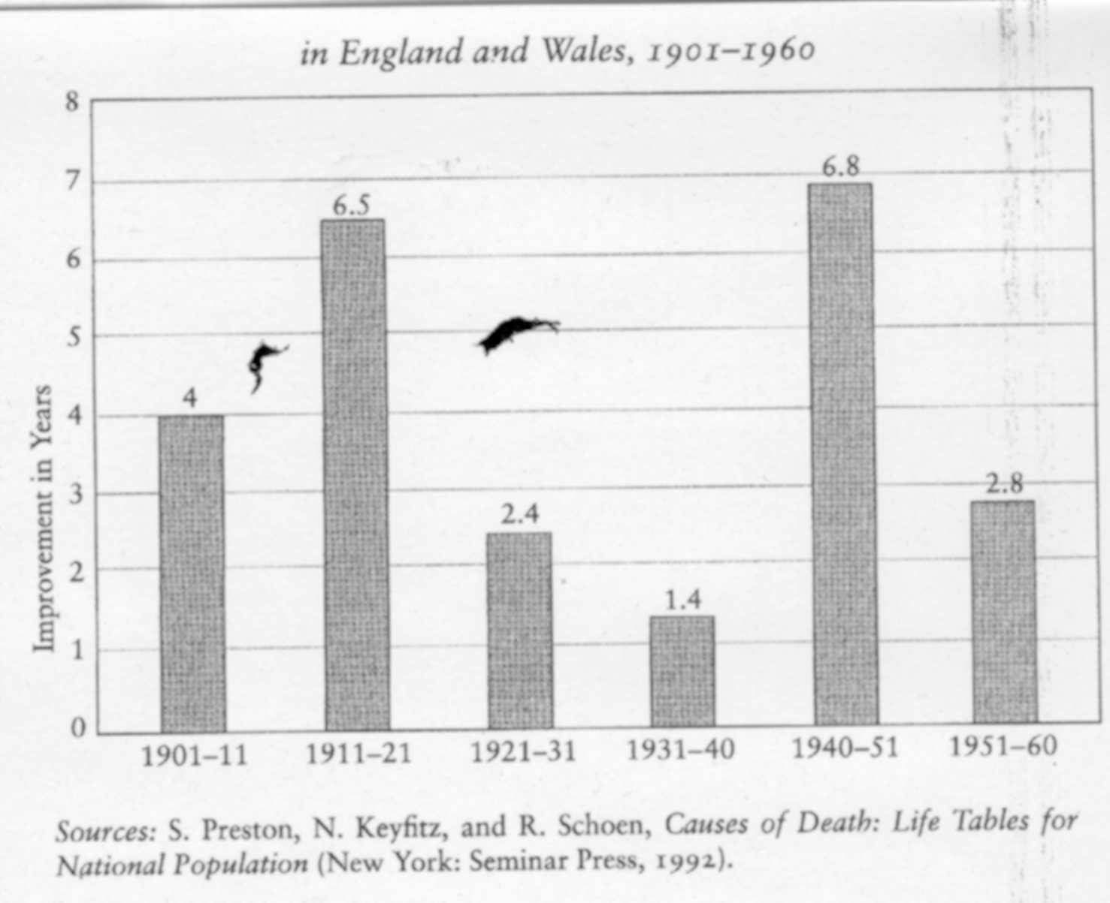
Figure 2.2: Improvements in Life Expectancy in England and Wales, 1901 - 1960

The expansion of programs of support for nutrition, health care and so on in Britain was not uniformly fast over the decades. There were two periods of remarkably fast expansion of support-oriented policies in this century; they occurred during the two world wars. Each war situation produced much greater sharing of means of survival, including sharing of health care and the limited food supply (through rationing and subsidized nutrition). During the First World War, there were remarkable developments in social attitudes about "sharing" and public policies aimed at achieving that sharing, as has been well analyzed by Jay Winter. During the Second World War also, unusually supportive and shared social arrangements developed, related to the psychology of sharing in beleaguered Britain, which made these radical public arrangements for the distribution of food and health care acceptable and effective. Even the National Health Service was born during those war years.
Did this make any real difference to health and survival? Was there, in fact, a correspondingly faster mortality reduction in these periods of support-led policies in Britain? It is, in fact, confirmed by detailed nutritional studies that during the Second World War, even though the per capita availability of food fell significantly in Britain, cases of undernourishment also declined sharply, and extreme undernourishment almost entirely disappeared. Mortality rates also went down sharply (except of course for war mortality itself). A similar thing had happened during the First World War.,-
Indeed, it is remarkable that interdecade comparisons, based on decadal censuses, show that by a very wide margin the most speedy expansion of life expectanacy occurred precisely during those two "war decades" (as shown in figure 2.2, which presents the increase in life expectancy in years during each of the first six decades of this century). While in the other decades life expectancy rose rather moderately (between one year and four years), in each of the two war decades it jumped up by nearly seven years.
We must also ask whether the much sharper increase in life expectancy during the war decades can be explained alternatively, by faster economic growth over those decades. The answer seems to be in the negative. In fact, the decades of fast expansion of life expectancy happened to be periods of slow growth of gross domestic product per head, as shown in figure 2.3. It is, of course, possible to hypothesize that GDP growth has its effects on life expectancy with a time lag of a decade, and while this is not contradicted by figure 2.3 itself, it does not stand up much to other scrutiny, including the analysis of possible causal processes. A much more plausible explanation of the rapid increase in British life expectancy is provided by the changes in the extent of social sharing during the war decades, and the sharp increases in public support for national services (including nutritional support and health care) that went with this. Much light is thrown on these contrasts by studies of health and other living conditions of the population through the war periods, and their connection with social attitudes and public arrangements.

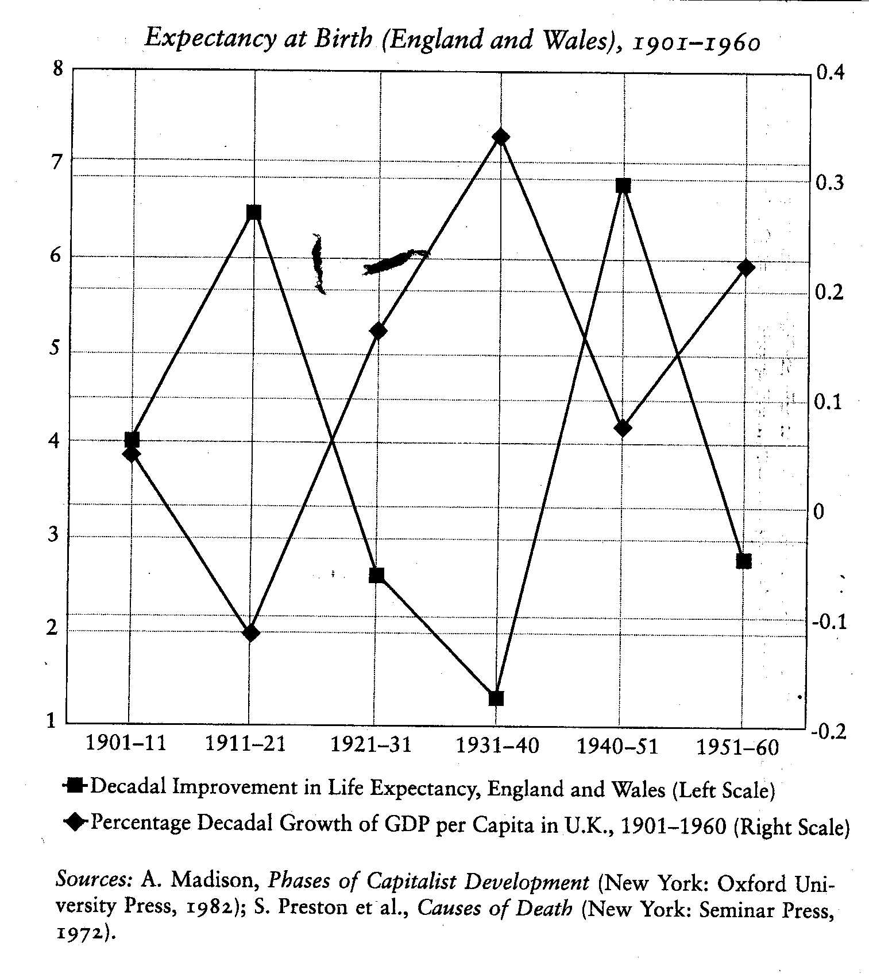
DEMOCRACY AND POLITICAL INCENTIVES
Illustrations of linkages can come from a great many other connections. Let me briefly comment on one more: that between political liberty and civil rights, on the one hand, and the freedom to avoid economic disasters, on the other. the most elementary vindication of this connection can be seen in the fact, on which I commented earlier (in chapter 1, and indirectly - in discussing the China-India contrast - in the present chapter) that famine does not occur in democracies. Indeed, no substantial famine has ever occurred in a democratic country - no matter how poor. This is because famines are extremely easy to prevent if the government tries to prevent them, and a government in a multiparty democracy with elections and free media has strong political incentives to undertake famine prevention. This would indicate that political freedom in the form of democratic arrangements helps to safeguard economic freedom (especially freedom from extreme starvation) and the freedom to survive (;against famine mortality).
The security provided by democracy may not be much missed when a country is lucky enough to be facing no serious calamity, when everything is running along smoothly. But the danger of insecurity, arising from changes in the economic or other circumstances or from uncorrected mistakes of policy, can lurk behind what looks like a healthy state. When this connection is discussed more fully (in chapters 6 and 7), the political aspects of the recent "Asian economic crisis" will need to be addressed.
A CONCLUDING REMARK
The analysis presented in this chapter develops the basic idea that enhancement of human freedom is both the main object and the primary means of development. The objective of development relates to the valuation of the actual freedoms enjoyed by the people involved. Individual capabilities crucially depend on, among other things, economic, social, and political arrangements. In making appropriate institutional arrangements, the instrumental roles of distinct types of freedom have to be considered, going well beyond the foundational importance of the overall freedom of individuals.
The instrumental roles of freedom include several distinct but interrelated components, such as economic facilities, political freedoms, social opportunities, transparency guarantees and protective security. These instrumental rights, opportunities and entitlements have strong interlinkages, which can go in different directions. The process of development is crucially influenced by these interconnections. Corresponding to multiple interconnected freedoms, there is a need to develop and support a plurality of institutions, including democratic systems, legal mechanisms, market structures, educational and health provisions, media and other communication facilities and so on. The institutions can incorporate private initiatives as well as public arrangements and also more mixed structures, such as nongovernmental organizations and cooperative entities.
The ends and means of development call for placing the perspective of freedom at the center of the stage. The people have to be seen, in this perspective, as being actively involved - given the opportunity - in shaping their own destiny, and not just as passive recipients of the fruits of cunning development programs. The state and the society have extensive roles in strengthening and safeguarding human capabilities. This is a supporting role rather than one of ready-made delivery. The freedom-centered perspective on the ends and the means of development has some claim to our attention.

