6 Costs: what the figures say

The Errols are formidably Britannic. They are, for example, both economists. Why both, 1 ask myself? One of them must feel permanently redundant.
Lawrence Durrell 1958

Ideological arguments are made for open learning, economic ones for distance education. lf it can produce similar results to those of conventional education at a lower cost, then distance education has a powerful appeal.
There are grounds for thinking that distance education may have economic advantages. There are two cornerstones to the argument. The educational cornerstone is the theory of media equivalence: that there are no significant differences in the effectiveness of different educational media. A long line of experiment and research has demonstrated this. It began with comparisons between radio and classroom learning in the 1930s, continued through studies of television as it was being introduced into education, and continues today." The consequence is that, if you can learn from print, or from a broadcast or cassette or computer, as well as you can from a teacher, there should be no educational objection to substituting another medlum for the teacher. (There may be social objections to this easy substitution.) If there is no teacher you do not need a school, college, or hall of residence in order to study: educational theory can help us reduce capital investment. The economic cornerstone was laid by Adam Smith and tapped into place by Henry Ford. Distance education allows a new division of labour, in which a group of teachers and producers manufactures teaching material, an organisational machine distributes it, and another group provides a minimum of individualised tutorial support to the students. Economies of scale become possible, provided there are enough students to justlfy the manufacturing cost of the first group and student contact is kept down in order to contain the costs of the second.
While open and distance learning has relied on the strength of this case, it provokes a set of questions. Does the evidence in fact support it? lf it does, are there economic arguments for using one approach within open and distance learning rather than another? Do the economics of open and distance learning influence the pattern of funding? All but the last of these can, in principle, be answered by cost-effectiveness analysis in which we compare the costs of different approaches to achieving the same result. To fill out the picture, we might want to go on to cost-benefit analysis in which, as well as comparing the costs, we compared outcomes in financial terms. In principle cost-benefit analysis would enable us to compare the economic value of - say - investing in more secondary education or in strengthening agricultural extension by discovering the financial value that could be attributed to each investment. In practice, there are severe difficulties in using cost-benefit analysis within education and, with minor exceptions, few attempts have been
made to go down this contentious road.
To answer the first question we need to compare the cost of open and distance learning with that of conventional education, overcoming practical, technical and sociological difficulties as we do so.
The main practical difficulty is a shortage of data. Managers are seldom interested in economic analysis; they want to make the best use of their own budget rather than compare it with somebody else's. Governments and institutions are often interested in only part of the story. International agencies blow bot and cold. The World Bank and UNESCO carried out a series of case studies between 1975 and 1985 (jamison, Klees and Wells 1978; jamison and McAnany 1978; Perraton 1982; UNESCO 1977, 1980, 1982), the Commonwealth Secretariat and the Commonwealth of Learning followed this with some work on teacher education between 1990 and 1993 (Perraton 1993), and the European Commission has funded some work within the European Union more recently (Hülsmann forthcoming; Perraton and Hülsmann 1998) but funds and data have since tended to dry up. As a result we have a modest number of cost studies that use a standard approach, and a larger number of partial accounts that are often methodologically less rigorous. They help fill out the picture but are often of limited value because they concentrate on recurrent costs and leave aside capital costs. As noted in chapter 5, where institutions have made data avallable about their students and their costs, they have often omitted any data about graduation rates. Without these we can compare costs per student but not costs per graduate.
The technical difficulties follow. Conventional and distance education are likely to make different use of capital so that, unless we have a sense of the amount of capital needed for either approach, only limited conclusions can be drawn. (Where data are avallable, Information is needed about the discount rate that is to be used in calculating an annual cost.) Where there are detalls of expenditure across a number of years, or a number of countries, costs need to be converted to a standard currency in order to make comparisons. In principle this should create no major problems. In practice, arbitrary but necessary decisions can have a large effect on the costs. lf, for example, we are looking at costs in Cöte d'Ivoire for a financial year 1993-94, international comparisons of the cost will be affected by use of the 1993 conversion rate of 50 CFA francs to one French franc or the 1994 rate of 100.
Sociological factors make it difficult to compare like with like. lf, to take the simplest example, we wanted to compare the cost of educating twenty people to degree level at an open university and at a conventional one, we would want to ensure that the two cohorts were similar in age and educational background and, lf possible, in economic circumstances and motivation. But the real world is not like that: students at a distance tend to be studying part-time, not whole-time; often they are older; quite often they are poorer or live in more remote places; those with the best educational record tend to go to conventional universities and those who have done less well in their school examinations to the open university.
The costs of distance education tend to behave differently from those of conventional education. One major difference is that distance education may make it possible to expand education without investment in bulldings: open universities need headquarters, and may need local centres, but do not demand a programme of campus building commensurate with the number of students they are to teach. A second major difference lies in expenditure on staffing. Generally, staff costs, which dominate educational recurrent budgets, rise with student numbers and are held back only by uncomfortable expedients such as cramming more into a classroom or introducing shift teaching. (There are still limits to hot-seat classrooms.) Distance teaching can hold down expenditure per student but needs a higher investment in course development. Academic staff, broadcasting producers, educational editors and printers all need to work and be pald in order to produce good texts and programmes. This increased expenditure can be justified by the economies of scale that are made possible: large numbers of students can use the same material, or listen to the same broadcast, and the same materials may be used for a number of years. A higher proportion of the costs of distance education tend to be fixed, and a lower proportion to vary with the number of students. As the number of students on a course increases, so the cost per student declines, something that does not happen with classroombased education.
To examine the economics of distance education, and make sound comparison with alternatives, its fixed and variable costs need to be examined. Fixed costs are those that remain the same regardless of the number of students, for items like the cost of the headquarters and material development, while variable costs are those that vary with the number of students, notably tutorial costs and some of the costs of printing and distribution. The total cost of a distance-education project is made up of the fixed cost together with the variable cost, that has to be met for each student, multiplied by the total number of students. With a large enough body of students, high fixed costs for making television programmes for example - can be l'ustified because they are spread over such a large number of people.
We have just enough data to use this approach and reach some conclusions about the comparative cost effectiveness of open and distance learning in the four sectors of education discussed in chapters 2 to 5.

BASIC EDUCATION

The difficulties in reaching conclusions are at their most extreme in looking at basic education, where there is the most severe shortage of data and costeffectiveness analysis is most difficult to apply. It lends itself to comparing the costs of teaching a student or producing a graduate, on- and off-campus, or of looking at the consequences of using radio or television as a component within a course. In applying it to basic education, especially for adults, we have no obvlous point of comparison. The rural education project in Pakistan (chapter 2), for example, was not like anything else that was happening in Pakistan at the time so that comparisons with alternatives are arbitrary and difficult. Primary schools give one possible point of reference: there is an overlap between the content of some basic education offered at a distance, and some primary education. But there is a lot that is different: you could not in practice expand adult basic education by sending all adults to school. Where the content of basic education programmes is also offered in residential or face-to-face centres it may be possible to use their costs as a comparatot. In other cases, distance-education approaches may be compared with those of conventional extension agencies.
Early studies reached one important conclusion about radio. lt was used, in a series of projects in Africa and Asia to support group meetings with project titles like 'radio farm forums'. Most of these fell away and remain, lf at all, as an occasional footnote in a ministry annual report. At the same time radio has continued to be used to support the work of agricultural and health extension. Because of its large audiences, and modest production and transmission costs, the cost per listener tends to be very low. A study in Malawi found that, in 1980 currency, it cost K956 ($2269) to produce one hour of broadcasting. For about $260 000 ($514 280) per year Malawl was reaching 300 000 farmers a year by radio for 41/2 hours a week (Perraton et al. 1983: 175). The cost per unit hour per listener was less than half a cent.
Four other sources of data make it possible to reach some general conclusions. The first source is the radio school movement of Latin America, offering basic education to adults, using radio and print, and supported by a network of animateurs. Cost studies were made of two radio schools ACPO in Colombia and Radio Santa Maria in the Dominican Republic which were using similar methods to offer a primary equivalence course to adults. ACPO had 170 000 students and Radio Santa Maria 20 000. With such a large body of students, ACPO's costs fell below those of conventional primary schools in Colombia while Radio Santa Maria's costs were comparable to those of regular schools, and lower than those of evening classes organised for adults. Costs for radio schools were, in 1978 currency, between $20 and $35 ($50-88) per student per year (Perraton 1984: 170). 21 These are unusual findings and, with reduced enrolments since then, radio school costs have probably risen in real terms.
The second source consists of detailed figures which are available for a radio education campaign in Zambia. These suggest the level of cost that may be expected for a short, intensive programme of radio education. Students worked in groups to follow radio programmes and printed Materials about the cooperative movement in a campaign designed to encourage active membership of cooperatives. An audience of just under 5000 attended ten weekly meetings in the slack agricultural season of August to October 1982. The cost per participant was, in 1977 currency, $8 ($22). The cost of teaching the same material in a farmers' training centre was over three t'mes as great at $27 ($72). Primary-school costs were then $55 ($147) so that, measured in terms of costs per student learning hour, the cost of the campaign was significantly greater than the cost of primary education (Perraton 1984:231-5). Again, the costs of radio broadcasts formed a small proportion of th e total expenditure.

Third, INADES-formation and AMREF glve us similar findings about the significance of using distance-education methods for training extension workers. As reported in chapter 2, a cost study of the work of INADESformation in Cameroon found that the cost for each student who was using correspondence lessons and attending three seminar sessions was, in 1977 currency, $365 ($981), although there is some reason to think that it may have fallen significantly since then, perhaps to arourid $235. This cost is high in comparison with much basic education and, indeed, with many other distance-education projects. But INADES-formation was training agricultural extension staff as well as farmers. lf its approach is seen as a way of raising the effectiveness of these staff, the costs look more reasonable. The figures from AMREF (chapter 2) bear this out - its costs per successful student were KSh8500 ($155) in 1996 - a figure that needs to be seen in the context of the multiplier effect of training rural health workers.
The fourth set of figures are from the Functional Education Project in Rural Areas (FEPRA) in Pakistan with a cost per learner of £35 in 1985 currency ($46) for eight meetings. Again, this compares unfavourably with the cost of primary schooling at some $31 per student but may well compare favourably to other approaches to adult education.
The figures are summarised in table 6.1. Three conclusions follow. First, where we are able to make comparisons, the cost of distance education for adult basic education generally compares favourably with other methods but unfavourably with the cost of primary education. The radio schools of Latin America were a rare exception, offering something like primary education at competitive costs. The costs of radio are so modest that its comparative educational neglect is puzzling and disturbing. But, second, the costs of much distance education are such that it is difficult to see how basiceducation projects could be replicated on a national scale.
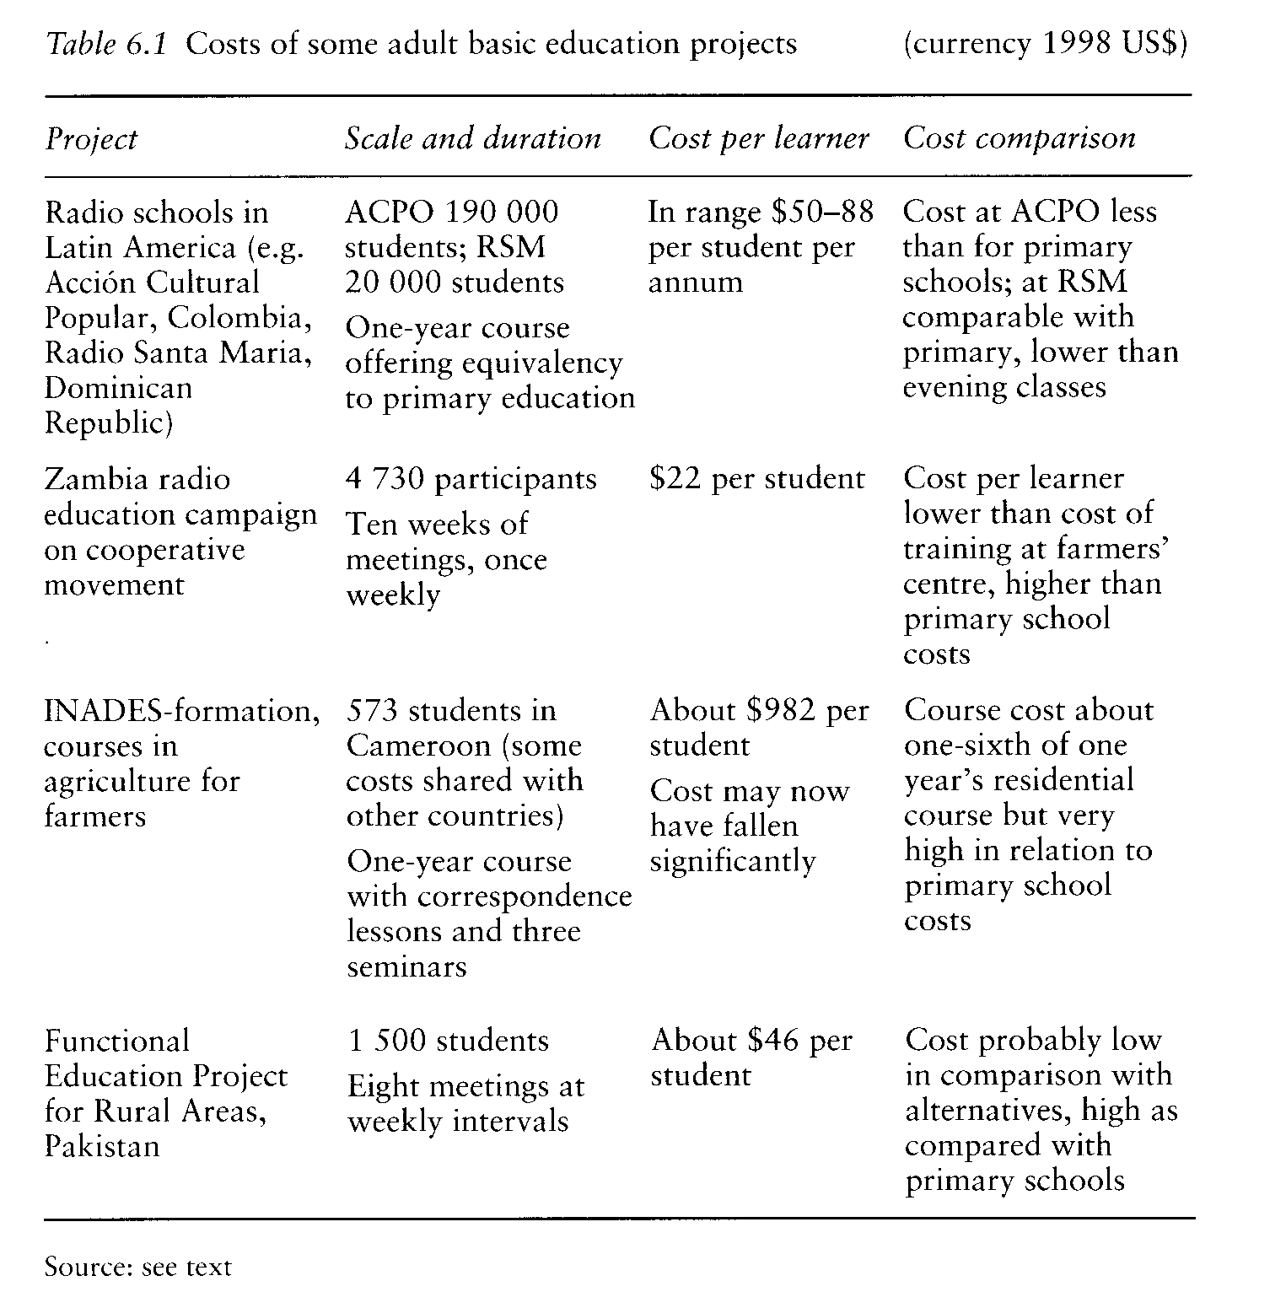

Where distance education has been used for basic education, its success has depended on providing student support along with the use of mass media. Different strategies have been used to mobilise that support: rellgious structures were used for this in Latin America, polltical in the case of the radio campaigns in Tanzania. Running a functional education project throughout Pakistan would have needed a comparable support structure. All of these put up the variable costs of projects, reducing the possibility of achleving economies of scale. Third, the experience of INADES-formation and AMREF, on opposite sides of Africa, suggests that there may be powerful arguments for using distanceeducation techniques as one element in inservice training for field workers. This, rather than direct education to adults, may be the most promising way forward.

SCHOOLING

There is a stark distinction between the costs of two approaches to using open and distance learning for schooling. Where it is used to offer an alternative to schools, we may expect the cost per student to be lower. Most of the evidence comes from ministries of education whose interest in open and distance learning is to provide an alternative to school: generally they are not interested in alternatives that cost more; it makes sense to bulld more schools instead. Projects that use broadcasting, or some other technology such as computers to raise the quallty of schools, are likely to raise costs; they have seldom been introduced with the intention of ellminating staff costs and therefore generally amount to an add-on cost.
Out-of-school prolects tend to have lower costs than conventional schools, even where they are offering something like full-time school equivalence, because both salary and accommodation costs are lower.
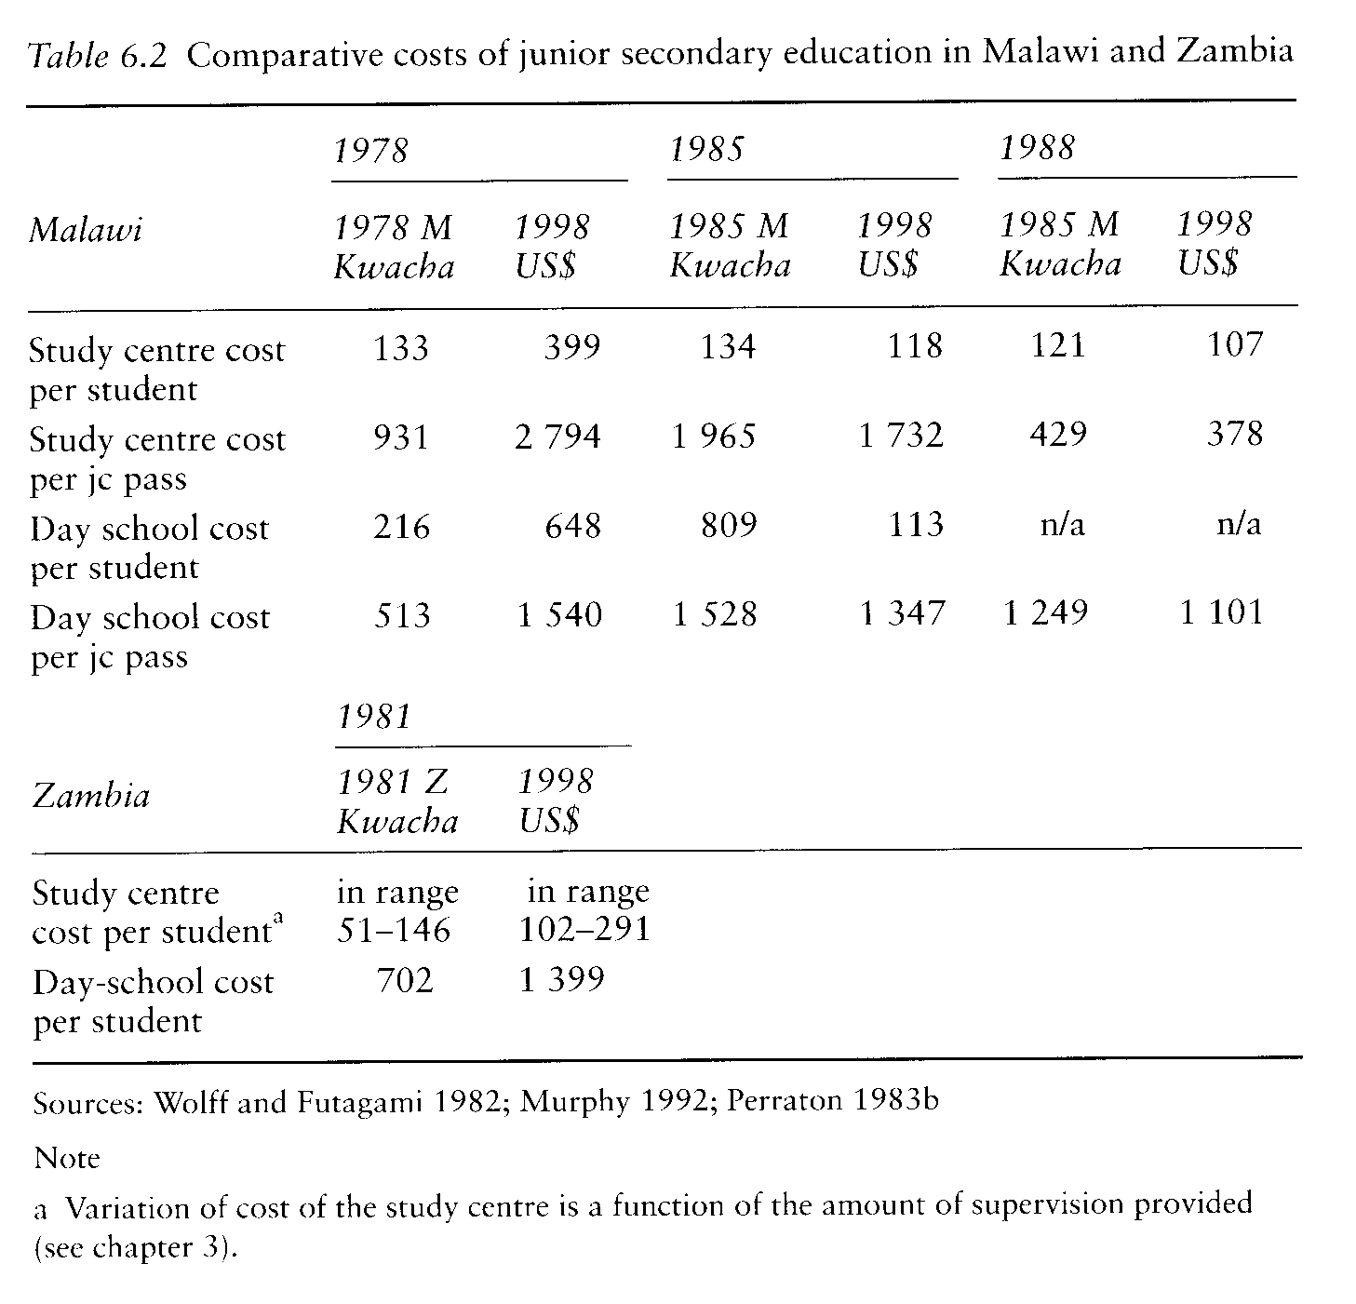

By employing unqualified or underquallfied monitors rather than tutors, it is possible to hold down staffing costs and, with adequate numbers, meet the costs needed to generate teaching material. In Malawi and Zambia, for example, as shown in table 6.2, the cost per student at correspondence centres was always lower than the cost in regular secondary schools. But, as noted in chapter 3, the lower examination pass rate meant that, in 1978, the cost per pass was higher at the correspondence centres. A remarkable improvement, coupled with an increase in student numbers, meant that ten years later the correspondence centres were at an advantage in terms of cost per pass as well as cost per student. In Zambia, where costs per pass were not available, it was estimated that the cost per pass between the two sectors would be about the same lf the correspondence centres had a successful completion rate of between 5 and 14 per cent, with the figure varying with the level of student support provided (Perraton 1983b: 11-12)
The data in table 6.3 show how costs compare generally with alternatives where we have information. Where there are time series of data, there appears to be a trend of declining costs in the 1980s in Africa and in Mexico, probably reflecting the economic decline of the decade. Most, but not all, of the projects show lower costs per student than the conventional alternative. In Brazil, for example, two projects were developed to offer an alternative form of junior-secondary schooling, both using radio with relatively high fixed costs for making programmes. The project in Bahia, which was operating in a single province, had costs per student higher than those of alternatives whereas the national Minerva project, with larger student numbers, was able to justlfy the broadcasting cost. When, however, we look at costs per successful student the picture is more mixed.
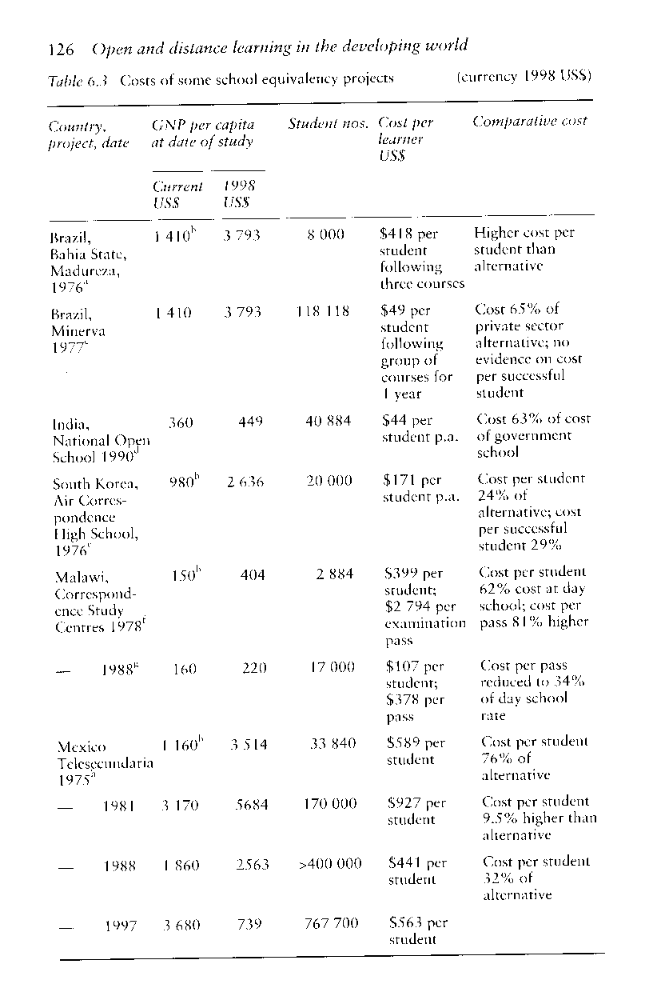

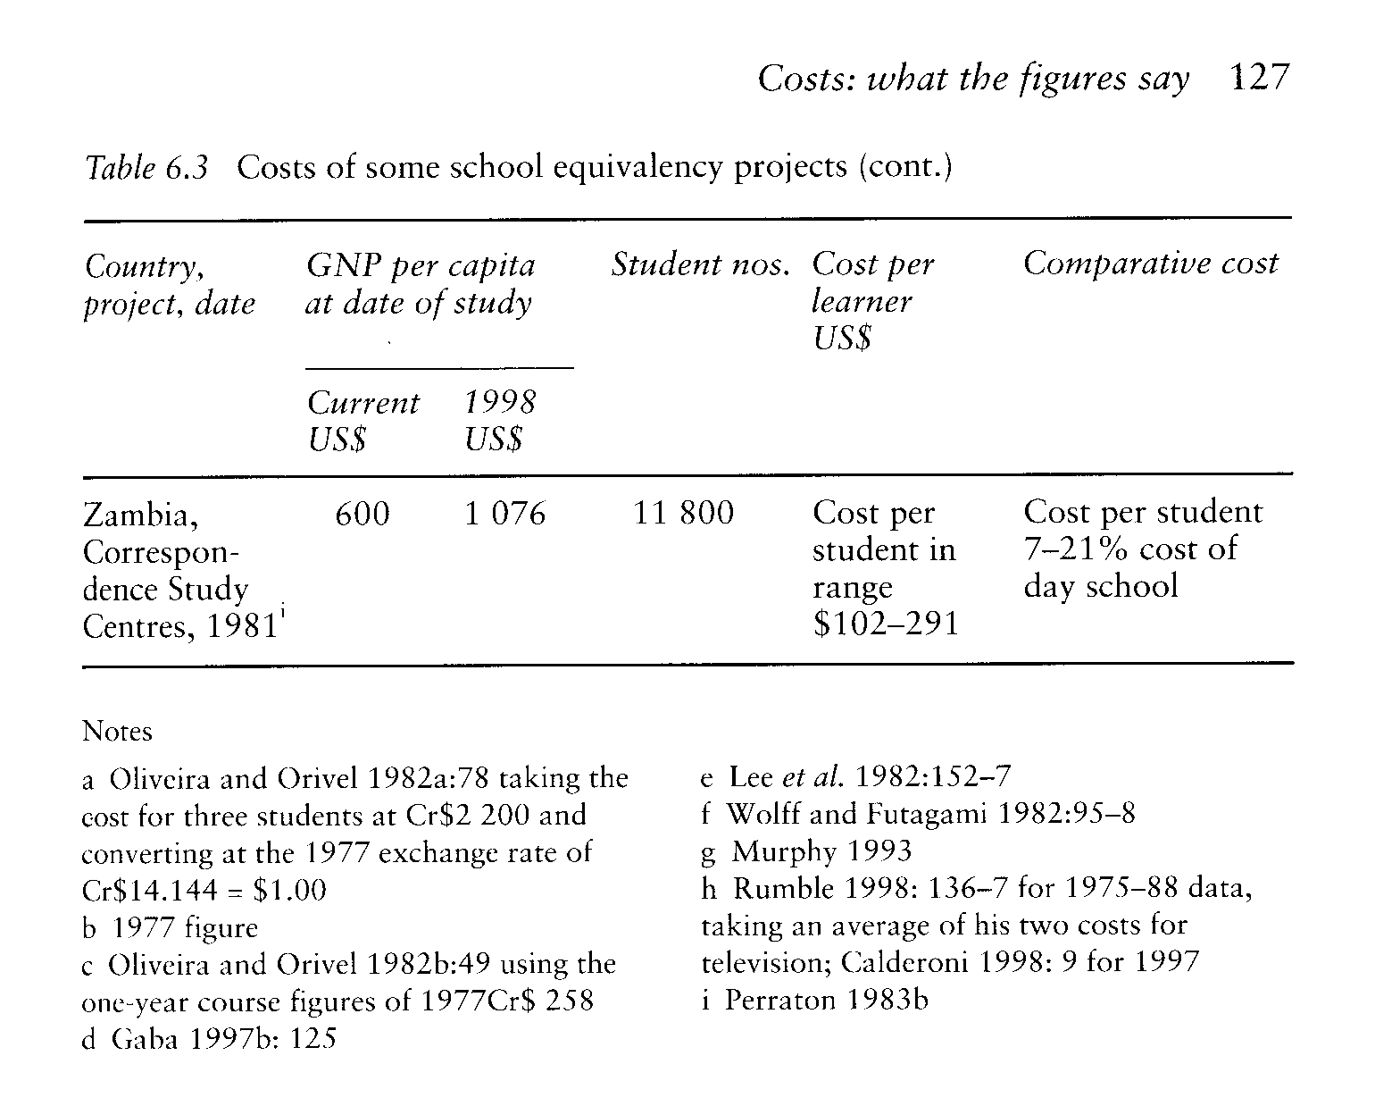

With academically poorer students and worse learning conditions, examination success rates tend to be lower for students following alternative rather than regular courses. The exception is in Korea where students worked with such diligence that the cost advantage remained even when measured in terms of cost per examination success.
We have only limited data on the costs of using technology to raise the quallty of teaching within schools. Costs are available for the original interactive radio project in Nicaragua. Costs for some of the later IRI prolects are set out in table 6.4. (The later study by Adkins (1999) suggests that many of these figures are likely to be under- rather than over-estimates.) They do, however, still bear out the contention of interactive radio's proponents that its costs are modest as compared with government expenditure per student, at between 1 and 2 per cent of the total cost in three of the cases, and much less than that in South Africa, where there is a much higher level of existing expenditure per student. But this is only part of the story: the fixed salary bill often makes up around 90 per cent of the total budget so that these figures would need to be multiplied by ten lf they were to be seen as a fraction of the budget for curricular support and materials. The evidence suggests that the costs were often not seen as sustainable by ministries of education once external funding was withdrawn.
Computers have been introduced into classrooms for a variety of reasons, discussed in chapter 3. As with radio, Computers make for add-on costs and do not replace teachers. We have two sets of cost data, both from Latin America. One found that 'computer prolects are generally expensive educational inputs which can cost, on a per student basis, 50 per cent or more of what countries are currently spending on all education inputs' (Potashnik 1996: 10). A more detailed study in Chile found that costs per student varied with the size of the school, as larger schools could allow more students to use each computer. Total costs, in 1995 currency, varied from $21 ($22) in a school of 1000 students to $78 ($83) in a school of seventy-five students. These figures are between 5 and 18 per cent of national recurrent expendlture per student at secondary level and between 10 and 37 per cent at primary level (ibid: 14-16).
We can summarise that open and distance learning methods can offer secondary education at lower unit costs than the conventional but that it is rarer for them to achleve competitive costs per successful student. Where educational technology, whether as simple as radio or as sophisticated as computers, has been used to enhance education rather than to provide an alternative, its costs are additional to those of regular schools. If these technologies are to be used, they need to demonstrate an educational value that justifies the extra cost.

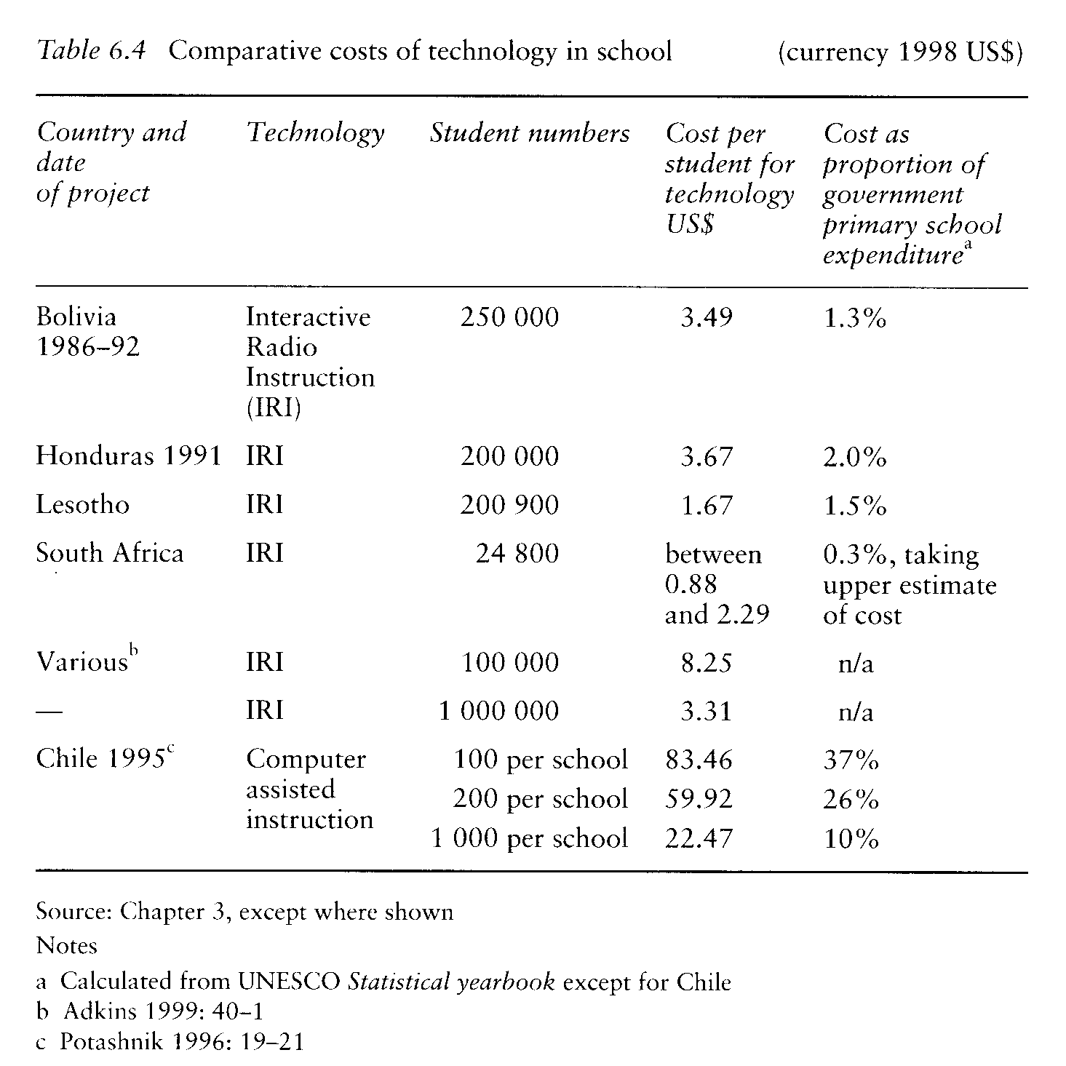

TEACHER EDUCATION

As we saw in chapter 4, a number of distance-education projects have shown economies as compared with the costs of conventional education. The data from a set of projects, where costs were analysed in a standard form, are shown in table 6.5 (see page 130). They confirm that, with the relatively high completion rates often achieved in teacher education, costs per successful student tend to compare favourably with those of conventional education. This differential holds true both for projects with quite modest costs per student, reflecting limited student support, as in Pakistan, and those with relatively high costs incurred for extensive student support and supervision of classroom practice, as in Tanzania.
The costs need to be seen in the context of teacher education generally. In countries where it has been treated in much the same way as higher education, conventional teacher education tends to have relatively high unit costs. These may be out of proportion with the costs of secondary education even where the curriculum is similar. The comparative cost advantage of some uses of distance education is a reflection of the relatively high cost of conventional teacher education.
Some projects were probably too small to show economies of scale. With enrolments of between 500 and 3000, the experlence of the Universities of Lagos and Nairobl is equivocal about the economic advantages of using distance education. In Uganda the Mubende Integrated Teacher Education Project pro'ect with 900 enrolments probably had higher costs than a notional alternative - but had the merit of keeping the teachers in the schools - while the later Northern Integrated Teacher Education Project, with 3000 students, had costs that compared favourably (Wrightson 1997). We have few reliable figures on costs for the early African teacher-education projects.
An earlier review emphasised two other factors that were signifikant in affecting costs.

Where extensive support was provided to students, or arrangements made for thorough supervision of their teaching practice, the variable cost of programmes was relatively high; supervision and support costs necessarily rise in proportion to the number of students so that economies of scale are not possible. The upgrading programme in Tanzania and the B.Ed. programme in Kenya, for example, had fairly high variable costs for this reason. In contrast, NTI in Nigerla provided rather less support to students and in consequence showed much lower variable costs per student. ...
In order to interpret the cost data we [also] need to consider the opportunity cost of study. As the Kenyan and Nigerlan degree studies show, in addition to paying fees to their universities, these students could have used their study time to earn from part-time employment so that they had to ,meet actual opportunity costs in terms of foregone earnings. ...
There may be a policy implication here. Historically, teacher upgrading programmes have often been offered free to students. They have attracted students, and maintained their interest, where they have offered improved status and increased pay on completion. Degree programmes like those in Kenya and Nigeria, however, have generally charged fees to their students. There is, in consequence, likely to be a point at which the opportunity cost, as perceived by an economistminded student, combined with the actual cost of fees, will outweigh the uncertain and future increase in income to be expected on graduation. Part-time education may be expensive for students in various ways as well as hard work.
(Perraton 1993: 388-9)

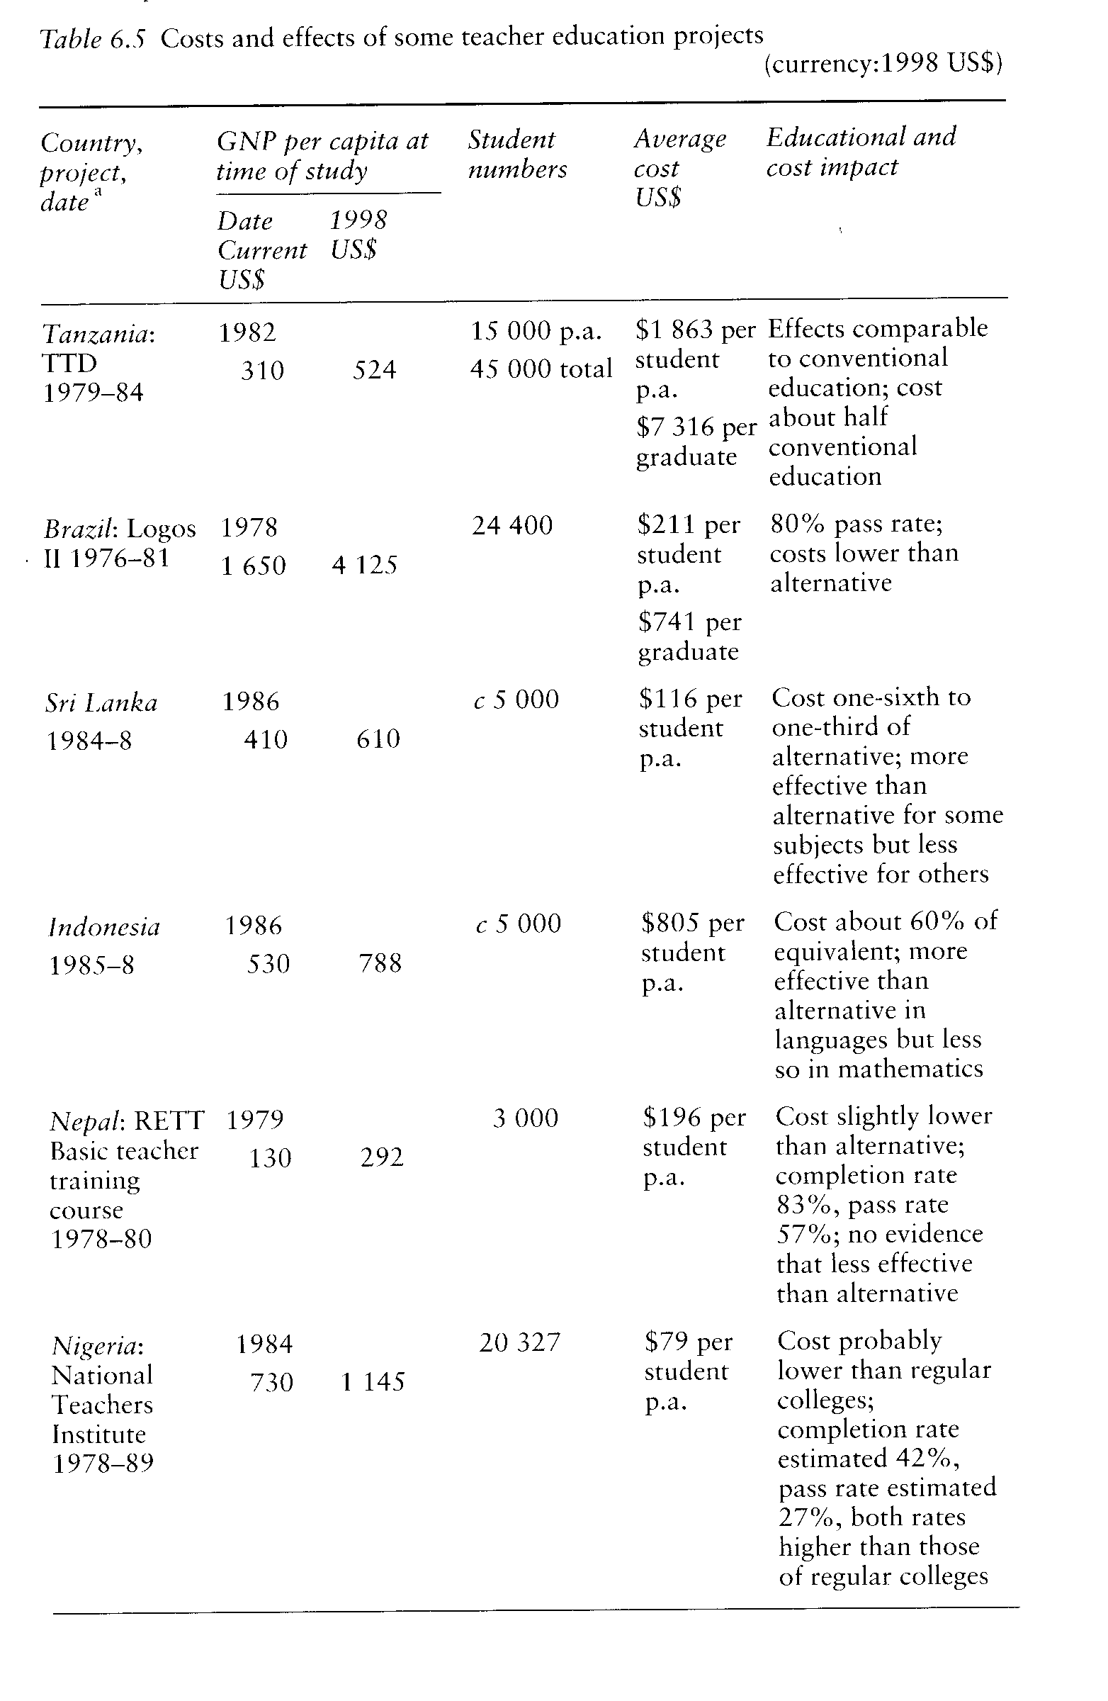

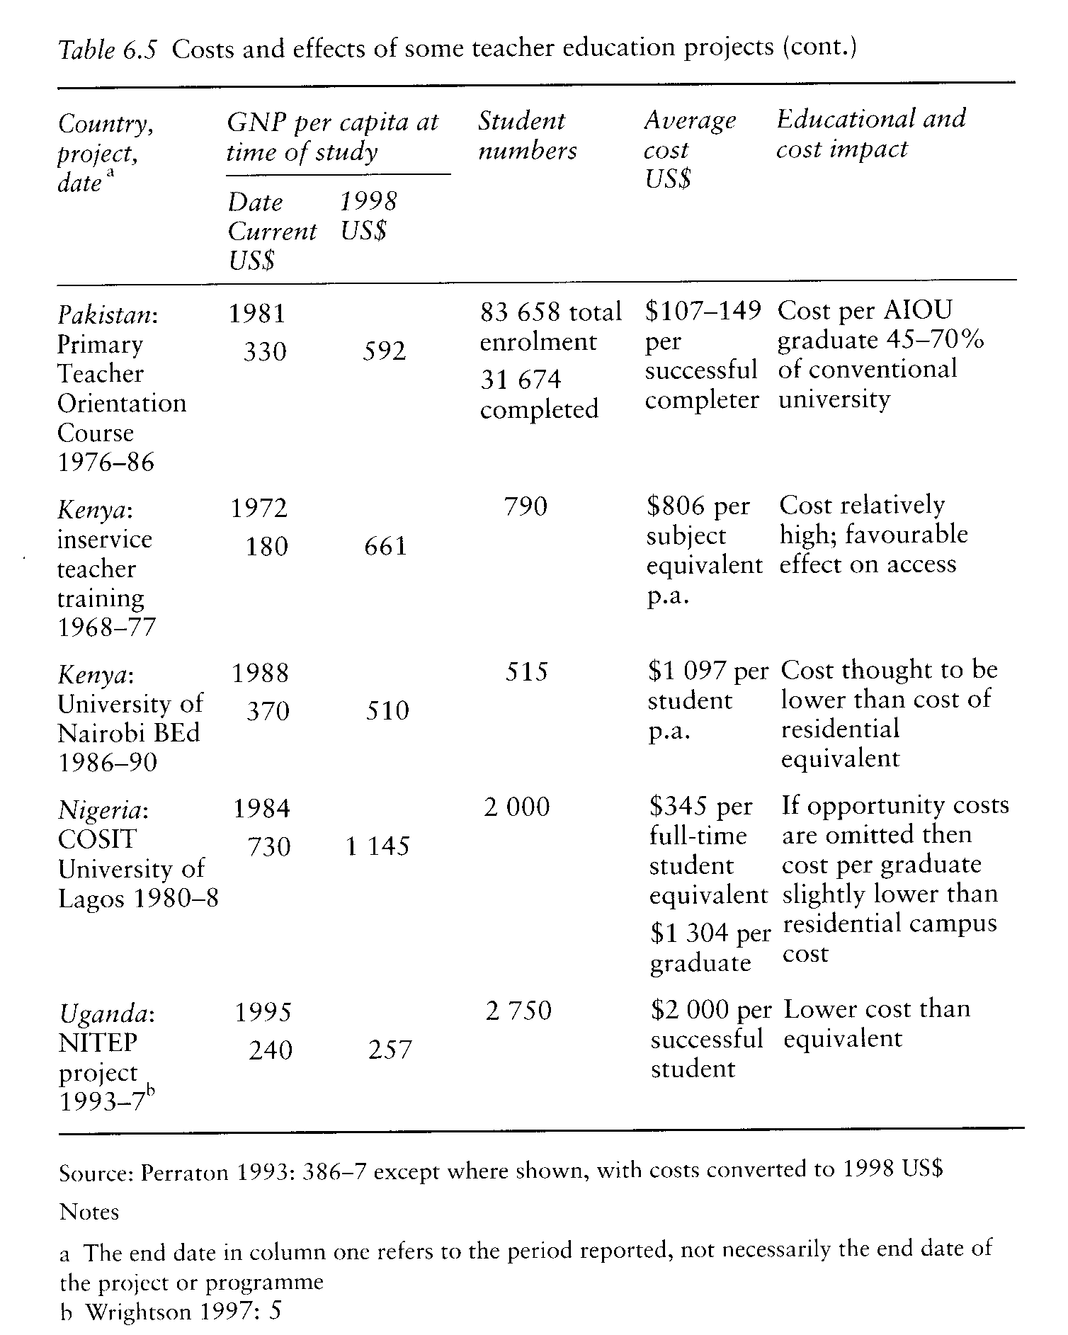

With these quallfications, we can treat the economic case for using open and distance learning in teacher education as fairly robust, with projects achieving costs per successful student at between a half and two-thirds of those in conventional education.

HIGHER EDUCATION

There are surprisingly few rigorous cost studies of open and distance learning in higher education. Where data are available, they tend to be for recurrent expenditure only. While this means that they tend to understate the cost advantage of a non-residential university, many reports give costs per student rather than per graduate, which may therefore overstate the cost advantages, at least lf effectiveness is measured in terms of producing graduates.
Reports on open universities tend to show that they have lower costs per student than conventional universities. The Chinese television universities are the supreme, and largest, example. Their recurrent cost per student was between 25 and 40 per cent of that for conventional universities. The reduced cost reflected both a less generous staffing ratio and lower costs for building space. The universities were operating at a scale that justified the necessarily heavy costs of broadcasting over 5500 hours of television a year.
Other Asian open universities have reported costs per head that compare favourably with those of the conventional sector. In Korea the cost to the government of the (then) Korean Air and Correspondence University in 1990 was US$93. Student fees made up half the income of the university which suggests an annual cost per student of $186 ($232). The cost of a conventional university place was than $2880 ($3591) (Kim 1992: 38). Early figures from STOU suggested that the annual cost per head was between 21 and 30 per cent of the cost of conventional universities (US$152-221 in 1986 prices ($226-329) and between $589 and 1010 ($1280-1502) at conventional universities (Wichit 1985: tables 14 and 15)." Later figures from India show that Dr B R Ambedkar Open University - the longest established open university in India - was operating at about 15 per cent of the cost of conventional universities while the, then smaller, Indira Gandhi National Open University had costs of around 40 per cent of the conventional sector (see table 6.6 on pages 134-5).
Where they are avallable, figures from dual-mode universities also show costs per student lower than in the conventional system. In India, a study of the costs for correspondence departments in 1980 suggested that their costs were only 15 per cent of conventional departments while a review in 1988-89 found a range of figures from as low as 1-2 per cent to 23 per cent (Ansarl 1994: 81). Many dual-mode universities in other countries have smaller student numbers than the Indian correspondence departments, but costs per student still tends to be lower than that of conventional departments. At the University of Nairobl, for example, the cost per head of a residential BEd (neglecting opportunity costs) was nearly three times the cost of the course offered at a distance, with a cost per head in 1988 of $808 ($1113) as compared with $3000 ($4134) (Makau 1993: 331).
But this is only half the story and low completion rates can erode the cost advantage lf we compare costs per graduate rather than costs per student.
Again, the evidence from China is clear and positive about the strengths of distance education. The high completion rates there suggest that costs per graduate for the television universities remain below those of conventional universities. Successful completion rates in the late 1980s were more than 80 per cent so that costs per graduate were reported as being 35 per cent of the cost for conventional universities in economics, 29 per cent in humanities and 41 per cent in science and engineering (Ding 1994: 160).
Evidence from other countries is more equivocal. As noted in chapter 5, we are short of data from India on graduation rates, which makes interpretation difficult. lf we neglect dropout rates, then, between 1989 and 1992, it would cost about Rs6000 ($417 at 1990 exchange rates) for IGNOU to produce a graduate with a bachelor's degree as compared with Rs15 000 to 18 000 ($1042-1251) in the conventional system (Kulandal Swami and Pillai 1994: 80). In a further analysis, Naldu went on to consider the effect of differential dropout rates on the cost per graduate at IGNOU. Assuming no dropout in conventional universities, IGNOU's cost per graduate would still be lower than the alternative even if only 40 per cent of its students graduated. But Naidu goes on to caution 'that there is a possibility that distance education may prove to be costlier than conventional education [because ofl high wastage rates, and therefore more empirical research may be necessary' (Naidu 1994: 65-6). lt looks a real possibillty: using Naidu's averaged cost of Rs16 428 per graduate in the conventional system, lf the wastage rate there was 20 per cent, and that in IGNOU 71 per cent, the distanceeducation cost would be higher. And, from the figures in chapter 5, it seems that wastage rates for degree courses between 80 and 90 per cent can often be expected.
Figures from Korea are consistent with this pattern. Following Kim's analysis (1992), lf KACU students took eight years to graduate, with a graduation rate of 12 per cent, the cost per graduate would be some $15 200, a higher figure than the cost of three years at conventional university lf we assume that it achleved a graduation rate of 80 per cent, giving a total cost of $13 253. An estimate of the costs per graduate at the University of Lagos was more optimistic than this. Provided there was an 80 per cent graduation rate for students in education or 50 per cent in business studies and students completed their courses within the minimum period, then costs would be lower than for regular study. lf students took eight years to complete, then costs in education would remain slightly below those of the alternative but would be 40 per cent higher in the case of business (Cumming and Olaloku 1993:
375).
The subsequent history of two open universities, where we have detalled early cost studies, confirms that it has been difficult to achieve planned savings in the cost of producing graduates. At the Universidad Estatal a Distancia of Costa Rica, the cost per student in 1980 was lower than that of conventional universities while the cost per credit, on the basis of which one could calculate an eventual cost per graduate, was roughly comparable.

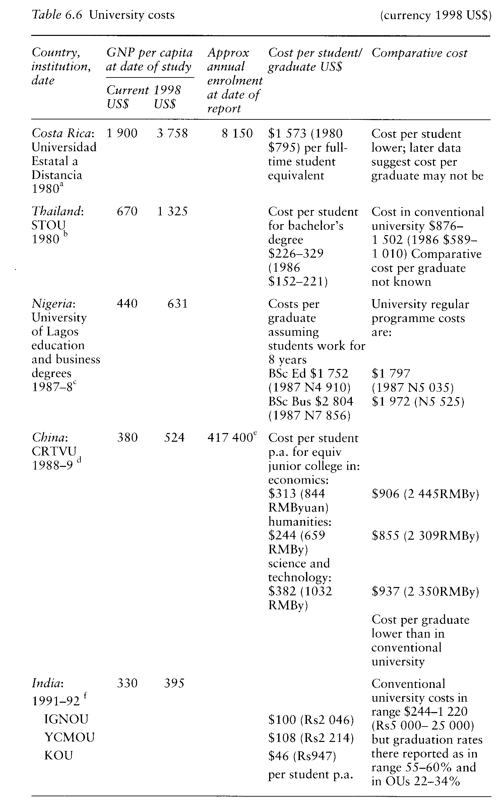

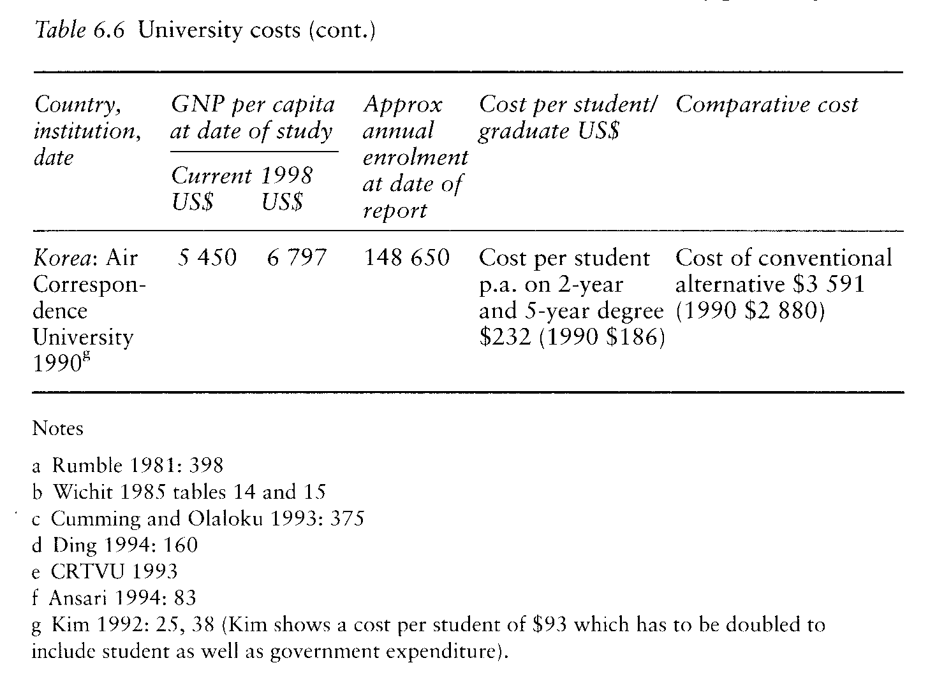

A cost study forecast that student enrolments might reach 15 000 to 17 000 (Rumble 1981: 379) and that, subiect to containing the dropout rate, the university had the 'potential for achieving greater economies of scale' (ibid: 399). A later study (see chapter 5) suggests that both forecasts were overoptimistic. Enrolments stabilised at around 10 000 while the dropout rate reached at least 84 per cent (Ramirez 1994: 69-72). While we have no later cost study, it seems most likely that the cost per graduate is now higher than in the conventional system. There is the same contrast between early hope and later achievement in Israel. Here, an early study forecast that Everyman University (now the Open University of Israel) would have about 6700 studying in any one year once it had reached a steady state, and a graduation rate of 37.5 per cent, glving a cost per graduate of $3600 ($9684). Degrees from universities with a comparable mix of subiects had a cost of $6000 to 8000 ($16 140-21 520) (Melmed et al. 1982: 236-7). While by 1992-3 the university was bigger than forecast with 19 000 students, graduation rates appear to have been much lower than forecast with only 405 graduates that year. Costs per graduate now appear to be higher than those at conventional universities, possibly as high as NIS195 487 ($92 487)."
The simple conclusion is that, while open and dual-mode universities are achleving lower costs per student than conventional ones, they may not always have favourable costs per graduate. If we regard their function as being to expand the production of graduates, then the economic case for using distance education would be strengthened if they could increase the efficiency of their teaching systems and raise their graduation rate. On the present figures, the economic case for investing in open and distance learning as a means of producing graduates is by no means well-established.

DETERMINANTS OF COST

There may be a social, polltical or educational case for using open and distance learning separate from any economic one, and we come back to the polltical case in chapter 9. In Australia, distance education was developed for school children because of a commitment to educating children in the bush, and a recognition that the political system made rural constituencies electorally important. The cost of the schools of the air was relatively unimportant. The same idea was carried across into higher education so that Australian orthodoxy insists that the same resources should be applied to students onand off-campus. As part-time off-campus students have lower completion rates than full-time on-campus students, the costs of graduation at a distance are higher than they are on campus. With that rare exception, governments and universities have usually approached open and distance learning in the expectation that it would have economic advantages. To estimate those advantages it is necessary not only to ask about global costs per student and per graduate, but about where the costs will fall, and how, if at all, economies can be found.
Some economies, from the standpoint of the funding agency, come because open and distance learning represents a way of diverslfying educational funding and getting students to pay a higher proportion of the cost. (We come back to this in chapter 9.) Others come from the cost structure of distance education. This may bring economies by allowing reductions in capital and in recurrent expenditure. The savings on capital expenditure arise because of reduced building costs for distance-teaching institutions and, especially, because they avold the need to build residential accommodation, and may allow cheaper buildings. The study centres of Malawi and Zambia, for example, cost less than normal school bulldings. The development of open or dual-mode universities also makes it possible to make more intensive use of the existing capital locked up in buildings: there are at least notional savings lf university classrooms or laboratories are used by part-time students during regular university vacations. At the same time, capital is needed for administrative centres, for equlpment, and in the case of large-scale projects possibly for broadcasting studios or even channels and transmitters. Recurrent costs are saved by moving away from fixed staffing ratlos; gerietally distance-teaching institutions have lower staffing ratlos than conventional ones.
Beyond this, many of the costs of a distance-education programme are a function of prevalling salary levels. They are also affected by the number of courses offered within the programme. An open university with 10 000 students who have a choice of twenty courses is likely to have lower total costs - other things being equal - than one in which students can choose from eighty.
For any one course, there are three main determinants of the cost per Student, which are shown in figure 6.1. The cost is likely to be made up of costs for course development, for the media used for teaching, and for student support. As the costs of course development are fixed, the cost per student tends to decline with the total number of students, so that numbers are allimportant. With relatively small numbers of students the cost of using any medium other than text is likely to be of considerable importance. Television, for example, is likely to have a production cost ten times that of radio. As a result the cholce and sophistication of the medlum chosen is the second determinant. A course may provide generous student support, either through face-to-face sessions, or through frequent marking of student assignments or even through computer-based interaction. And so the third determinant is the amount of tutorial support that is built into the course.
A course with few students, sophisticated media, and generous student support will appear at the top, left and back of the block diagram, at a1, bl, c1 and have high unit costs. At the other extreme, at a2, b2, c2, a course will have many students, simple media, and limited student support. Finance officers will tend towards the former and educators to the latter. For any one course there will be a face ax, by, cz, at which the costs per student will be the same as they are for a conventional course.

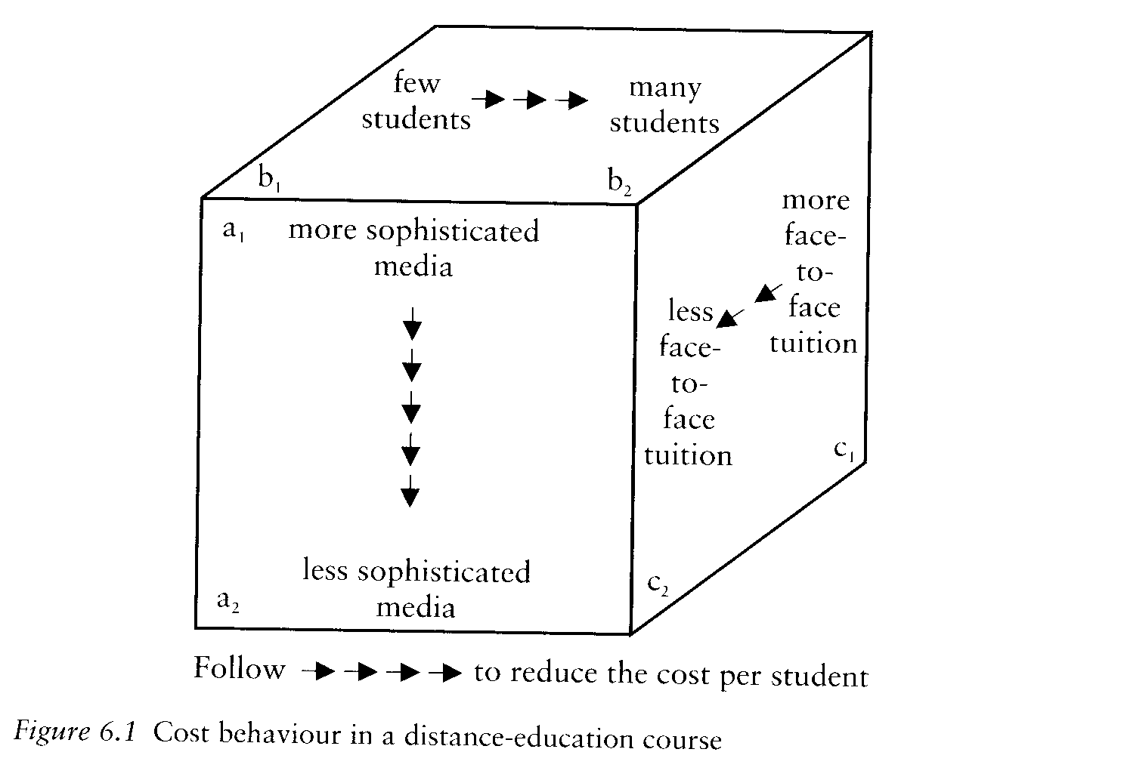

But, as was apparent from looking at costs per student and per graduate, there is a sting in the tall. lt may well be that increased student support, and even the use of lively, imaginative, sophisticated and expensive teaching media, will raise completion rates so that, while they increase costs per student, they reduce costs per graduate. This may have a bearing on fee pollcy. lf a university is heavily dependent on student fees, it will be under pressure from its students to keep fees down. Among the ways of doing this, especially with large student numbers, is to hold back expenditure on student support whose costs rise inexorably with the number of students, even though this may be the element that most increases the effectiveness of the Institution and keeps up completion rates."

CONCLUSION

We began with a puzzle, asking whether there was an economic case for open and distance learning that would justlfy its remarkable expansion.
The evidence is mixed. Basic education for adults, on a large scale and in a poor country, may be possible only by using mass media linked with some kind of student support, perhaps provided by unpaid volunteers. Even so its costs tend to be higher than those of primary schools and it is difficult to see how governments could afford to expand it to reach large, national audiences. Distance education has particular strengths where it is used to support extension agents so that a multiplier effect comes into play. Education out of school, whether for adults or through alternative secondary schools, has lower costs than conventional education and would probably not exist unless it did so. In many cases its modest costs are matched by modest success; poor completion and pass rates mean that its costs per successful student tend to compare much less favourably with conventional alternatives. Teacher education has a potential multiplier effect and high motivation levels, for teachers expecting promotion, and has brought high success rates with competitive costs per graduate. In higher education, so far as we can tell, there are many examples of costs per student being kept quite modest while costs per graduate may rise to equal or exceed those of the conventional sector.

