1. Introduction: golden goose or ugly duckling

There is the familiar circle to be squared: a poor country cannot afford health and education, but without them it cannot even develop such economic resources as it has.
W. M. Macmillan 19381

Distance education began in 1963. In that year Michael Young and Brian Jackson were establishing the National Extension College as a pilot for an open university; Harold Wilson, soon to become prime minister, was calling for one; UNICEF was planning to use distance education to train refugee Palestinian teachers, and the Ecole Normale Supérieure at St Cloud was beginning to experiment with what came to be called educational technology. The Robbins report on higher education noticed with approval and surprise that the Soviet Union was using correspondence education. A global flurry of activity has followed. The Open University was established in Britain to be followed by thirty more across four continents. Radio campaigns have been used for public education in Africa, and open schools set up in Asia. Today, between 5 and 12 per cent of university students in industrialised countries are likely to be studying at a distance; in developing countries the figure is often between 10 and 20 per cent. The pace at which this has happened, and the scale it has now reached, make open and distance learning worth critical analysis. This book attempts that analysis, asking how well open and distance learning has responded to the educational needs of the south in the late twentieth century.
Open and distance learning has grown because of its perceived advantages:

First is its economy: school buildings are not required and teachers and administrators can be responsible for many times more students than they can accommodate in a school. Its second main advantage is its flexibility: people who have got Jobs can study in their own time, in their own homes, without being removed from their work for long periods. Its third advantage is its seven-league boots: it can operate over long distances and cater for widely scattered student bodies.
(Dodds et al. 1972: 10)

In response to this kind of argument, educators in both industrialised and developing countries have used open and distance learning to help solve their problems of resources, access, quality, and quantity: running education with too little money; opening doors to new groups of students; raising the quality and standard of education; expanding numbers.

EXPANSION AND CONSTRAINT

Open and distance learning has grown within a more general expansion of education. The world's schools, colleges and universities have grown more rapidly in the last forty years than ever before. In 1960, as the European empires were fading away, only one child in four got to school in subsaharan Africa, one in two in Asia, and only just over one in two in Latin America. Today, though millions are still outside school, most children throughout the world at least start at primary school. Some developing countries of the south are now sending nearly as many of their children and young people to school and college as the industrialised countries of the north; others have reached the levels that were the norm in OECD countries in the 1960s (UNESCO 1993: 30-1). And this huge improvement has been achieved alongside other dramatic social advances. The world has managed to get to 80 per cent immunisation of children and, just in the 1980s, increased the proportion of families with access to safe drinking water from 38 to 66 per cent in South-East Asia, from 66 to 79 per cent in Latin America, and from 32 to 45 per cent in Africa' (Bellamy 1996: 62). Although it has been uneven, there has been progress in an old-fashioned nineteenth-century sense which can be measured in terms of the numbers of children and young people in school or college (see table 1.1). That progress can be acclaimed as a colossal human achievement in filling the educational cup even half-full. But of course it is not the whole story.
By the late 1960s it was being argued that it would be difficult to sustain the rate of educational expansion. There was a 'quantitative mismatch between the social demand for education and the means for meeting it' as the developing countries of the world faced an unprecedented set of demands (Coombs 1985: 34). They needed to expand education, in response both to political pressure and to the growing economic and social evidence of its benefits. They were doing so with dependency ratios much less favourable than those that had applied when the industrialised countries moved to universal education. (When Britain attained universal primary education in 1880, 36 per cent of the population were below the age of 15; the figure had fallen to 22 per cent when Britain reached universal secondary education in 1947.

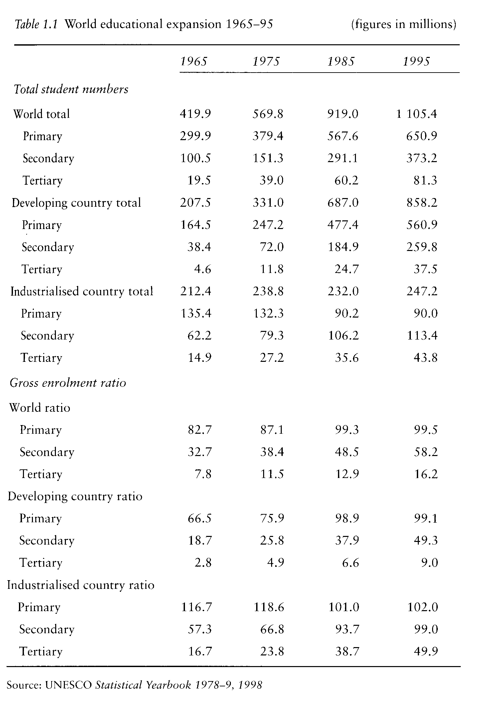

The comparable figures for subsaharan Africa and South Asia in 1970 were 44 and 45 per cent.) And they were expanding education at a time when rapid population growth meant that educational systems needed to tun in order to stay still. Literacy figures illustrate the conundrum; while the proportion of illiterate people in the world has been falling since the 1960s, it was only during the 1980s that the actual number began to drop. In 1990 there were still 900 million illiterate adults (UNESCO 1993: 24).
Ministries of education of the developing world needed to resolve another paradox as they built more schools and enrolled more children. The shortage of qualified labour for the modern economy, and the need to localise employment in the highly visible public sector, together made the case for expanding secondary and tertiary education as a priority. This view agreed with that of the major funding agencies. From its very first loans for education in the 1960s, the World Bank was prepared to lend for secondary and vocational education (Jones 1992: 75) and in practice, over many years, has also funded higher education (ibid: 208). Expansion at these levels also responded to powerful political demands: the children of the urban elites, of those who were making the key educational decisions, were the ones who would suffer if investment in secondary and tertiary education was held back at the expense of primary schools, and especially of rural primary schools. The cost per student at these levels was higher, in some cases dramatically so, than the costs of primary education. At the most extreme, putting one child into university kept sixty out of primary school.' And yet the political and economic case for expanding primary education remained unassailable.
A series of checks have constrained the expansion of schooling. In the 1 970s, one 'was the OPEC oil shock, which sent prices soaring and ended the era of cheap energy and cheap industrialization - and therefore of cheap development. The other was the global food shortage brought about by two disastrous world harvests in 1972 and 1974' (Bellamy 1996:55). Developing countries found that they could not expand education at the same pace in the 1970s as in the 1960s. Worse was to come. Falling prices for primary products marked the downturn in world economies in the 1980s. Many developing countries were forced to turn to the World Bank and IMF who negotiated or imposed policies of structural adjustment designed to transform longterm economic prospekts. One element of structural adjustment, which fitted well with the views of the new right, was to hold back government expenditure, on education as in other sectors. Public expenditure on education in developing countries fell from $200 billion in 1980 to $150 billion in 1985 (in constant 1998 currency)' while expenditure per inhabitant fell by 30 per cent from $61 to $42 (see table 1.2).

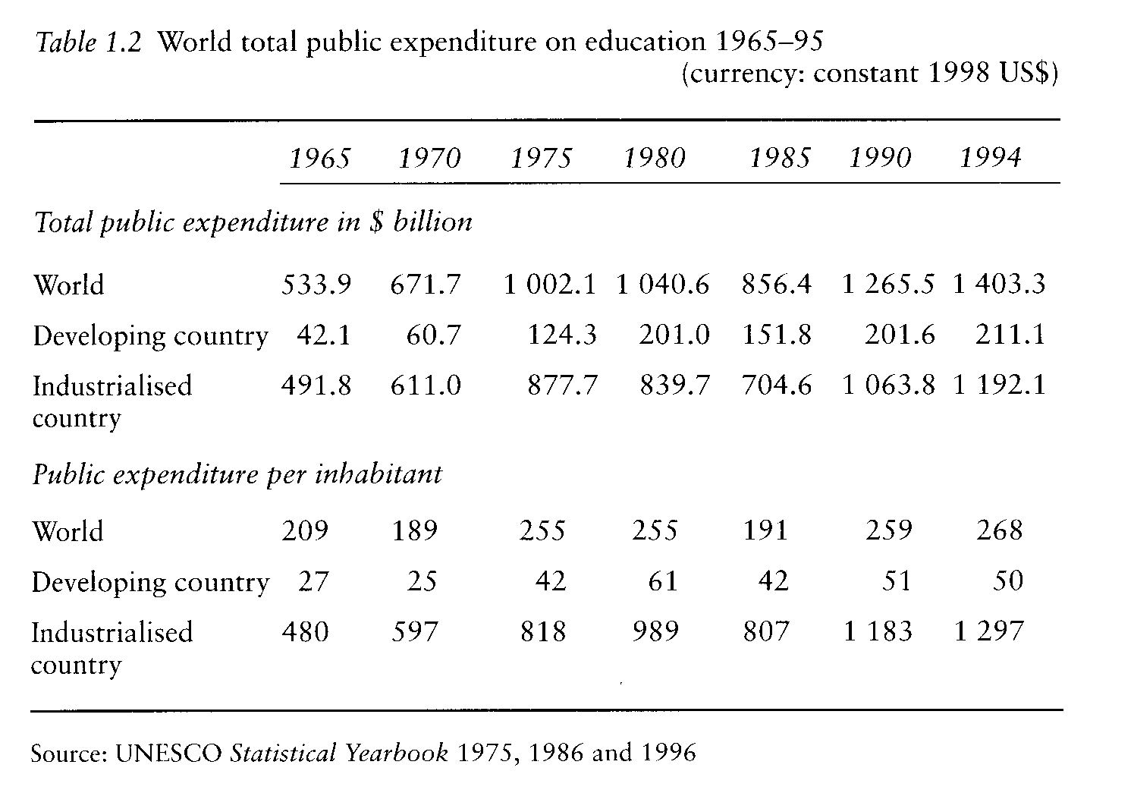

The effect was at its most severe in subsaharan Africa. Africa's total debt, as a proportion of GNP, soared between 1980 and 1995 so that it surpassed its GNP (ibid.); increases in Asia have been more modest while indebtedness in Latin America and the Caribbean declined from the early 1980s. Less money meant fewer children in school. In fourteen countries, a smaller proportion of primary-age children were going to school in 1992 than in 1980 (UNESCO 1995: 130-1). Africa continued to suffer as its dependency ratio increased in the 1980s, in contrast with a reduction in 61 out of 74 states in much of the rest of the developing world (UNESCO 1993: 32). In 1991 UNESCO forecast that Africa would need to employ an additional 5.6 per cent of primary school teachers and 7 per cent at secondary level each year, in order to achieve its own forecasts for the end of the century, which would still fall short of universal primary education (UNESCO 1991: 78).
The shortage of resources has not just kept children out of school but has restricted the quality of education for those who do get there:

Schools in developing countries often lack the most basic resources needed for education such as qualified teachers, facilities and textbooks. Double and triple shifts of a few hours are the norm in some regions; the number of days in the school year has been reduced; and teachers' salaries have declined so much that fully qualified teachers are often a luxury and teacher turnover and attendance are problematic. Even with low salaries, almost all of the school budgets are spent on personnel, so there is little left for school textbooks and other instructional materials - less than $l in low-income countries at the primary level, versus $52 in industrialized countries.
(Levin and Lockheed 1993: 3)

Five years later a survey of schools in least developed countries found that,

the average classroom is not much more than a designated meeting place for a teacher and a group of pupils. ... In half the countries [surveyed] ... over 90 per cent of the pupils in the final grade of primary education do not have any textbook in their mother tongue, over a third of them do not have a maths textbook in any tongue and over a third ... do not have a desk or writing place, as distinct from just a place to sit.
(UNESCO 1998: 56-7)

Recent accounts of higher education in many developing countries tell a comparable story: of teaching without resources, of libraries without journals, of the desperate pursuit of research without equipment. Quality has inevitably suffered as education has been impoverished.
Numbers tell only part of the story. There has always been a golden age in education, just before the span of memory, when schools were enlightened, standards high, children hardworking, and teachers respected. Aristophanes saw it that way in the fourth century BC. Comparisons of the quality or of the standard of education across generations and across cultures are notoriously difficult; we cannot accept at face value populist criticisms that education is at fault in England today because children perform badly on the mathematical tests of 191 1, or in Barbados because coeducation has reduced the significance of cricket in school. But, despite the difficulties, there is evidence enough that, even where the world is moving towards education for all, its quality is still far short of adequate.
Some measures of quality are easy. If education is interesting, affordable, and clearly relevant to children's adult life, then they are likely to stay in school and complete one, two or even three cycles. Measures of school dropout are one proxy for a measure of quality. On the face of it, we can expect that schools in Botswana, where 89 per cent of the 1994 cohort reached grade five of primary school, are doing a better job than Mozambique where the figure was only 47 per cent (UNESCO 1998: table 5). Quality depends on teachers and we might therefore seek another indicator of quality by looking at the educational background of the teaching force. Although, as we shall see in chapter 4, it is not quite that simple, there should be some correlation between the training of the teaching force and the quality of education. Again, the figures are disturbing. In India, for example, in 1996 there were 240 000 untrained teachers (out of a total primary-school teaching force of 1.7 million) and the number of untrained and unqualified teachers was increasing (National Steering Committee 1996: 2).
Since 1960, the International Association for the Evaluation of Educational Achievement has been
using comparable tests within a set of developing and industrialised countries to measure children's
performance in language, mathematics and science. While international comparisons are crude and
beg questions about resources, language and culture, the one consistent result from the comparisons is that developing countries 'almost invariably come bottom of these "cognitive Olympics"' (UNESCO 1993: 87). In tests on reading taken by 14-year olds in 1990-1, Finland, Hong Kong, New Zealand and Sweden headed the table with Venezuela, Nigeria, Zimbabwe, and Botswana at the foot. However, the results need to be treated with caution. They are not comparing like with like; learners in their mother tongue are being compared with learners in a second or third language and UNESCO make the point that they tell us nothing about the efficiency with which schools in developing countries are working, or about the added value of the education they provide. Unsurprisingly, the factors that distinguished high-scoring countries on reading were 'large school libraries, large classroom libraries, regular book borrowing, frequent silent reading in class, frequent story reading aloud by the teachers, and more scheduled hours spent teaching the language' (ibid.). All these demand resources. Schools with scarce resources tend to offer a poorer education. For all their limitations, the tests confirm the intellectual poverty of the education offered by many schools of the south.
With fifty million teachers and a billion students in the world, most of them in the developing countries of the south, any summary of educational progress over the last forty years is inevitably crude. The purpose of summarising is to ground the argument that follows about the role of open and distance learning. At the most General, the quantitative advances mean that, in much of the world, we are in sight of universal primary education and have some chance of attaining universal secondary education. The main exceptions are in subsaharan Africa and South Asia. At the same time, budgetary constraints are holding back the expansion and improvement of education. There remain large numbers of adults who never went to school or who dropped out early; their life chances are restricted and their potential contribution to their society and economy may also be reduced. The combination of budgetary restraint and rapid expansion means that much education is of limited quality and so of restricted effectiveness.

THE USE OF DISTANCE EDUCATION

Over the last twenty years developing countries have used open and distance learning, where they have, as part of a response to the critical educational problems of numbers, resources and quality. The main stream of developments has had to do with education out of school, with access to schooling and ways of raising its quality, with the supply of teachers and with the demand for higher education.
Educational techniques that do not demand school buildings seem to lend themselves to public or adult
education, as described in chapter 2. Both ministries and nongovernment organisations have long used
mass media for public education about agriculture and health as well as for literacy and basic education. Radio continues to be used to guide farmers as a regular part of many programmes of agricultural extension. In Latin America radio schools, with backing from the church, have half a century's experience of running adult education for rural families.
Distance education has struggled to find an alternative to schools, with study centres in southern Africa running parallel to regular schools and open schools being developed in Asia. If the right model could be found, the techniques of open and distance learning might be adapted to the needs of some of the millions who drop out of school, or who dropped out in a previous Generation. But distance education has also been used within schools, either with the grand ambition of transforming them or the more modest one of strengthening some parts of their teaching, using television, radio, and sometimes computers. This is the theme of chapter 3.
In the last twenty years, teachers have received part of their education and training through distance education in every continent. The record is discussed in chapter 4. Distance education has been used both as an emergency solution to a temporary problem, responding to demands for a sudden expansion of the teaching force and as part of a continuing programme of teacher education and upgrading. Its attraction to the planner as a technique of mass education lies partly in its capacity to reach large numbers, and to do so without taking them away from the classroom, and partly as it seems to offer a means of raising school quality. As UNESCO has pointed out.- 'Although some researchers, mainly in North America and Europe, have questioned whether teachers really make a difference in students' learning, the puzzle is to explain how the latter is going to be improved without them' (UNESCO 1991: 81).
Higher education always gets the most attention and demands the most resources. The one
development in distance education in the last twenty years that has caught the headlines is the development of open universities in some twenty-five developing countries. Chapter 5 discusses their achievements. Some of the open universities are on a modest scale; in 1997-8 the open university of Costa Rica had an annual enrolment of 7000 while the specialist Sabana open university in Colombia, devoted to teacher education, had a total enrolment of 2200. But in Asia, open universities in India, Indonesia and Thailand have enrolments of over 100 000 while the Chinese radio and television university system has even larger numbers. Where the national population makes it difficult to justify the establishment of a dedicated open university, a growing number of universities are introducing or expanding distance-education departments.
One consequence of the expansion of open and distance learning is that it has acquired a new
legitimacy. Correspondence education developed in the nineteenth century but spent the first half of
the twentieth at the educational margins, dominated by profit-making colleges, and used as a route to
social mobility by the socially and educationally disadvantaged. Of course there were exceptions:
land-grant universities ran correspondence programmes from the late nineteenth century and, in Britain, they were a staple of vocational training in the few professions with a significant number of working class entrants such as accountancy and surveying. In the colonial world it was an important route to educational qualifications; discussions of distance education among ministers of education in Africa in the 1970s got a warm response because many of the ministers had undertaken some of their education by correspondence. The Soviet Union used distance education to increase the stock of trained labour in the 1930s. For all the exceptions, it was an area of education that attracted neither government support nor regulation. It had little public esteem: 'she spoke in a strange, little girl's voice, with an accent that suggested she had taken a correspondence course in posh, but had failed to complete the curriculum' (Forbes 1996: 144).
All this has changed. Governments have invested heavily in open and distance learning, and a new academic literature has grown up as a protective thicket around it. The main international agencies have generated policy statements: the European Commission in 1991 and UNESCO in 1997 (Commission of the European Communities 1991; UNESCO 1997). Open and distance learning was specifically referred to in the Maastricht treaty in 1993. The European Commission's policy statement was matched by money. Its main vehicle for promoting educational cooperation in Europe was the Socrates programme, funded with 850 million ecu ($1.19 billion) for its first five years, rising to 1.4 billion ecu ($1.57 billion) for the second. Within this programme, most of it devoted to conventional student mobility, the Commission has supported regional open and distance learning projects, 63 of them in 1998. The World Bank and other regional development banks have provided support for distance education. Expenditure on open and distance learning, its volume of academic literature, its appearance in Legislation, even the fact that distance-education students today read their Open University texts as they commute where they used to hide them in brown paper wrappers, all are markers of a new legitimacy.

WHY AND HOW HAS IT HAPPENED?

With colleagues 1 looked in 1980 at the role distance education might play in responding to some of the educational problems of what we identified as the third world in both formal and nonformal education (Young et al. 1980).' We argued the case for a parallel, nonformal, curriculum and organisational structure in which Africa might build on the experience of the radio schools of Latin America. And of course we got things wrong. On the grand scale, we did not foresee the intellectual domination of Reaganomics. On our own patch we did not notice how the large open universities, then just getting under way in Asia, would become the dominant institutions in distance education at least in terms of enrolments. Our general conclusion was upbeat, that radio colleges of the kind we were advocating had advantages which meant that they could 'offer a different kind of education - not an inadequate copy of traditional schooling but something qualitatively different' (ibid: 130). In practice, while open and distance learning has expanded and changed since then, gaining a legitimacy we might not have expected, its main achievements occur in quite other areas from those for which we argued.
Expansion, at least in some sectors, has been more rapid than expected. Why has it attracted public support and funding? Economics and education each give part of the answer. The promise that open and distance learning could extend educational opportunities at a lower cost than conventional education was a powerful motivator. lf it could teach more, and reach more, or accelerate educational change, then these were reasons enough for the educational planner to try lt. Of course these arguments spring from particular educational philosophies justifying expansion and reform. Once we carry the analysis beyond arguments for expanding or changing education that are, in a sense, endogenous to it we can distinguish between ideological, economic and technological reasons for investing in open and distance learning.
To start in Britain, an ideological imperative to expand education and to widen opportunities for adults lay behind the establishment of the British Open University in 1969. It was not just that the Crowther report had demonstrated, from its statistics of educational tests taken by all conscripts, that we were wasting untapped resources because of the inadequacy of the educational system or that the Robbins report legitimised the expansion of higher education and rejected the claim that 'more means worse' (Central Advisory Council for Education 1959: 119; Committee on Higher Education 1963: 8). lt was also an ideological statement that university education, with unimpeachable standards and quality, should be open to all adults, regardless of their previous education or lack of it, and that this vision merited government support and funding. In just the same way, Julius Nyerere argued that Tanzania should move to universal primary education in 1977, well before the educational planners thought feasible. If teachers were to be trained for the new school places, distance education was the only way of training them.
Unless we are severely reductionist the various ideological justifications for educational change, and so for the use of open and distance learning as a mechanism, can be distinguished from a set of economic arguments. In comparing the British and Chinese Open Universities, Wei (1997) notices that while ideological reasons influenced decisions in Britain, distance education was used in China to expand the trained workforce as the education system recovered from the cultural revolution. In Europe, along with an ideological commitment to educational cooperation across frontiers there is a strong economic motive for the European Union's education and training programme: to keep the Union competitive with the other major economic blocs. In the Caribbean, the vice-chancellor of the University of the West
Indies argued for the expansion of its work in distance education as a way of increasing the production of graduates at a time when the region was lagging behind East Asia.
Technology, as well as ideology and economics, has spurred the development of open and distance learning. In industrialised and developing countries alike there have been waves of projects that have responded to the availability of new technologies at least as much as they have tried to solve major educational problems. Computer technologies are influencing the curriculum in order to provide a computer literate population as well as the computer specialists who will lead, baffle or guide lt. Computer and satellite technologies are offering new ways of extending the range of education and so providing new opportunities to open and distance learning. Chapter 7 asks how far the development of open and distance learning has been driven by technology.

EFFECTIVENESS, EFFICIENCY, QUALITY

The new scale of open and distance learning, its sense of legitimacy, and the power of the educational, ideological, economic and technological arguments for its expansion have, in turn, attracted its critics. (There are oddly few of them: perhaps a mark that, despite its claims, open and distance learning remains a much smaller enterprise than the huge human activity of teaching children in schools.)
One line of criticism has questioned the evidence of the effectiveness and significance of open and distance learning. Many evaluations have been carried out by researchers closely associated with the projects they were assessing. Their work has suffered from two biases:
The first is called the 'benefit of the doubt' or BOD aspects of the analysis which led [researchers] to accept and utilize very deficient data when they favor the instructional technology over traditional alternatives. ... The second bias is that which is reflected in the narrowing of the scope of the analysis to those items on the agenda of the sponsoring agency while ignoring other effects.
(Carnoy and Levin 1975: 387)

Reflecting their caution, we need to view with some care the claims of parity between open and conventional universities where we have data on enrolment rates but not on graduation rates.
The evidence that open and distance learning can be effective is reasonably firm, and contrasts with that on efficiency and quality. Ample studies have shown that people studying at a distance and through open learning can pass examinations and gain qualifications that attract formal recognition and public esteem. Teacher trainees, studying at a distance, perform as well in the classroom as those trained more conventionally. Nonformal programmes have achieved results in terms of changes of practice in health and agriculture. Questions remain, however, about the efficiency of open and distance learning. The easiest measures of efficiency include examination pass rates and successful completion rates, or their inverse, dropout rates. Some forms of distance education are notoriously inefficient; correspondence colleges used to make their money by taking students' money in advance and providing such a poor service that they could spend the minimum on tuition. Profitability depended on inefficiency. Nor can we Attribute this inefficiency just to the conflict between educational values and those of the market place: successful completion rates tend to be lower for open and distance learning than in conventional education, where it has been possible to make direct comparisons between them.
In asking questions about the quality of open and distance learning we move on to more difficult ground. If we are to avoid the naturalistic fallacy then we are likely to sympathise with Pirsig's hero:

Even the name 'Quality', was a kind of Definition since it tended to associate mystic reality with certain fixed and limited understandings. Already he was in trouble. Was the mystic reality of the universe really more immanent in the higher-priced cuts of meat in the butcher's shop? These were 'Quality' meats, weren't they? Was the butcher using the term incorrectly?

(Pirsig 1991: 131-2)

Nor can the difficulty be avoided by equating 'quality' with 'fitness of purpose': if the purpose of an educational programme is to contain educational demand (as has been asserted of nonformal education), or to prevent students meeting and threatening the state (as was asserted of the Free University of Iran under the Shah), or to educate Christian gentlemen to rule the empire (as was asserted by some English schools when there was an empire), then some educators will be uncomfortable with the equation. Whose fitness, whose purpose? Without seeking to answer those questions at this point, we can rephrase them to ask whether the methods of open and distance learning are inherently at odds with widely accepted educational values. A fuller answer will be attempted in the last chapter after reviewing the evidence for various sectors of education. lt is easy enough to argue that open and distance learning lends itself to rote learning, or that it enables people to pass examinations without following a worthwhile programme of study. But these are not of the essence: there are bound to be low-quality programmes of distance education just as there are poor schools. We need to ask broader questions about the social and economic consequences of open and distance learning.
The believers and sceptics have chosen higher education as the ground on which to argue their case. Klees drew evidence from higher education in arguing that, 'distance education Systems... have thus usually been seen as giving a second-class inferior education to... the most disadvantaged' (Klees 1995: 403). From the slightly more restricted standpoint of the large open universities, Daniel reached an upbeat conclusion that, 'these megauniversities are revolutionary in two respects: they have brought down the cost of higher education dramatically and they have made lifelong learning a reality for adults wherever they live and work' (Daniel 1996.- 86). The contrast between the two views, especially if we were to generalise from them to the use of open and distance learning at other levels of formal and nonformal education, justifies the analysis that follows. The next four chapters report what has been happening in open and distance learning in four sectors of education over the last twenty years. In an attempt to explain the history, chapters 6 to 9 examine the historical record within a political and economic framework, asking how the economic evidence, the changing technologies, globalisation, and national political priorities have shaped the development and use of open and distance learning. The final chapter moves from description to evaluation, attempting to answer questions about the quality and legitimacy of open and distance learning.

DEFINITIONS

Alongside the alarming growth of literature about open and distance learning there is a meta-literature about its terminology. Those who want to follow it can start with Rumble (1989) and Lewis (1990) but should remember Browning's warning against pedantry that, 'There's a great text in Galatians, Once you trip on it, entails Twenty-nine distinct damnations, One sure, if another fails' (Browning 1842). I proposed in 1982 a Definition for distance education as 'an educational process in which a significant proportion of the teaching is conducted by someone removed in space and/or time from the learner' (Perraton 1982: 4). This was good enough for the World Bank, and has been used as the basis of Legislation, so 1 will stick with it. The term 'open learning', with its ambiguities about the meanings of the term 'open' has led some of its protagonists to shy away from defining it, labelling it a philosophy rather than a method, as lf that were an excuse for vagueness. Here it is used for 'an organised educational activity, based on the use of teaching materials, in which constraints on study are minimised either in terms of access, or of time and place, pace, methods of study, or any combination of these' (Perraton 1997). The European Commission has adopted the term 'open and distance learning' to cover work that would fall within either of these definitions. Language follows funding and 1 have generally followed European usage in this chapter. But language also reflects geography and, in much of the developing world, the term 'open learning' is hardly used, perhaps because it suggests openness to entry requirements, seldom a popular idea. 'Distance education' remains the more usual term. In this book therefore, while genuflecting towards the term 'open and distance learning , the term 'distance education' will be used to embrace both distance education and open learning - as defined more narrowly above.
In much the same way 1 have used the terms 'south' and 'developing countries' and 'third world' almost as synonyms, with no ideological intent, accepting that New Zealand is in the south, that industrialised countries are also developing, and that the destruction of the Berlin Wall ended the actual and symbolic division between the first and second worlds. There is a real difficulty, unavoidable in an overview, in bringing together evidence from the whole variety of the south. The linguistic problems matter less. Purists can object. The meaning should be clear.

